TEACHER’S GUIDE
For a course covering 1877 to the Present

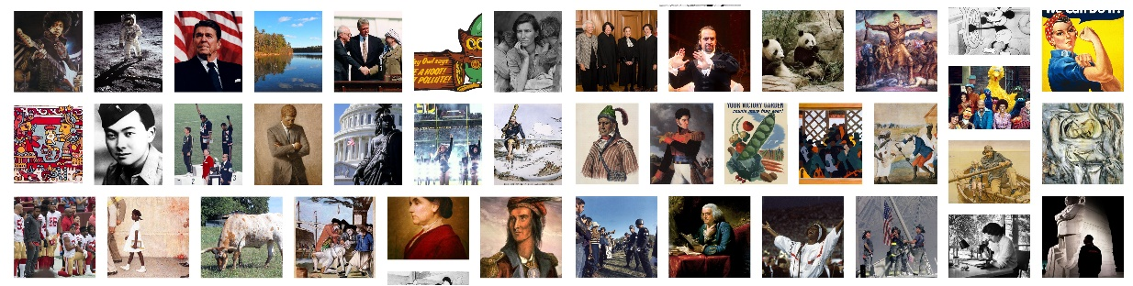

Updated December 28, 2022

ENGAGING WITH THE TEXT
THREE OPTIONS
PRINT VERSION  Features:  - PDF format  - Ready to print in small booklets for each unit  - Includes the introduction and conclusion to each reading  - Each reading has about 3-5 images  - Summary with the big idea appear at the end of the text  - Vocabulary terms are defined side-by-side with the text  - Vocabulary terms also appear as a list at the end of the text  - For some chapters there are translations in PDF format with side-by-side texts with English original. These may contain errors  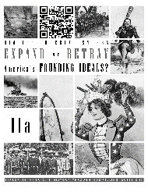  Advantages:  - Easy for students to carry  - Some students prefer paper to screens  - Does not require an internet connection  Disadvantages:  - Few images  - Xerox print is black and white  - Requires a lot of paper and time to copy  - Class time spent distributing  - No audiobook integration  - Old copies may not include the latest updates and corrections  - Limited translations |  | ONLINE VERSION  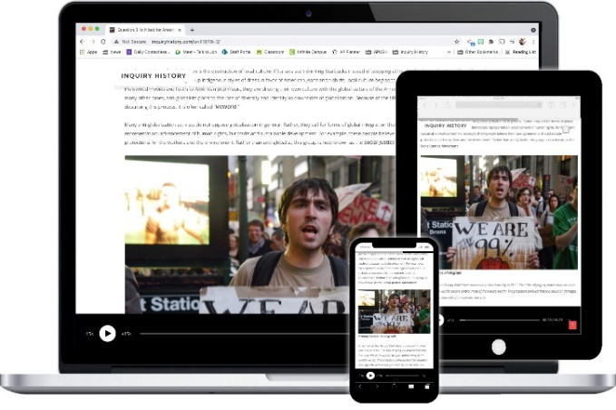  Features:  - Accessible on desktop computers, tablets or phones  - Includes the introduction and conclusion to each reading  - Each reading has about 3-5 images  - Summary with the big idea appear at the end of the text  - Vocabulary terms appear as a list at the end of the text  - Link to auto translate the text into many languages (Micronesian languages not available)  - Simplified English versions available for some readings  - Audio option available for students to listen to or for reading along  Advantages:  - Students can access at any time  - Does not require distribution of paper copies  - Audiobook option  - Translations on demand  - Contains the latest updates  Disadvantages:  - Some students don’t like reading on the computer  - Requires internet access and a device

VIDEO VERSION

Features:
- YouTube videos of each reading
- Side-by-side scrolling text with images
- Vocabulary terms are highlighted
- Integrated audiobook
- Mr. Loomis presents the introduction and conclusion without images
- Includes goals for the lesson and the big idea at the start of the video
- Full text is published as closed captions which can be auto-translated

Advantages:
- Good for students who struggle with reading
- Many more images (about 50-100 per reading)
- Integrated text and audio
- Can be played at different speeds
- Students can turn off the audio and read for themselves as the text scrolls
- Closed captions can be auto-translated
- Can be used to create EdPuzzle assignments

Disadvantages:
- Vocabulary terms are highlighted but not defined
- Requires a device and internet connection
- Some students do not like reading on a screen

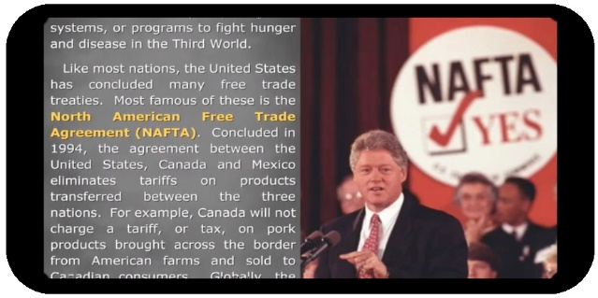

PACING GUIDE
FIRST QUARTER |  | SECOND QUARTER
INTRODUCTION: REVIEW OF EARLY AMERICAN HISTORY  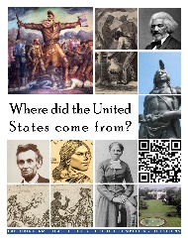  - The Origins of America  - The Revolution & the New Government  - Westward Expansion  - The Civil War  9: GILDED AGE BUSINESS, LABOR & GOVERNMENT  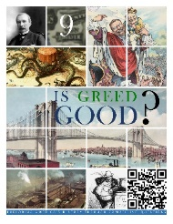  - The Industrialists  - Corruption & Philanthropy  - Organized Labor  - Government Regulation  10: GILDED AGE IMMIGRATION, URBANIZATION & REFORM  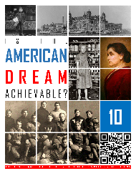  - Immigration & Urbanization  - Writers & the Yellow Press  - The Progressives  - Women's Rights  11a: IMPERIALISM  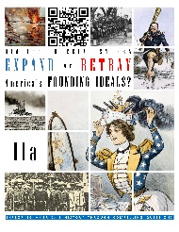  - Origins of Imperialism  - Spanish-American & Philippine-American Wars  - Asia & Latin America |  | 11b: WORLD WAR I  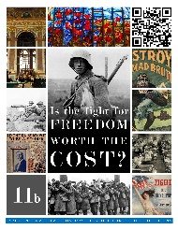  - Neutrality & the Start of World War I  - The World War I Homefront  - The End of World War I & Isolationism  12: THE 1920s  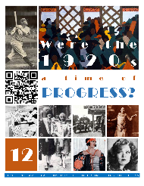  - Politics, Innovation & the Economy  - Popular Culture  - The Harlem Renaissance  - Social Conflicts  13: GREAT DEPRESSION & NEW DEAL  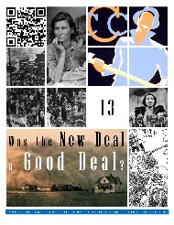  - The Start of the Depression  - Life in the Depression  - The First New Deal  - The Second New Deal  14: WORLD WAR II  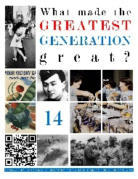  - Neutrality & Pearl Harbor  - Winning the War  - The World War II Homefront

THIRD QUARTER |  | FOURTH QUARTER
15: THE COLD WAR  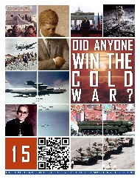  - Origins of the Cold War  - Containment  - The Arms Race  - The Cold War at Home  - The Later Cold War  - The End of the Cold War  16: THE CIVIL RIGHTS MOVEMENTS  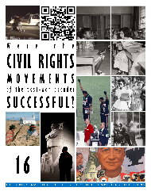  - School Desegregation  - Marches & Successes  - Frustration & Violence  - Other Movements  17: THE SOCIAL REVOLUTION  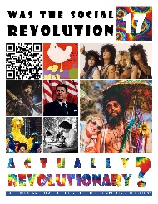  - The 1950s  - The Counterculture  - The Great Society  - Environmentalism  - The Feminist Movement  - The Conservative Revolution |  | 18: FAILURES  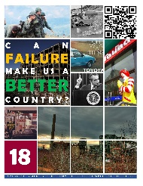  - Vietnam  - Scandals  - Globalization  19: THE PAST 30 YEARS  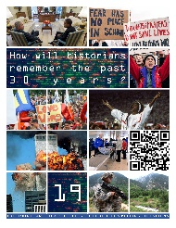  - The Post-Cold War World  - The War on Terror & Gun Violence  - The American People  - Race in Contemporary America  - The Digital Revolution  - Contemporary Politics  REVIEW FOR THE END-OF-COURSE EXAM

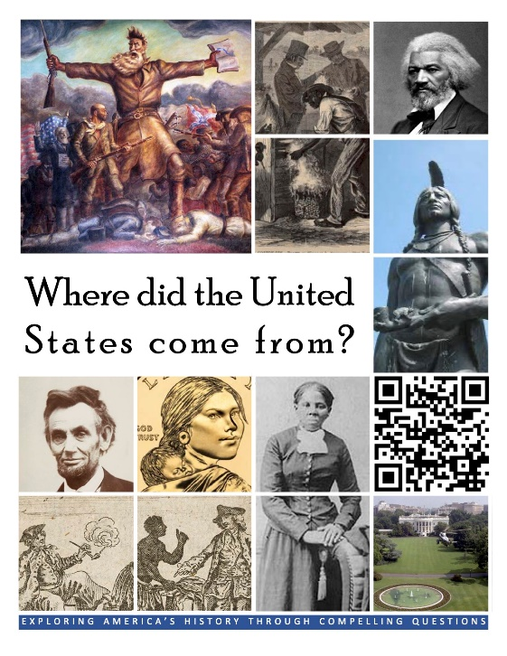  HCSSS STANDARDS  There are no high school standards for this content. It is covered in eighth grade. This unit is designed to be a review.  TESTED TOPICS  - English Colonial Locations  - Jamestown  - Massachusetts Bay Colony  - Mayflower Compact  - Declaration of Independence  - Enlightenment  - George Washington  - Taxation without Representation  - Women's Right to Vote  - 49ers  - Manifest Destiny  - Mexican-American War Impact  - Oregon Trail  - Westward Expansion Effects  - Emancipation Proclamation  - End of Slavery  - Gettysburg  - King Cotton  - North's Advantages  - Popular Sovereignty | INTRODUCTION
 | Four Lessons
1: THE ORIGINS OF AMERICA
What made the colonies so different if they were all settled by people from the same country?
- Virginia and the South
- New England
- The Middle Colonies

2: THE REVOLUTION & THE NEW GOVERNMENT
What is freedom?
- Declaring Independence
- The War for Independence
- The New Government
- The Bill of Rights

3: WESTWARD EXPANSION
Was the spread of the United States across the continent destiny or design?
- Expansion in the Early 1800s
- Texas & Mexico
- The Last of the Indian Wars

4: THE CIVIL WAR
Was the Civil War a righteous judgement for America’s embrace of slavery?
- Slavery
- Causes of the Civil War
- Fighting the Civil War
- Emancipation
- Gettysburg Address
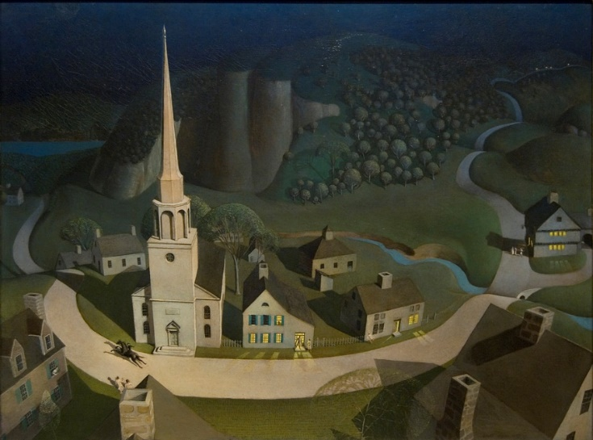
- Reconstruction
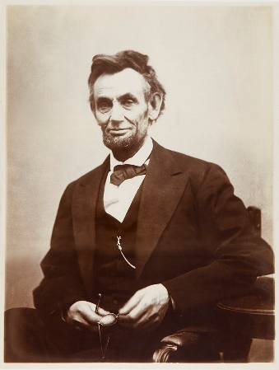
REVIEW OF EARLY AMERICAN HISTORY

Where did the United States come from?

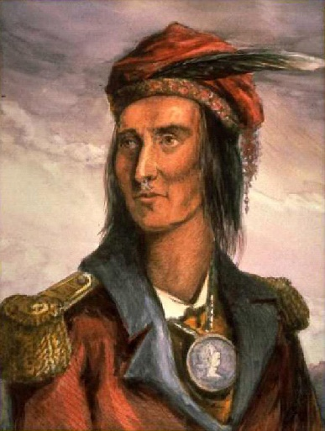
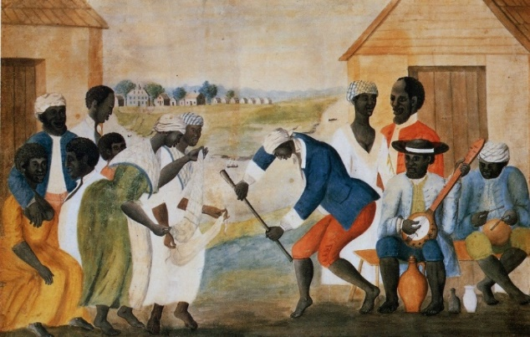
0-1: THE ORIGINS OF AMERICA
What made the colonies so different if they were all settled by people from the same country? ?
TOPICS
- Virginia and the South
- New England
- The Middle Colonies
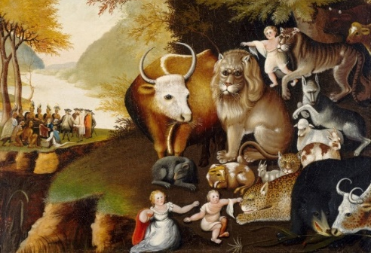
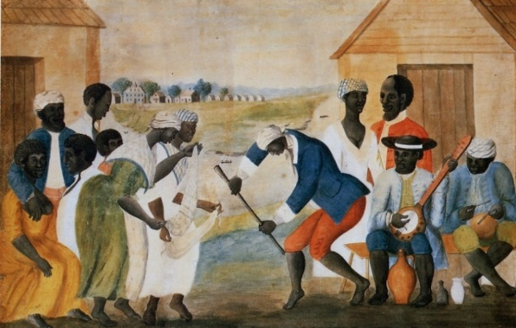
BIG IDEA: The United States is made up of many different people, but the origins of the nation lie in English settlements along the Atlantic coast in the 1600s. People came there for different reasons, and some were brought from Africa as slaves.
Jon’s Teaching Tips:
It is good to help student learn some basic geography early in the course and this is a good chance to teach it in context. It’s also good to help students get a feel for the differences in regions which show up later on as well.
THE LESSON BY THE NUMBERS
Reading Level: 9.2
Audio Time: 10:02
Vocabulary Terms: 23

Shorter and Easier than Most

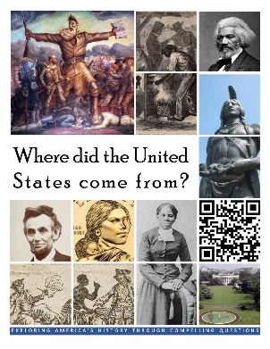
VOCABULARY

IDEAS
Triangle Trade
Chattel Slavery
City Upon a Hill

LOCATIONS
Jamestown
Plymouth
Massachusetts Bay Colony
New York
Pennsylvania
Maryland
Georgia
Appalachian Mountains

PEOPLE & GROUPS
John Smith
House of Burgesses
Indentured Servants
Church of England
Separatists
Pilgrims
Massachusetts Bay Colony
Puritans
Quakers
Scotch-Irish

DOCUMENTS
Mayflower Compact

EVENTS
Thanksgiving

LESSON SUMMARY
The English developed their first colony in America at Jamestown. It was a business venture that failure in the beginning. The settlers did not know how to farm so they starved. Only with help from the local Native Americans did some settlers survive. However, they discovered that they could grow tobacco, which they could sell back in Europe. Tobacco make Jamestown and the surrounding Chesapeake Bay region profitable.
Work in the colonies was done both by indentured servants and eventually by African slaves. Merchants made a lot of money buying and selling slaves. They were an important part of the Triangle Trade. Slaves were purchased in Africa and brought to the Americas. Sugar, tobacco, cotton and other raw materials were loaded onto the ships in America and taken back to Europe. In Europe the ships were reloaded with finished products like furniture and guns, which were shipped off to Africa.
In time, slaves were seen as property the same as horses or wagons. Strict laws, or codes, were passed throughout the colonies defining the various rights slaves did not have and restricting aspects of their lives. Some slaves resisted, but these rebellions were always stopped, and resulted in the passage of more strict slave codes.
New England was settled by religious dissenters who wanted to create a new life for their families far from the control of the English church leaders. They created a society based on religion and towns rather than wealth and cash crop exports.
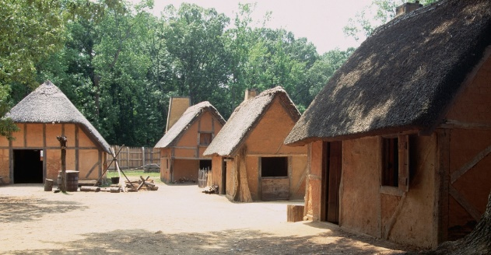
Plymouth was founded by separatists called Pilgrims. They were a small group but set an important precedent in America by agreeing to the Mayflower Compact and holding elections for community leaders. A much larger group came to nearby Massachusetts Bay Colony. They were Puritans rather than separatists. They believed in a covenant with God. They thought that if they were good Christians, God would reward them and make their colony prosper. They also believed their colony would be an example of a pure society on earth that everyone else could copy. They referred to it as a city upon a hill.
Between New England and the Chesapeake colonies that grew up around Jamestown, there were a variety of other English colonies. These were often more focused on trade and more tolerant of differences. In the interior, non-English groups settled who also left their mark on the nation.
0-2: THE REVOLUTION & THE NEW GOVERNMENT
What is freedom?
TOPICS
- Declaring Independence
- The War for Independence
- The New Government
- The Bill of Rights
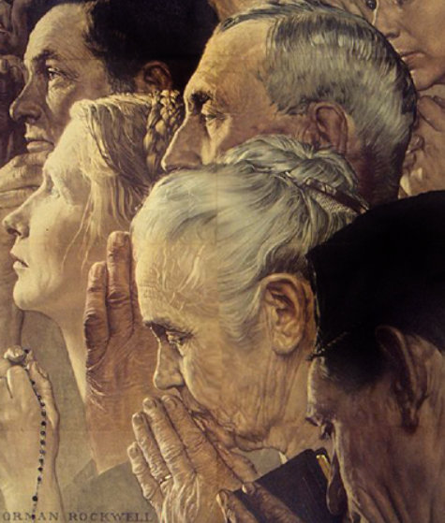
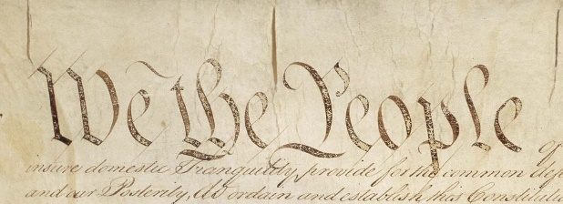
BIG IDEA: Americans declared and fought for independence for a variety of reasons. Enlightenment ideas about government and economic factors were both important. These ideas were later incorporated into a new system of government.
Jon’s Teaching Tips:
Students should have a basic understanding of the structures of our government to understand many lessons latter in the course. It is worth taking time to make sure they know the three branches, how laws are made, and the Bill of Rights.
THE LESSON BY THE NUMBERS
Reading Level: 10.6
Audio Time: 11:18
Vocabulary Terms: 15

Shorter and Easier than Most

VOCABULARY

IDEAS
Enlightenment
Taxation without
Representation
Shot Heard ‘Round the World
Great Compromise

EVENTS
Boston Massacre
Boston Tea Party

PEOPLE & GROUPS
Thomas Jefferson
George Washington
James Madison
Founding Fathers
Federalists
Anti-Federalists

DOCUMENTS
Declaration of Independence
Articles of Confederation
Bill of Rights

LESSON SUMMARY
The English settlers in America chose to declare and fight for independence after a long series of conflicts with their government. Most of these centered around economic problems and their right to participate in government. Americans were influenced by Enlightenment ideas.
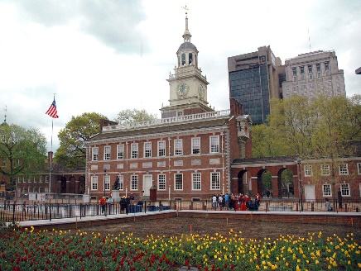
American leaders did not want to declare independence right away and tried unsuccessfully to resolve their differences with the government in England. The Declaration of Independence laid out the reasons for independence and remains an important document in American history.
The War for Independence was long and difficult. Eventually with the help of the French, Washington's army was able to force the British to surrender and recognize American independence.
For the first few years of American independence, the federal government was weak and ineffective at dealing with major problems. A rebellion in Massachusetts eventually pushed leaders to seek a new system of government.
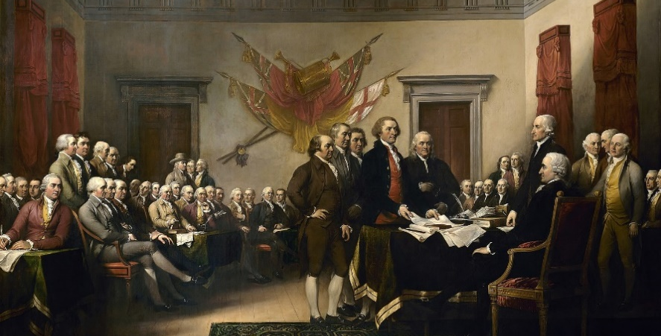
The creation of the Constitution and our current system of government was due to problems that existed in the late 1780s and was the result of a series of compromises. The Founding Fathers tried to enshrine the ideals of the Revolution in a functioning system of government.
The debate about ratification of the new Constitution divided the nation's leaders but led to the creation of the Bill of Rights.
0-3: WESTWARD EXPANSION
Was the spread of the United States across the continent destiny or design?

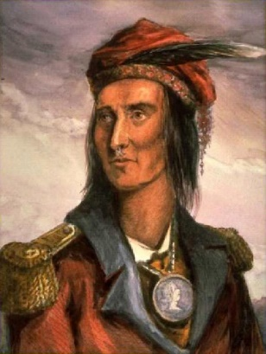
BIG IDEA: Since the first English settlements along the Atlantic Coast, White Americans spread westward and were involved in conflicts with both Native Americans and Mexicans who blocked the spread of the United States across the continent.
Jon’s Teaching Tips:
The overall theme of conflict over land should be easy to drive home. This is a good chance to introduce alternate perspectives, especially about land ownership.
TOPICS
- Expansion in the Early 1800s
- Texas & Mexico
- The Last of the Indian Wars

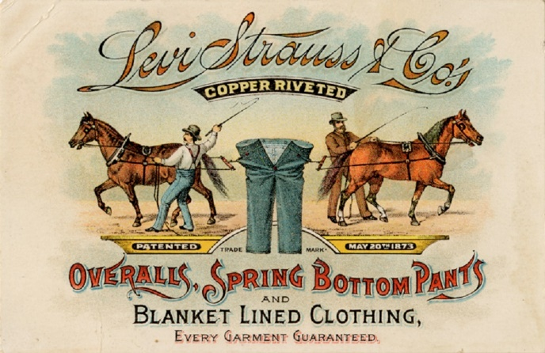
THE LESSON BY THE NUMBERS
Reading Level: 9.9
Audio Time: 9:23
Vocabulary Terms: 15

Shorter and Easier than Most

VOCABULARY

IDEAS
Manifest Destiny

PEOPLE & GROUPS
Lewis and Clark
Tecumseh
Homesteader
Sioux

EVENTS
Louisiana Purchase
Texas Revolution
Mexican-American War
Battle of Little Big Horn
Wounded Knee

ANIMALS
Buffalo

LOCATIONS
Louisiana Purchase

LESSON SUMMARY
Native Americans had been fighting White expansion for many years. Their primary goal was preserving their land which was the principal factor in their decisions about who to side with the Seven Years War, American Revolution, War of 1812, and in their own conflicts with White Americans.
Americans who moved to Texas initiated a war for independence from Mexico, and later President Polk launched a war against Mexico that resulted in Mexico giving half of its land to the United States.
Hispanics who found themselves in the United States after the Mexican-American War often lost their land to Whites. Some fought back, but they generally lost out as Whites pushed west.
There were many groups of people who defined the character of the West. Mountain men, miners were some of the first Whites to move into the West. Later ranchers and eventually pioneer farmers moved west. As Whites settled in new territories, railroads were built to connect them.
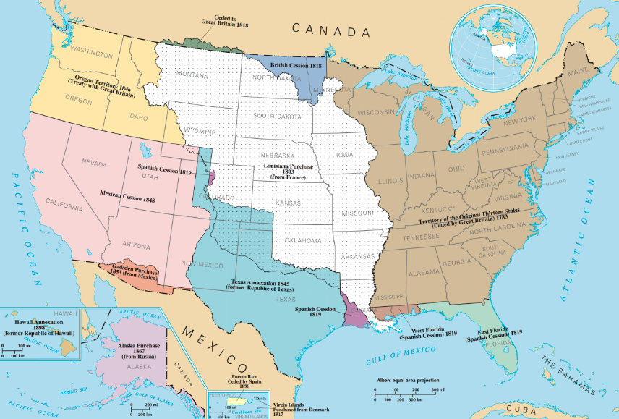
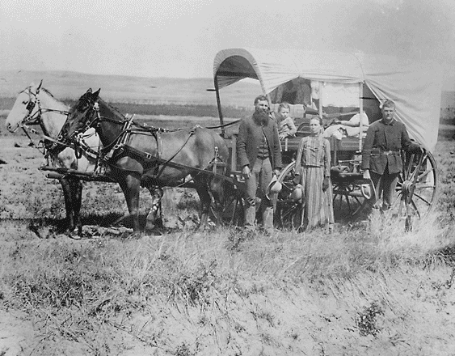
The last violent conflicts between Whites and independent Native Americans were in the late 1800s on the Great Plains. Ultimately the army defeated the last of the tribes and forced them to move to reservations where official government policy attempted to destroy Native culture.
0-4: THE CIVIL WAR
Was the Civil War a righteous judgement for America’s embrace of slavery?
TOPICS
- Slavery
- Causes of the Civil War
- Fighting the Civil War
- Emancipation
- Gettysburg Address
- Reconstruction
BIG IDEA: In the 1800s, slavery divided America. In 1860 things fell apart and the northern states and southern states fought a long, bloody civil war. The North won, preserving the union and ending slavery. However, southern White leaders were able to maintain the social hierarchy that kept African Americans at the bottom of the social structure.
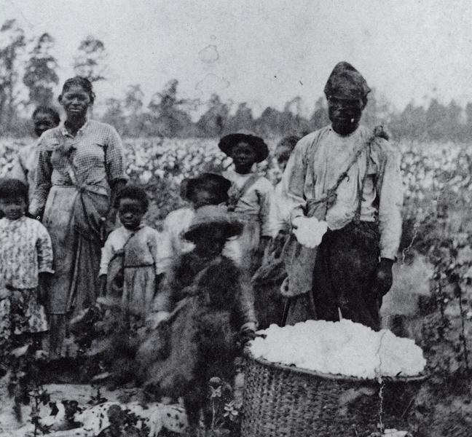
Jon’s Teaching Tips:
There are a variety of ways you can approach this topic. You can teach it as a conclusion to the unfinished questions of the Revolution or as a setup to later lessons about the Harlem Renaissance and Civil Rights Movement.
THE LESSON BY THE NUMBERS
Reading Level: 9.0
Audio Time: 15:36
Vocabulary Terms: 18

Shorter and Easier than Most

VOCABULARY

IDEAS
King Cotton
Abolition
Underground Railroad
Popular Sovereignty
Jim Crow

PEOPLE & GROUPS
John Brown
Abraham Lincoln
Robert E. Lee
Ulysses S. Grant
Share Croppers
Freedmen

LOCATIONS
Confederate States of America

EVENTS
Battle of Gettysburg
Reconstruction

DOCUMENTS
Emancipation Proclamation

SPEECHES
Gettysburg Address

LAWS
13th, 14th and 15th Amendments

COURT CASES
Dred Scott v. Sanford

LESSON SUMMARY
Slavery was the root cause of the Civil War. As the nation grew, slavery also grew and formed the basis for much of the nation's wealth. The small abolition movement in the North slowly gained support and helped facilitate a system to help slaves escape to freedom in Canada.
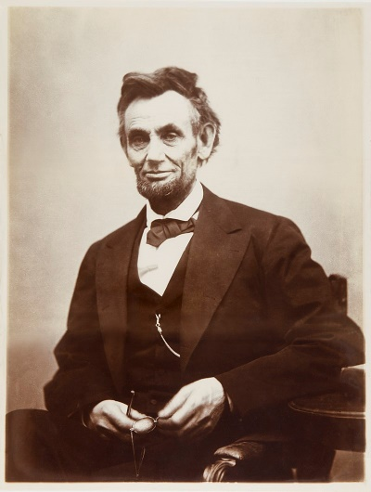
Westward expansion increased conflicts about slavery as the addition of each new state threatened to upset the balance between free and slave states in the Senate. Politicians tried compromise and popular sovereignty to deal with this problem.
In the 1850s politicians tried but were unable to stop the increasingly divisive issue of slavery from leading to the outbreak of war between the slave states of the South and the free states of the North.
The North and South both had advantages and weaknesses in the Civil War, but eventually the North's industrial might and willingness to persevere through a long and destructive war led to victory.
Northerners led by President Lincoln originally were fighting to preserve the Union. By the end of the war Lincoln had made ending slavery a part of the North's mission, giving the war a moral purpose.
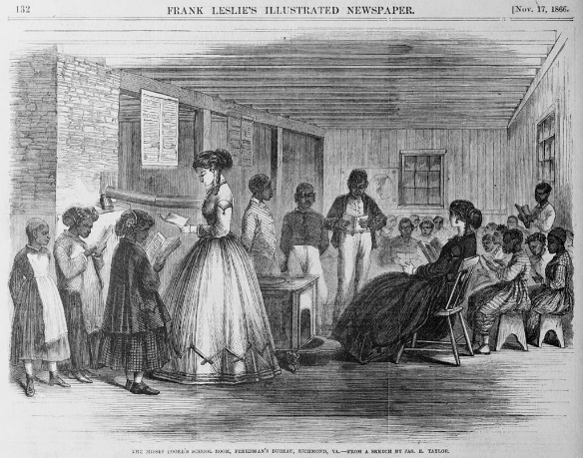
After the war ended in 1865, Northerners tried unsuccessfully to remake Southern society. Although it is often said that the South won Reconstruction, three constitutional amendments were passed that ended slavery, gave citizenship to anyone born in the United States, and guaranteed the right to vote to all men.
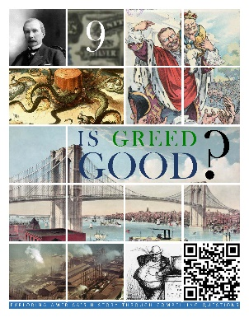  HCSSS STANDARDS  - SS.US.2.10.1 Analyze features of distinct market structures and government efforts to influence them  - SS.US.2.7.2 Assess how business magnates came to dominate politics in the Gilded Age  - SS.US.2.7.3 Evaluate the effectiveness of labor unions and populists in shaping public policy  TESTED TOPICS  - Captains of Industry vs. Robber Baron Concept  - Major Industrialists and their Industry  - Business Consolidation Types  - Philanthropy  - Gospel of Wealth  - Political Machine  - Strike  - Scabs  - AFL  - Haymarket Square Effects on Public Support for Labor  - IWW  - Upper and Lower Classes  - Government Opposition to Unions  - Anti-Trust Legislation  - T Roosevelt’s Attitude toward Trusts  - Ways Businesses Influenced Government Policy  - Public Attitude toward Trusts | UNIT 9
 | Four Lessons
1: THE INDUSTRIALISTS
Were they Captains of Industry or Robber Barons?
- Vanderbilt
- Carnegie
- Mellon
- Morgan
- Rockefeller
- Others: Field, Stanford and Clark
- Consolidation Practices

2: CORRUPTION & PHILANTHROPY
Does money make you powerful?
- President Grant
- President Garfield
- Scandal and Civil Service Reform
- Big City Corruption
- Tammany Hall
- Thomas Nast
- The Gospel of Wealth

3: ORGANIZED LABOR
Who should be in charge, workers or owners?
- First Labor Unions
- Great Upheaval
- Types of Labor Unrest (Strike, Boycott, etc.)
- Knights of Labor
- Haymarket Square
- AFL and Samuel Gompers
- Eugene Debs, Socialism, and the Wobblies

4: GOVERNMENT REGULATION
How should government balance the power of social classes?
- Theodore Roosevelt
- Anti-Trust Legislation
- Trust Busting
- Taft’s Presidency
- Election of 1912
- Wilson’s New Freedom
- Creation of the Federal Reserve and FTC

GILDED AGE BUSINESS, LABOR & GOVERNMENT

Is greed good?

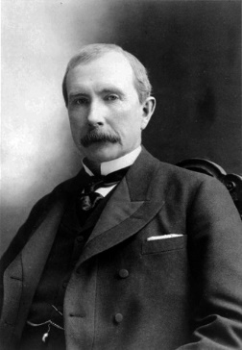
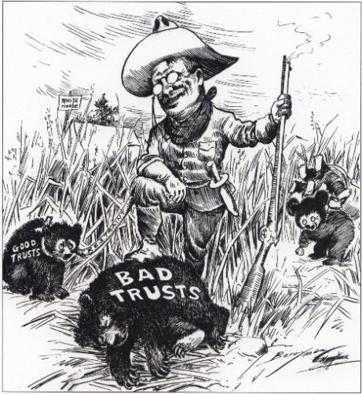
9-1: THE INDUSTRIALISTS
Were they captains of industry or robber barons?
TOPICS
- Vanderbilt
- Carnegie
- Mellon
- Morgan
- Rockefeller
- Others: Field, Stanford and Clark
- Consolidation Practices (Cartel, Vertical, Horizontal, Trust, etc.)
BIG IDEA: In the late 1800s, the industrial revolution went into overdrive. Business in America was dominated by a few enormously wealthy tycoons who engaged in unethical business practices, but also gave away their fortunes to benefit all of society.
Jon’s Teaching Tips:
Students should learn the major industrialists and their industries, but the judgement as to whether or not their practices were good or bad is an engaging way to capture the students’ interest.
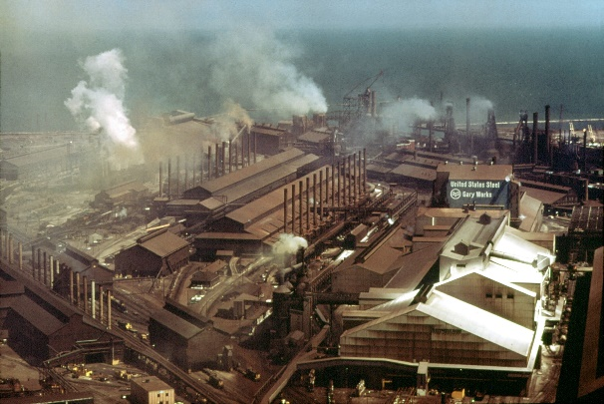
THE LESSON BY THE NUMBERS
Reading Level: 9.6
Audio Time: 17:35
Vocabulary Terms: 21

Shorter and Easier than Most

VOCABULARY

IDEAS
Philanthropy
Horizontal Integration
Vertical Integration
Rebate
Captain of Industry
Robber Baron

PEOPLE & GROUPS
Cornelius Vanderbilt
Andrew Carnegie
Henry Clay Frick
Andrew Mellon
J.P. Morgan
John D. Rockefeller
Marshall Field
Leland Stanford
William Clark

LOCATIONS
Pittsburg, Pennsylvania
Titusville, Pennsylvania

COMPANIES
Carnegie Steel Company
U.S. Steel

LESSON SUMMARY
In the decades after the Civil War, the industrial revolution exploded in the North. This period saw a rise in consolidation and the development of monopolies dominated by extraordinarily wealthy industrialists.
Cornelius Vanderbilt dominated the transportation industry. He stared with ferries, but later owned the New York Central Railroad. He was the first to start giving away his fortune. His money built Vanderbilt University.
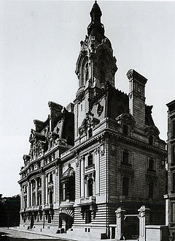
Andrew Carnegie consolidated the steel industry. Pittsburg grew as the center of the steel industry. Carnegie sold his steel empire to J.P. Morgan in 1901. He gave his money away to build libraries, universities and Carnegie Hall in New York City.
Andrew Mellon was a leader in the banking industry. He also served in government as Secretary of the Treasury. He gave his money to build the National Art Gallery in Washington, DC.
J.P. Morgan was also a banker. He bought Carnegie’s steel company and renamed it US Steel. He also owned controlling stakes in General Electric, AT&T and numerous railroads.
John D. Rockefeller was the nation’s richest man. He owned Standard Oil. He pioneered the use of trusts as a way to avoid antitrust laws. Rockefeller gave his money away to build universities and hospitals.
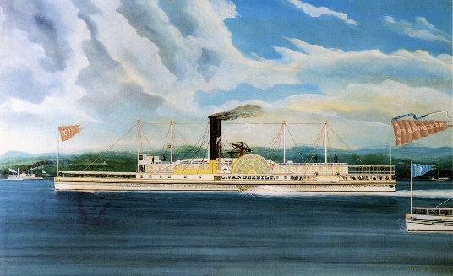
Other great industrialists of the time included Marshall Field who owned a department store chain and Leland Stanford who owned land and railroads in California. Stanford University was built with his money. William Clark dominated copper mining.
People who admired these men called them captains of industry. Those who criticized them for their underhanded competitive tactics and mistreatment of workers called them robber barons.
Some of these industrialists tried to dominate all of one stage of a business. For example, Clark bought all of the copper mines. This is a horizontal monopoly. Others bought one company at each stage of business. Carnegie bought a steel mine, iron ore mine, railroad and ships. This is a vertical monopoly. Rockefeller used trusts to hide his businesses. In this way, he controlled many companies that the public thought were competitors.

9-2: CORRUPTION & PHILANTHROPY
Does money make you powerful?
TOPICS
- President Grant
- President Garfield
- Scandal and Civil Service Reform
- Big City Corruption
- Tammany Hall
- Thomas Nast
- The Gospel of Wealth
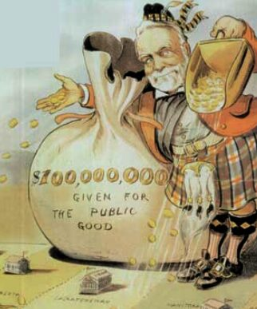
BIG IDEA: The late 1800s was a time of both enormous political corruption and the beginning of corporate philanthropy.
Jon’s Teaching Tips:
This is a good opportunity to introduce political cartoons. There are many Nast cartoons about Tammany Hall. Students can also read selections from the Gospel of Wealth.
THE LESSON BY THE NUMBERS
Reading Level: 10.7
Audio Time: 14:03
Vocabulary Terms: 16

Shorter and Easier than Most

VOCABULARY

IDEAS
Mayor
Political Machine
Boss
Bribe
Voter Fraud
The Gospel of Wealth
Carnegie Library

LAWS
Pendleton Civil Service Act

PEOPLE & GROUPS
Ulysses S. Grant
Rutherford B. Hayes
James Garfield
Chester Arthur
William “Boss” Tweed
Tammany Hall
Thomas Nast

EVENTS
Crédit Mobilier Scandal
LESSON SUMMARY
The years after the Civil War saw a series of forgettable presidents who did not have much power relative to Congress. One thing government dealt with was corruption. The Pendleton Civil Service Act made many government jobs open to candidates based on competitive exams. This helped limit the spoils system of giving jobs as rewards for supporting political candidates.
This period was also a time of corruption in city governments. Big city mayors used their power to give jobs and contracts to friends. In exchange they bought votes, stayed in power, took bribes, and became rich. These political machines were common. The most famous was nicknamed Tammany Hall in New York.
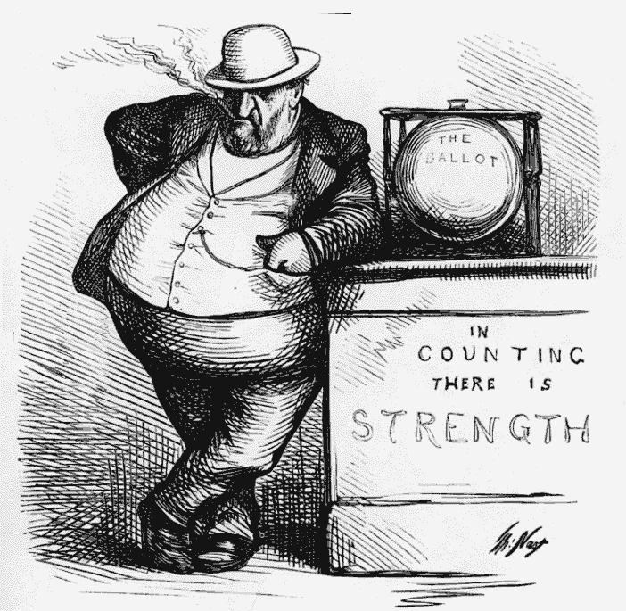
Money was not always as source of corruption and evil. Andrew Carnegie’s essay the Gospel of Wealth encouraged the wealthy to use their money to benefit humanity.
9-3: ORGANIZED LABOR
Who should be in charge, workers or owners?
TOPICS
- First Labor Unions
- Great Upheaval
- Types of Labor Unrest (Strike, Boycott, etc.)
- Knights of Labor
- Haymarket Square
- AFL and Samuel Gompers
- Eugene Debs, Socialism, and the Wobblies
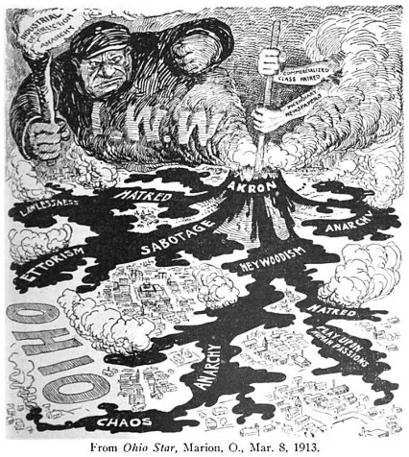
BIG IDEA: Organized labor unions emerged in the late 1800s, although their efforts were often limited because government generally sided with business owners.
Jon’s Teaching Tips:
Avoid focusing too much on the details of each union or individual strike. Instead, work to help the students understand the overall idea of the conflict between workers and owners and the way government tended to side with business leaders during the Gilded Age.
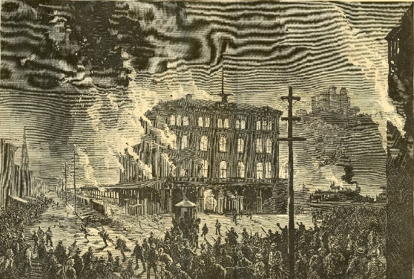
THE LESSON BY THE NUMBERS
Reading Level: 9.1
Audio Time: 26:55
Vocabulary Terms: 23

Easier to Read than Most

VOCABULARY

IDEAS
Union
Mass Strike
Boycott
Sabotage
Lockout
Yellow-Dog Contract
Scab
Picket Line
Blacklist
Bread and Butter Issues
Socialist
Arbitration

PEOPLE & GROUPS
National Labor Union
Knights of Labor
Samuel Gompers
American Federation of Labor
Eugene Debs
Socialist Party
Industrial Workers of the World
William “Big Bill” Haywood

EVENTS
Great Upheaval
Haymarket Square Incident
Pullman Strike

LESSON SUMMARY
The period after the Civil War saw a growth of labor unions. The Great Upheaval of 1877 was the nation’s first mass strike as workers in the railroad industry started a strike that spread and was supported by striking workers across the nation.
Labor unions used boycotts and strikes to stop work and try to force owners to meet their demands. Owners locked out workers and hired scabs to break strikes. Most strikes in the late 1800s went badly for workers. A large number of immigrants were willing to work for low wages and take the place of striking workers. Government usually supported owners and the police and army broke strikes at Carnegie’s steel plant in Pittsburg and a strike at the Pullman railroad car factory in Chicago.
The first major union was the Knights of Labor. They lost support after the Haymarket Square Riot.
A new union grew as the Knights of Labor fell out of favor. The American Federation of Labor was led by Samuel Gompers and focused on basic issues like wages and working conditions instead of political reform. The AFL was a composite of many smaller craft unions, so they did not represent unskilled workers.
Eugene Debs led the American Socialist Party. This group wanted to change America’s system of government. They wanted to take leadership of the nation’s industries away for the rich. Although they were popular with workers, they never gained the support of more than a small percentage of all Americans.
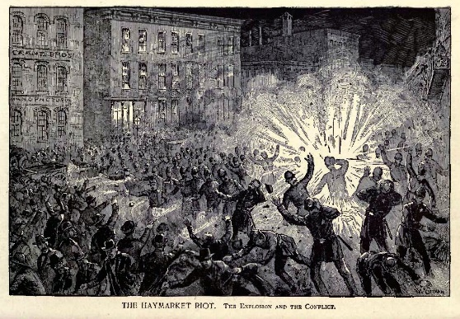
A more extreme group were the Industrial Workers of the World. They wanted a violent revolution to take power away for the wealthy and the overthrow the government. Although Americans rejected these ideas, they eventually caught on in Russia and led to the Communist Revolution there in 1917.
9-4: GOVERNMENT REGULATION
How should government balance the power of social classes?
TOPICS
- Theodore Roosevelt
- Anti-Trust Legislation
- Trust Busting
- Taft’s Presidency
- Election of 1912
- Wilson’s New Freedom
- Creation of the Federal Reserve and FTC
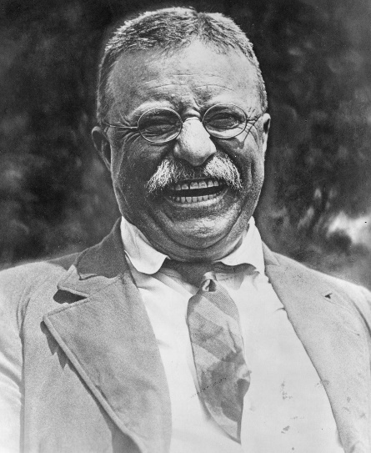
BIG IDEA: A series of progressive presidents in the first decades of the 1900s, beginning with Teddy Roosevelt, tried to balance the power of workers and owners and took trusts and monopolies to court.
Jon’s Teaching Tips:
The Fed is a hard topic for students to understand, but it comes around again when they study the Great Depression. Instead, use this chance to focus on the ways business leaders sought to influence legislation.
THE LESSON BY THE NUMBERS
Reading Level: 9.3
Audio Time: 20:29
Vocabulary Terms: 11

Shorter and Easier than Most

VOCABULARY

IDEAS
Trust Buster
New Freedom

LAWS
Sherman Anti-Trust Act
Clayton Antitrust Act

PEOPLE & GROUPS
Mark Hanna
William Howard Taft
Bull Moose Party
Woodrow Wilson

EVENTS
Election of 1912

GOVERNMENT AGENCIES
Federal Reserve
Federal Trade Commission

LESSON SUMMARY
Theodore Roosevelt took an interesting road to the White House. He was born rich, became a national hero in the Spanish-American War, was briefly a cowboy, became Governor of New York, and eventually vice president. Republican leaders who didn’t like Roosevelt chose him to be vice president on purpose, because they believed he would be sidelined and would have no influence. They didn’t expect McKinley to be assassinated.
As president, Theodore Roosevelt wanted to balance the needs of workers and owners. When trusts were beneficial to the growth of the nation, he ignored them. When he thought business leaders were hurting people and the nation, he took them to court to break up their monopolies.
Roosevelt grew tired of the job and helped William Howard Taft win as his successor. Taft continued Roosevelt’s trustbusting ways. In 1912, Roosevelt came back, this time with his own Bull Moose Party to try to win back his old job. Republicans were split between Taft and Roosevelt, giving the electoral win to Woodrow Wilson, a democrat.
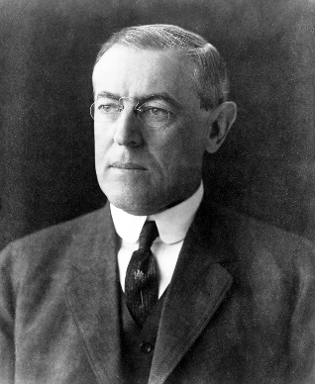
Wilson was also a progressive and used government’s power to promote reform. During his time in office he created the Federal Reserve to stabilize the nation’s banking system and the Federal Trade Commission to oversee business practices.
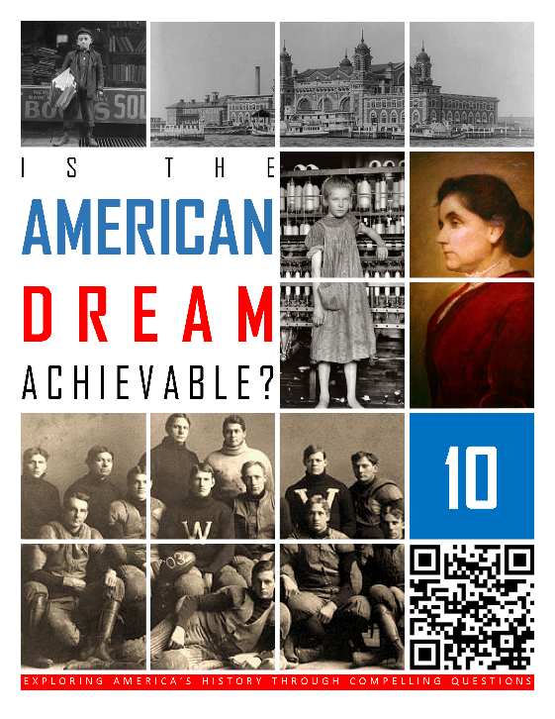  HCSSS STANDARDS  - SS.US.1.16.1 Analyze reasons groups migrated to and within the United States  - SS.US.1.8.2 Assess effects of anti-immigrant politics on public policy  - SS.US.3.15.1 Analyze the benefits and challenges associated with rapidly growing urban areas  - SS.US.3.8.2 Assess the efforts of Progressive Era reform movements to improve society, government, business, and the environment  - SS.US.3.7.3 Analyze the development of the women’s suffrage movement over time and its legacy  TESTED TOPICS  - New Immigrant Jobs  - New Immigrant Origins  - Nativism  - Chinese Exclusion Act  - Muckrakers  - Meat Inspection Act  - Yellow Press  - Progressive Issues  - Child Labor  - Triangle Shirtwaist Fire  - Graduated Income Tax  - Settlement House Movement  - Environmentalism  - Alice Paul / NWP  - 19th Amendment  - Progress of Suffrage | UNIT 10
 | Four Lessons
1: IMMIGRATION & URBANIZATION
Was it beneficial or harmful for America to become a nation of cities?
- New Immigrants
- Impacts of Immigration
- Nativism
- Urbanization Causes
- Challenges and Innovations

2: WRITERS & THE YELLOW PRESS
Can writers make the world a better place?
- Yellow Press
- Muckrakers
- Magazines

3: THE PROGRESSIVES
What does it mean to be progressive?
- Populists
- Election of 1896
- Progressives vs. Laissez Faire
- Social Gospel
- Child Labor
- Education Reform
- Political Reform
- Conservation

4: WOMEN’S RIGHTS
Was suffrage essential to improve the lives of women?
- Victorian Values
- Free Love
- Birth Control
- Muller v. Oregon
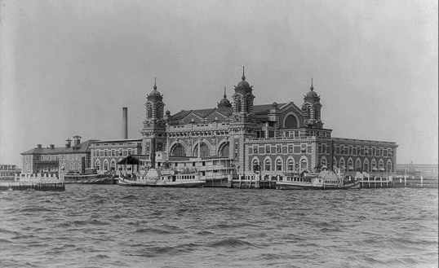
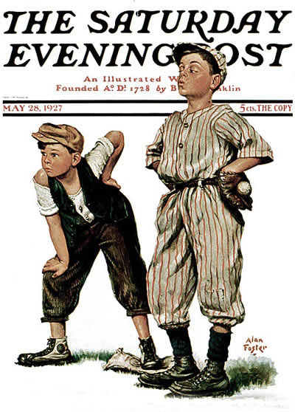
- 19th Amendment

GILDED AGE IMMIGRATION, URBANIZATION & REFORM

Is the American dream achievable?

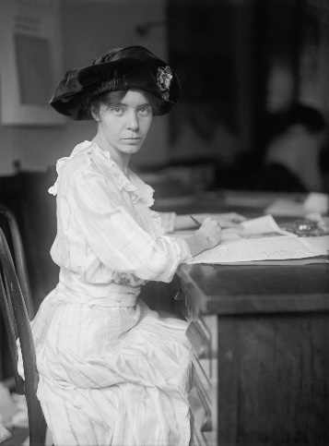
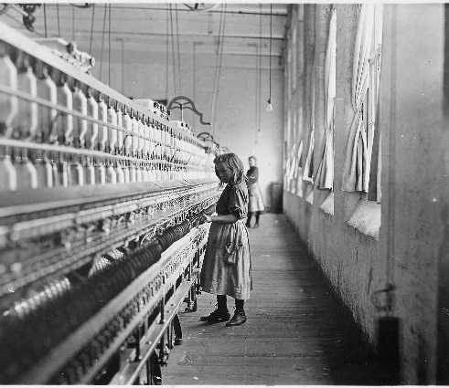
10-1: IMMIGRATION & URBANIZATION
Was it beneficial or harmful for America to become a nation of cities?
TOPICS
- New Immigrants
- Impacts of Immigration
- Nativism
- Urbanization Causes
- Challenges and Innovations
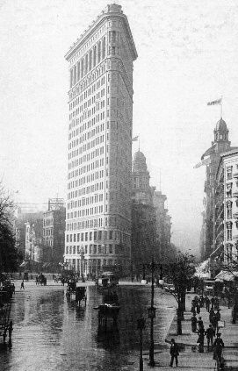
BIG IDEA: The late 1800s and early 1900s was a time of enormous immigration and internal migration. For the first time more Americans lived in cities than on farms and inventors and leaders had to deal with the problems of growing cities.
Jon’s Teaching Tips:
In teaching this topic, focus on contrasts: new vs. old immigrants and land of farmers vs. land of city dwellers. Also, included can be problems and corresponding solutions in cities and attitudes toward immigrants: welcoming as represented by the Statue of Liberty vs. nativism.

THE LESSON BY THE NUMBERS
Reading Level: 12.5
Audio Time: 28:25
Vocabulary Terms: 32

About as long, but harder than most.
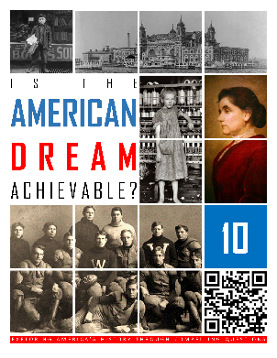
VOCABULARY

IDEAS
Push Factors
Pull Factors
Nativism
Melting Pot
Urbanization
City Beautiful Movement
Vaudeville

PEOPLE & GROUPS
New Immigrants
Josiah Strong
Elisha Otis
Thomas Edison
Nikola Tesla
Alexander Graham Bell
Frederick Law Olmsted
Harry Houdini

SCIENCE & TECHNOLOGY
Mass Transit
Omnibus
Electric Trolley
Elevated Train
Subway
Skyscraper
Tenement
Cholera
Yellow Fever
Tuberculosis
Sewer Systems

LAWS
Chinese Exclusion Act

LOCATIONS
Ellis Island
Ethnic Neighborhoods
Statue of Liberty
Suburbs
Central Park
LESSON SUMMARY
Beginning in the 1880s, America experienced about four decades of massive immigration. These people are called the New Immigrants because they were different from earlier immigrants in important ways. First, they were poor and didn’t come with many skills. They left their homelands to escape poverty, war, famine and persecution. They came in search of jobs, religious freedom, and opportunities for their children. Most came from Southern and Eastern Europe. They were Italian, Greek, Romanian, Polish and Russian. Also, Chinese immigration increased.
New York City’s Ellis Island was a major immigration station and the city grew and expanded its reputation as a multicultural melting pot. Immigrants tended to settle into neighborhoods with support systems in place that they could rely on. The growth of ethnic enclaves such as Chinatown or Little Italy was a hallmark of urban growth at this time.
Some Americans did not like these new immigrants. Nativism once again was common. Efforts to make English the official language expanded. Anti-Semitism grew. Eventually, the KKK embraced these anti-immigrant ideas. The Chinese Exclusion Act officially banned all immigration from China, a victory for nativists. In contrast, the Statue of Liberty stood as a sign of welcome and symbol of all that immigrants hoped for in their adopted country.
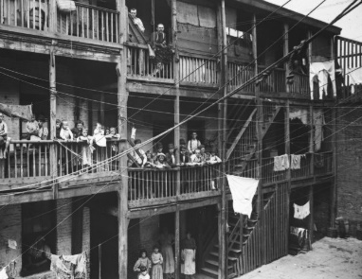
Immigrants and migration from the countryside drove urbanization. It was around the year 1900 that America became a nation where more people lived in cities than on farms. As cities grew, so did problems associated with urban areas. Garbage and polluted water, crime, fire, poverty, and overcrowding were issues. In response, city leaders created professional police and fire departments.
Mass transit was developed. Cities built the first subways and trolley systems. Mass transit made it possible for people to live in suburbs and commute to work, so cities expanded outward. Otis’s safety elevator made skyscrapers possible, and cities expanded upward as well. Edison and Tesla’s work on electricity resulted in electric lights both inside and out. Bell’s telephone also revolutionized American city life.
Tenements were built to help house the poor. These low-rent apartments soon became overcrowded and emblematic of the problems with growing cities.
Cities built sewer systems to combat disease. The City Beautiful Movement encouraged the construction of parks such as Central Park in New York City. Americans went to baseball games for fun. Vaudeville performers travelled from place to place in the time before movies to entertain the masses.
10-2: WRITERS & THE YELLOW PRESS
Can writers make the world a better place?
TOPICS
- Yellow Press
- Muckrakers
- Magazines
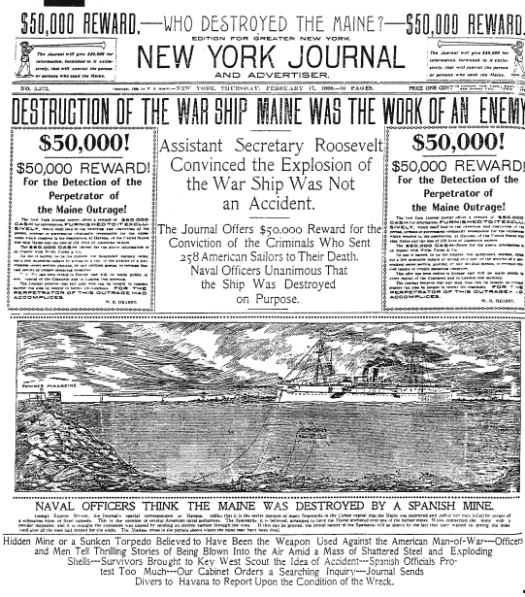
BIG IDEA: In the late 1800s, newspaper publishers competing for readers developed the Yellow Press style of sensational headlines and articles. This led to misleading journalism, but also fueled the muckrackers who exposed corruption and scandal in politics and business.
Jon’s Teaching Tips:
Students are familiar with the concept of “clickbait” on the internet that is designed to be sensational and engage them. This is a good modern connection to help them understand the concept of Yellow Press. Muckrakers are a great chance to introduce primary sources and teach cause and effect.
THE LESSON BY THE NUMBERS
Reading Level: 11.0
Audio Time: 24:40
Vocabulary Terms: 24

About the same as most.

VOCABULARY

IDEAS
Human Interest Story
Yellow Journalism
Pulitzer Prize

BOOKS & MAGAZINES
The Shame of the Cities
How the Other Half Lives
The Jungle
Puck
McClure’s
Collier’s
The Saturday Evening Post

TECHNOLOGY
Linotype Machine

PEOPLE & GROUPS
Journalist
Dorothea Dix
Joseph Pulitzer
William Randolph Hearst
Muckraker
Lincoln Steffens
Ida Tarbell
Jacob Riis
Nelly Bligh
Upton Sinclair

GOVERNMENT AGENCIES
Food and Drug Administration

LAWS
Pure Food and Drug Act
Meat Inspection Act
LESSON SUMMARY
The beginning of the 1900s was a time of growth in the print industry. Before the Internet, radio or television, most people got their news from newspapers, and even small cities had multiple newspapers that were printed twice a day. Two great publishers, Pulitzer and Hearst competed for subscribers and developed a style of sensational journalism that exaggerated the truth and used flashy headlines to catch potential readers’ attention. Called Yellow Journalism, it was both good and bad.
The Yellow Journalists loved publishing stories that exposed wrongdoing by politicians and business leaders. These muckrakers did America a great service by showing the wrongs of city life, the meat packing industry, robber baron practices, and government corruption. Some of their work led directly to changes in laws that made America better. The best-known example is the connection between Upton Sinclair’s The Jungle and the passage of the Meat Inspection and Pure Food and Drug Acts.
This was a time period of growth in magazines as well. Weekly publications such as Puck, McLure’s, Collier’s, and the Saturday Evening Post grew in popularity and remained a staple of American life until after World War II when television replaced reading as a favored pastime.
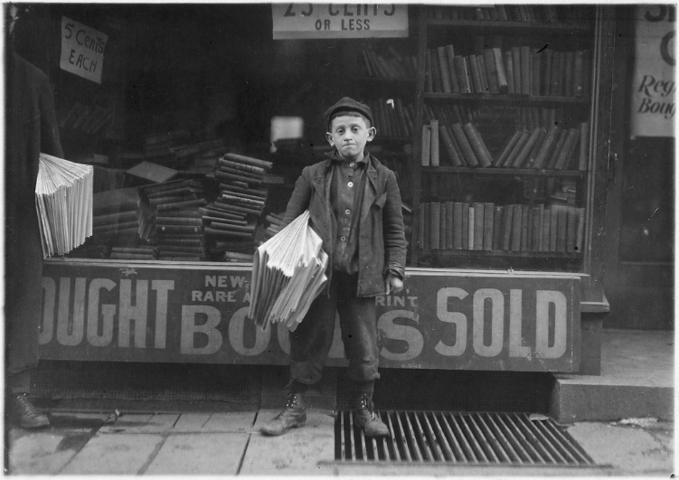
10-3: THE PROGRESSIVES
What does it mean to be progressive?
TOPICS
- Populists
- Election of 1896
- Progressives vs. Laissez Faire
- Social Gospel
- Child Labor
- Education Reform
- Political Reform
- Conservation
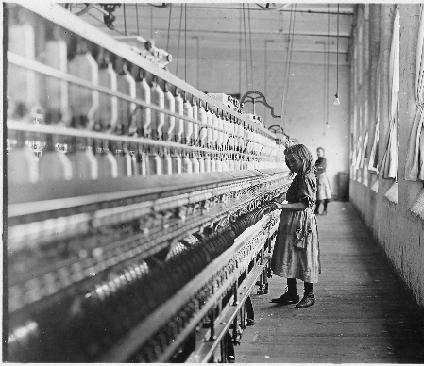
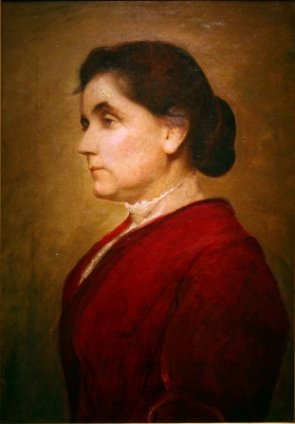
BIG IDEA: Populists and Progressives tried to reform society around the turn of the last century. They focused on fair business practices, education, political reform, the income tax, aid to the poor, workplace safety, food safety, women's rights and conservation.
Jon’s Teaching Tips:
There is a lot of information here. Students seem to respond well if they view it all as variations on a theme: progressives saw problems and tried to find solutions. Although there are multiple topics, they each fit the theme.
THE LESSON BY THE NUMBERS
Reading Level: 10.8
Audio Time: 33:01
Vocabulary Terms: 44

Easier but longer than most.

VOCABULARY

IDEAS
Free Coinage of Silver
Graduated Income Tax
Initiative
Referendum
Recall
Whistle-Stop
Laissez Faire
Social Darwinism
Settlement House
Work Permit
Normal School
High School
City Commission
City Manager

PEOPLE & GROUPS
Patrons of Husbandry / Grange
Populist Party
Jacob Coxey
Coxey’s Army
William Jennings Bryan
William McKinley
Progressives
Progressive Party
YMCA & YWCA
Christian Science
Salvation Army
Jane Addams
John Dewey
Robert La Follette
John Muir
Sierra Club
Boy Scouts
Girl Scouts

LAWS
Keating-Owen Act
Fair Labor Standards Act
16th Amendment
17th Amendment

GOVERNMENT AGENCIES
National Child Labor Committee (NCLC)

LESSON SUMMARY
Farmers in the West were upset with the railroad in the late 1800s. They needed railroads to carry their crops to the East where they could be sold to hungry people in growing cities. However, railroads were the only way to move these products, and they were charging enormous rates, so the farmers wanted government to take over the railroads and lower prices. The farmers also wanted inflation which would make it easier for them to repay loans. Thus, they wanted the government to start minting silver money. These two key political goals led to the creation of the Populist Party. A group of farmers led by Jacob Coxey even marched to Washington, DC to demand change. William Jennings Bryan championed these ideas. Although he never won the presidency, Bryan’s Cross of Gold Speech captured the Populists’ grievances. Government regulation of the railroads and free coinage of silver didn’t became law, and eventually, the Democratic Party took on these issues and absorbed the Populist voters.
Other reformers around 1900 were more pragmatic. They looked for small changes they could achieve. These were the Progressives.
Some political reforms did become law. Initiatives, referendums and recalls became law, making it easier for the people to get rid of corrupt politicians and pass laws that politicians might be unwilling to vote for on their own. City commissioners became common as a way to stop political machines. The 17th Amendment provided for the direct election of senators. Before this, the state legislatures had elected senators.
Americans passed the 16th Amendment to make an income tax legal. The graduated income tax required the wealthy to pay a higher percentage of their income than the poor.
Some progressives were inspired by religion. The Social Gospel Movement encouraged people to serve others the way they believed Jesus would have done. They created the YMCA and YWCA. They built settlement houses to help the waves of new immigrants. They opened the Salvation Army to serve the poor. This era of service-minded Christianity is sometimes called the Third Great Awakening.
Other Progressives tried to improve working conditions. The Triangle Shirtwaist Fire showed just how bad working conditions were. These reformers were especially concerned with children who had to work instead of attending school. Although the Keating-Owen Act that was passed at the time was later declared unconstitutional, the Fair Labor Standards Act still stands as protection against exploitation of children as workers.
EVENTS
Panic of 1893
Third Great Awakening
Triangle Shirtwaist Fire
LOCATIONS
Hull House

EVENTS
Cross of Gold Speech

Progressives worked to improve public education and the first free, public high schools were built.
The first environmentalists emerged. President Theodore Roosevelt helped launch the National Park Service as a means of protecting America’s natural wonders. The Boy Scouts and Girl Scouts were founded, as was the Sierra Club.
10-4: WOMEN’S RIGHTS
Was suffrage essential to improve the lives of women?
TOPICS
- Victorian Values
- Free Love
- Birth Control
- Muller v. Oregon
- 19th Amendment
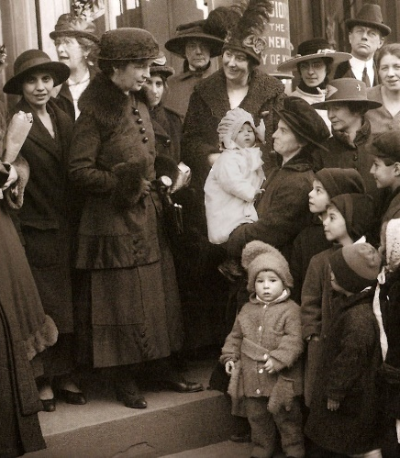
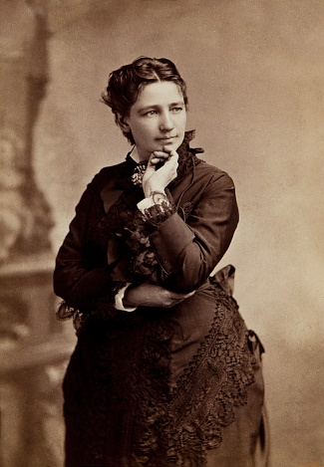
BIG IDEA: Women had one of their greatest successes in 1920 when the 19th Amendment was ratified, guaranteeing them the right to vote. Women at this time had less success in their efforts to win workplace equality and access to birth control.
Jon’s Teaching Tips:
It is good to help the students see the 19th Amendment as an important step in a very long struggle for women’s rights rather than a climactic moment in isolation.
THE LESSON BY THE NUMBERS
Reading Level: 12.5
Audio Time: 24:16
Vocabulary Terms: 22

Harder but about as long as most.

VOCABULARY

IDEAS
Cult of Domesticity
Free Love
Contraception
Birth Control
Suffrage

LOCATIONS
Brownsville Clinic

LAWS & COURT CASES
Comstock Act
Muller v. Oregon
19th Amendment

PEOPLE & GROUPS
Victoria Woodhull
Henry Ward Beecher
Emma Goldman
Margaret Sanger
Planned Parenthood
Susan B. Anthony
Elizabeth Cady Stanton
Lucy Stone
National American Woman Suffrage Association (NAWSA)
Alice Paul
National Woman’s Party (NWP)
Carrie Chapman Catt
National Association Opposed to Woman Suffrage
LESSON SUMMARY
During the 1800s, Americans were very conservative about the roles of men and women and especially about how women could behave and dress. In the 1870s, Victoria Woodhull challenged these beliefs. She championed free love, the idea that she could love whoever she wanted and change her mind as much as she wanted. Her ideas were controversial, but she was an important early challenger to social restrictions.
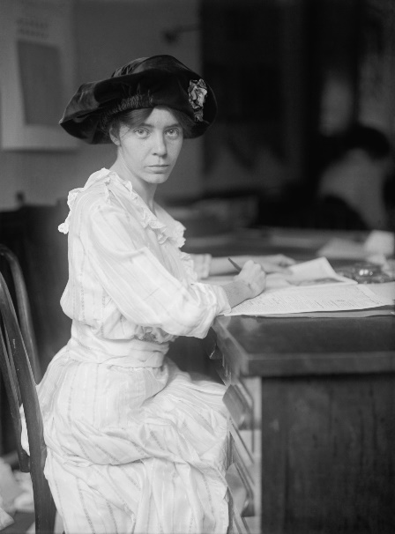
Margaret Sanger believed that women couldn’t be free if they had no control over how many children they would have. She challenged the Comstock Act which prohibited the promotion of birth control. She went to jail multiple times for sending information about birth control through the mail and for opening a birth control clinic in New York City. Her organization grew and is now called Planned Parenthood. Although she wasn’t successfully able to change the law at the time, the government did become concerned about promoting reproductive health during World War I when American troops started contracting STDs. After the war, Americans continued to use condoms they had learned about while in the army.
Women suffered a legal setback in their quest for equality in the Muller v. Oregon Supreme Court Case when the Court ruled that laws that limited the number of hours women could work were constitutional. They reasoned that the primary role women played in society was to be mothers and that allowing women to work as much as they wanted might hurt society.
Women finally won the right to vote in 1920 with the passage of the 19th Amendment. Women had been working for this right since the early 1800s, but Alice Paul and Carrie Chapman Catt succeeded in convincing men in government to approve the amendment. Many western states had already granted women the right to vote in state elections.
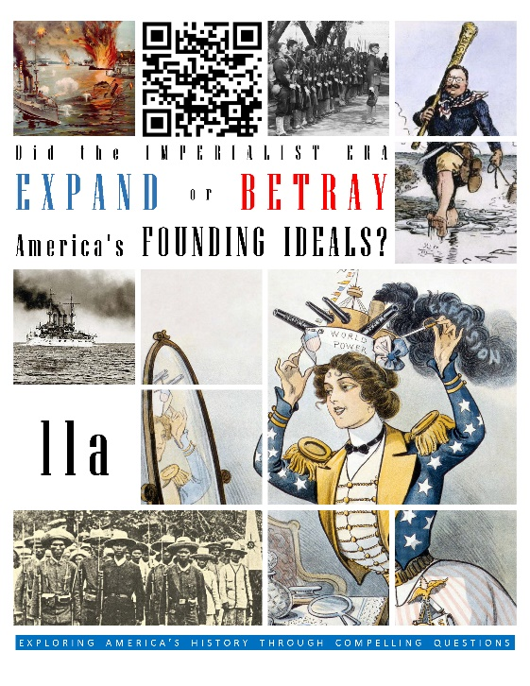  HCSSS STANDARDS  - SS.US.4.19.1 Analyze the factors that enabled the United States to become an imperial power  - SS.US.4.16.2 Evaluate the effects of U.S. foreign policy in Latin America, Asia, and the Pacific  TESTED TOPICS  - Alfred T. Mahan  - Annexation of Hawaii  - Economic Causes of Imperialism  - Social Darwinism  - White Man’s Burden  - Opposition to Imperialism  - Causes and Effects of the Spanish-American War  - USS Maine  - Platt Amendment  - Philippine-American War  - Boxer Rebellion  - Open Door Policy  - Panama Canal  - Roosevelt Corollary  - Dollar Diplomacy  - Moral Diplomacy | UNIT 11a
 | Three Lessons
1: ORIGINS OF IMPERIALISM
Did America need to be an imperial nation?
- American Exceptionalism
- Alaska
- Economic Causes
- Missionaries
- White Man’s Burden
- European Imperialism
- Mahan & Sea Power
- Hawaii
- Opposition

2: SPANISH-AMERICAN & PHILIPPINE-AMERICAN WARS
Did America deserve the outcomes of the Spanish-American and Philippine-American Wars?
- Cuban Independence Movement
- USS Maine
- Spanish-American War
- Philippine-American War
- Opposition
- Consequences
- Platt Amendment

3: ASIA & LATIN AMERICA
How should America project its power around the world?
- Spheres of Influence & Open Door Policy
- Big Stick Diplomacy
- Panama Canal
- Roosevelt Corollary
- Gentlemen’s Agreement
- Russo-Japanese War
- Dollar Diplomacy
- Banana Republics
- Moral Diplomacy
 | 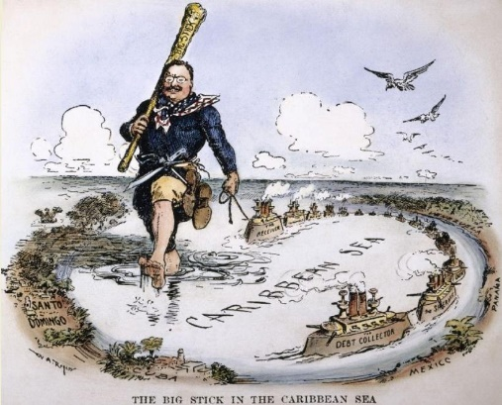

IMPERIALISM

Did the Imperialist Era expand or betray America’s founding ideals?

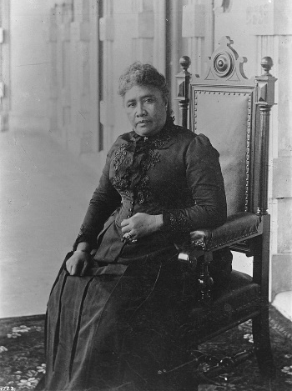
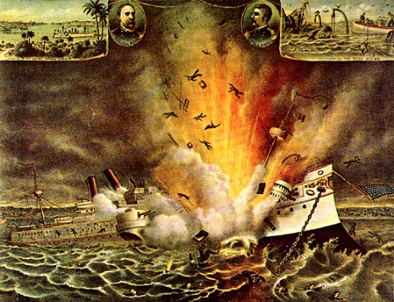
11a-1: ORIGINS OF IMPERIALISM
Did America need to be an imperial nation?
TOPICS
- American Exceptionalism
- Alaska
- Economic Causes
- Missionaries
- White Man’s Burden
- European Imperialism
- Mahan & Sea Power
- Hawaii
- Opposition
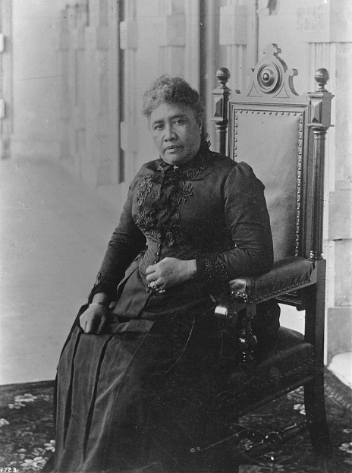
BIG IDEA: American leaders sought to expand and become an imperial nation for a variety of reasons, but most significantly to have access to natural resources and markets. There were some critics of imperialism.
Jon’s Teaching Tips:
Helping students understand causes is critical to the study of history. This is a great lesson to show how some events have diverse causes. It is also a good lesson to help students understand how attitudes that we would consider overtly racist and unacceptable today were widespread in the past. It is a good chance to practice map skills as well.
THE LESSON BY THE NUMBERS
Reading Level: 13.9
Audio Time: 23:01
Vocabulary Terms: 13

Harder but about as long as most.

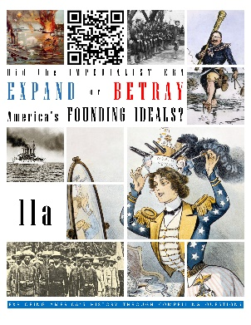
VOCABULARY

IDEAS
City Upon a Hill
Social Darwinism
White Man’s Burden
American Exceptionalism

PEOPLE & GROUPS
Alfred T. Mahan
Queen Liliuokalani
American Anti-Imperialism League

EVENTS
Seward’s Folly
Annexation of Hawaii

BOOKS
The Influence of Seapower upon History

LOCATIONS
Contiguous United States
Pearl Harbor
American Samoa
LESSON SUMMARY
Americans have believed for a long time that we are exceptional in the world. This idea has led American leaders to involve ourselves in other countries. Sometimes we think we can fix problems or can teach other people the best way to live or run their government. This idea might go as far back as the Pilgrims who believed that their success as a colony in the 1600s was because they had a special covenant with God.
The most common reason Americans took control of distant lands was to make money. Sometimes they were looking for raw materials. Sometimes they wanted to have access to markets with people who would buy American-made goods.
Sometimes imperialism was motivated by religion. Christian missionaries in the United States travelled abroad to spread their beliefs. Usually they looked down on the beliefs and traditions of the people they met. Hawaii is one example where this was true.
Other Americans (and Europeans) believed that their culture was superior to all others, and it was their responsibility to share their way of life with the lesser people of the world. This idea was nicknamed the White Man’s Burden. Clearly, it is based on racism.
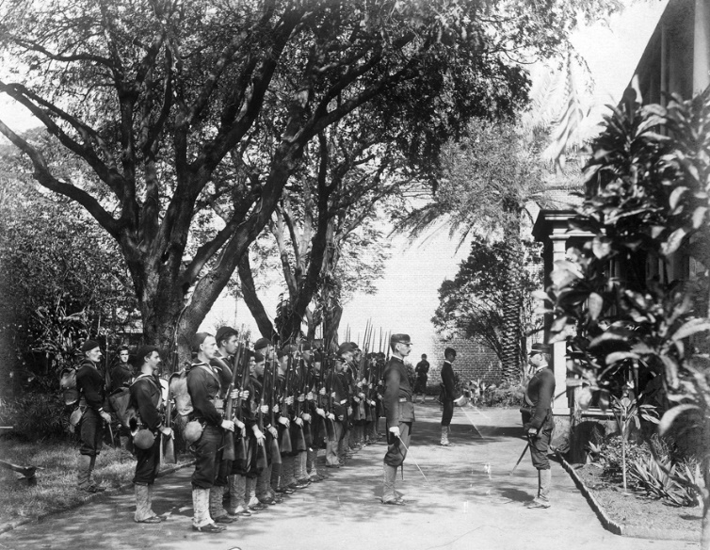
An important reason politicians became interested in taking control of territory was to provide ports for the navy to stop and refuel their ships. The author Alfred Mahan argued that great nations need colonies and navies to protect trade. Theodore Roosevelt believed in this idea. Hawaii, Guam and the Philippines all had good harbors.
The United States began taking control of territory outside of the contiguous 48 states in 1867 when we purchased Alaska. Later in the 1890s we took control of more territory by annexing Hawaii and Samoa. The European nations also were involved in imperialism at this time in both Asian and Africa.
Not all Americans liked imperialism. Some believed it was bad to take land that belonged to other people. Some thought it was too expensive. Still others did not like the thought of foreign people moving to the United States after their homes became American territories.
11a-2: THE SPANISH-AMERICAN AND PHILIPPINE-AMERICAN WARS
Did America deserve the outcomes of the Spanish-American and Philippine-American Wars?.
TOPICS
- Cuban Independence Movement
- USS Maine
- Spanish-American War
- Philippine-American War
- Opposition
- Consequences
- Platt Amendment
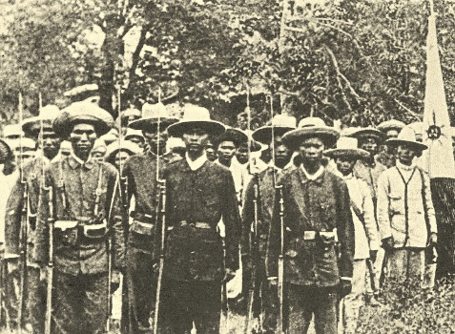
BIG IDEA: The United States fought a war with Spain that was about Cuban independence, but led to the acquisition of former Spanish territories such as Puerto Rico and the Philippines.
Jon’s Teaching Tips:
This is a good lesson to help students evaluate how competing interests converge. In this case, independence movements vs. American imperial interests. Yellow journalism was introduced in the previous unit and it is good to revisit that idea here, which provides a chance to discuss the influence of the press in forming public opinion and a good opportunity to introduce primary sources.
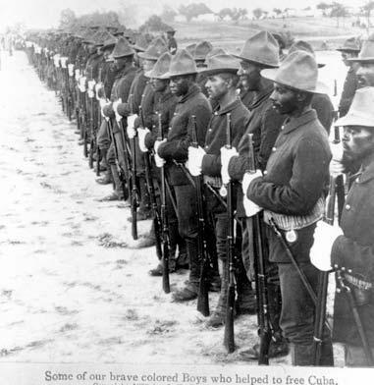
THE LESSON BY THE NUMBERS
Reading Level: 13.1
Audio Time: 22:13
Vocabulary Terms: 24

Harder but shorter than most.

VOCABULARY

IDEAS
Remember the Maine
Splendid Little War

PEOPLE & GROUPS
José Martí
George Dewey
Rough Riders
Smoked Yankees
William Howard Taft
Emilio Aguinaldo
Mark Twain

TREATIES & LAWS
Teller Amendment
Jones Act
Treaty of Manila
Treaty of Paris of 1898
Platt Amendment

SHIPS
USS Maine

LOCATIONS
Cuba
Havana
Puerto Rico
Guam
Philippines

EVENTS
Explosion of the USS Maine
Spanish-American War
Battle of Manila
Philippine-American War

LESSON SUMMARY
The United States went to war with Spain in 1898 because of Cuba. Cuba was one of the last Spanish colonies in the Americas. Cubans wanted independence, and some people in the United States were sympathetic to the Cuban cause.
At the time, newspapers were competing with each other to sell more copies. Writers and publishers exaggerated stories and used bold, sensational headlines. A popular topic was Spanish cruelty toward Cubans. After reading such stories, many Americans wanted the United States to intervene in Cuba.
The USS Maine, an American battleship, exploded while visiting Havana, Cuba. It is still unclear why the explosion happened, but Americans blamed the Spanish and demanded war.
As part of the declaration of war, Congress passed a law stating that it would not make Cuba an American colony.
The Spanish-American War was a lopsided victory for the United States. American ships destroyed the Spanish fleet in the Philippines and American troops overran the Spanish troops in Cuba. Theodore Roosevelt became a national hero while leading his men in battle in Cuba.
True to their promise, the United States allowed Cuba to become independent, but passed a law saying that they would intervene if there were problems in Cuba. In this way, Cuba was always mostly, but not entirely independent.
As a result of the war, the United States took control of the Spanish territories of Puerto Rico, Guam and the Philippines.
The Filipinos had also been fighting for independence when the war broke out. Filipino leaders thought that the war would lead to independence the same that it had for Cuba. However, after defeating the Spanish, the Americans stayed. The Filipino freedom fighters began a rebellion against American rule. A bloody conflict resulted.
In the end, Americans captured Emilio Aguinaldo, the leader of the Filipino resistance and the rebellion ended. The Filipinos agreed to a deal in which the Americans maintained control of the country but allowed the Filipinos to make many of their own decisions. The United States kept the Philippines as a colony for about 50 years.
11a-3: ASIA & LATIN AMERICA
How should America project its power around the world?
TOPICS
- Spheres of Influence & Open Door Policy
- Big Stick Diplomacy
- Panama Canal
- Roosevelt Corollary
- Gentlemen’s Agreement
- Russo-Japanese War
- Dollar Diplomacy
- Banana Republics
- Moral Diplomacy
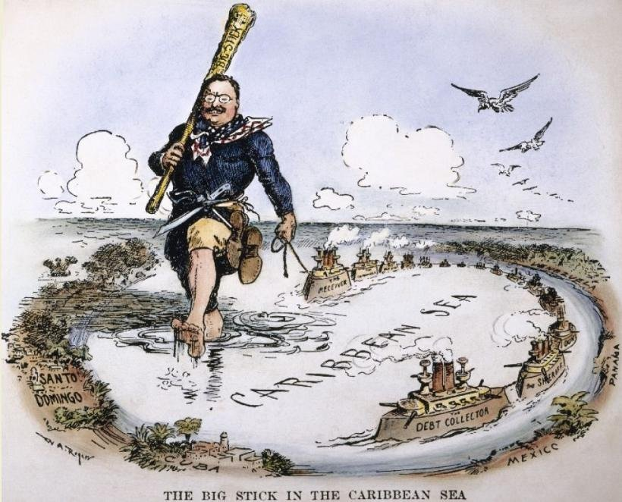
BIG IDEA: Americans wanted access to markets in China and influence in Latin American. Leaders were willing to use overt military power and economic influence to get their way.
Jon’s Teaching Tips:
In addition to helping the students understand the various places around the world where America spread its influence, help the students see the three different approaches to foreign policy. Judging which they feel is right is a good way to engage student interest.
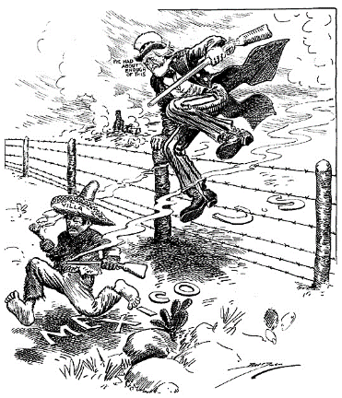
THE LESSON BY THE NUMBERS
Reading Level: 15.1
Audio Time: 29:02
Vocabulary Terms: 16

Harder but about as long as most.

VOCABULARY

IDEAS
Spheres of Influence
Banana Republic

PEOPLE & GROUPS
John Hay
Dr. Walter Reed
Pancho Villa

POLICIES
Open Door Policy
Big Stick Diplomacy
Roosevelt Corollary
Good Neighbor Policy
Dollar Diplomacy
Moral Diplomacy

LOCATIONS
Panama Canal

EVENTS
Boxer Rebellion
Russo-Japanese War
Great White Fleet

COMPANIES
United Fruit Company

LESSON SUMMARY
European powers had been interested in having control in China for many years. There were important markets with lots of customers in China. Instead of taking full control and making China a colony, Europeans carved up China into zones. These spheres of influence were places where only businesses from one country could operate. The British controlled Shanghai, for example.
The United States did not like this arrangement. American leaders declared an Open Door Policy. They said that Europeans had to let American companies do business anywhere they wanted.
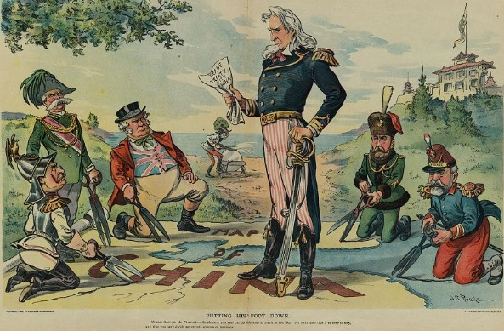
Some leaders in China objected to the control Europeans and Americans had in their country. In one case, a group called the Boxers launched a rebellion and the Europeans and American had to send 2,000 soldiers to defeat them.
During the early 1900s, three American presidents dealt with issues related to imperialism. The first was Theodore Roosevelt. His approach was nicknamed the Big Stick. He believed that he could use American military power (usually the navy) to intimidate less powerful nations. One example was when he sent the navy to Panama to support the Panamanian Revolution and secure the right to build the Panama Canal.
The Panama Canal was a major undertaking that was initiated by Theodore Roosevelt. The canal connects the Atlantic and Pacific Oceans and allows the United States to quickly shift its warships from one ocean to the other. It also serves as an important trade route.
Roosevelt expanded the Monroe Doctrine. President Monroe had declared that the Western Hemisphere was off limits to European nations. Roosevelt added his own Corollary in which he declared that the United States would intervene in Latin American nations when there were problems. The United States has done this multiple times. This American policy has not been particularly popular south of the border.
Theodore Roosevelt won the Nobel Peace Prize for helping to negotiate an end to the Russo-Japanese War.
President Taft followed Dollar Diplomacy. He wanted to use American economic power to influence other nations. This led to the development of the so-called banana republics. One notable example was Honduras where the American United Fruit Company manipulated the government in order to pay lower taxes.
President Wilson believed in Moral Diplomacy. He wanted people to decide on their own government. However, his idealism did not extend to American territories. When Mexican revolutionary Pancho Villa attacked an American town, Wilson sent the army into Mexico to try to catch him.
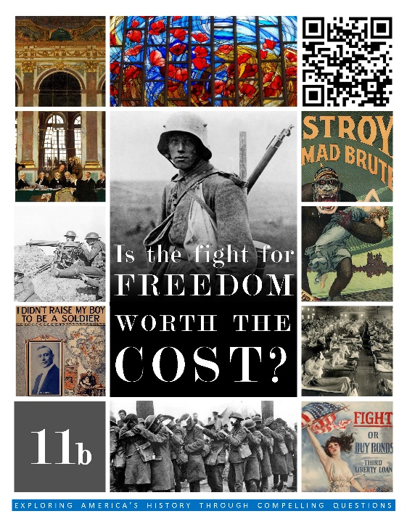  HCSSS STANDARDS  - SS.US.5.19.1 Distinguish between the long-term causes and triggering events that led the United States into World War I  - SS.US.5.8.2 Evaluate wartime restrictions on civil liberties  - SS.US.5.18.3 Analyze how internationalism and isolationism shaped U.S. foreign policy after World War I  TESTED TOPICS  - WWI Allies and Central Powers  - Start of WWI  - Neutrality  - Cause of entering the war  - Lusitania  - Zimmerman Note  - 14 Points  - Selective Service Act  - Conscientious Objectors  - Committee on Public Info.  - Funding for the War  - Espionage and Sedition Acts  - Schenck v. United States  - Opposition to League of Nations  - Wilson's Publicity Campaign | UNIT 11b
 | Three Lessons
1: NEUTRALITY & THE START OF WORLD WAR I
Is Wilson’s idea of moral diplomacy possible in the real world?
- Start of WWI
- New Technologies
- Neutrality
- Lusitania
- Zimmerman Note
- Declaration of War

2: THE WORLD WAR I HOMEFRONT
Are restrictions on basic freedoms justified in times of crisis?
- Mobilization
- Selective Service
- Conscientious Objectors
- Expansion of Government
- Propaganda
- Espionage & Sedition Acts
- Organized Labor
- Women, African Americans

3: THE END OF WORLD WAR I & ISOLATIONISM
Should America be involved in the world or isolationist?
- America’s role in fighting the war
- Flu Pandemic
- Treaty of Versailles
- Debate over ratification
- Sacco & Vanzetti
- First Red Scare
- Immigration Act of 1924
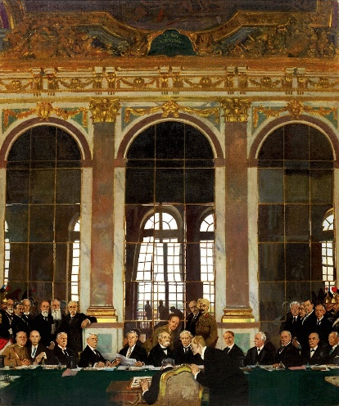
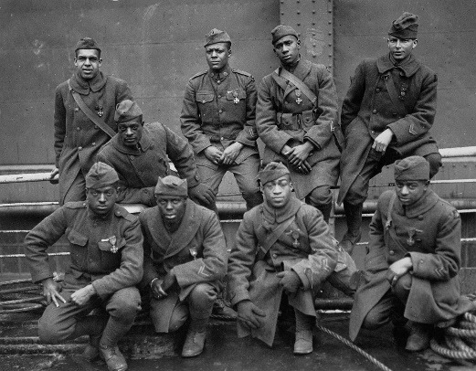

WORLD WAR I

Is the fight for freedom worth the cost?

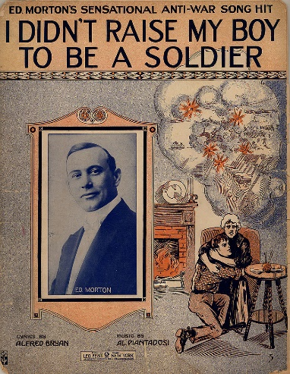
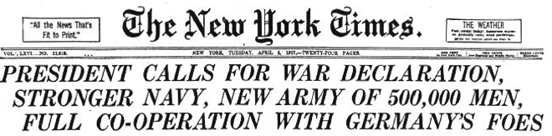
11b-1: NEUTRALITY & THE START OF WORLD WAR I
Is Wilson’s idea of moral diplomacy possible in the real world?
TOPICS
- Start of WWI
- New Technologies
- Neutrality
- Lusitania
- Zimmerman Note
- Declaration of War
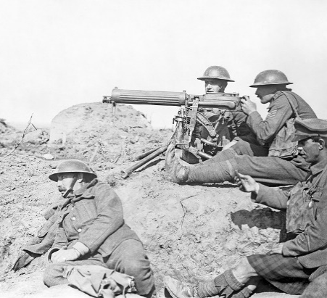
BIG IDEA: Americans did not want to participate in World War I, but eventually chose to join the fight after it appeared Germany was inciting Mexico to attack the United States.
Jon’s Teaching Tips:
WWI is just over 100 years old and visuals such as maps and photographs of the trenches help students understand the terrible nature of this conflict and why Americans were so eager to stay out of it.
THE LESSON BY THE NUMBERS
Reading Level: 13.1
Audio Time: 20:59
Vocabulary Terms: 16

Harder but shorter than most.
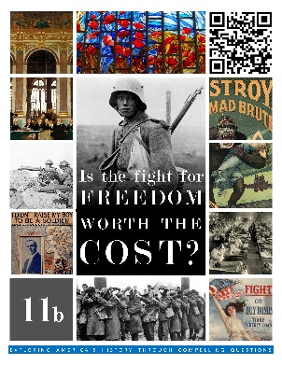
VOCABULARY

IDEAS
Trench Warfare
Neutrality

PEOPLE & GROUPS
Queen Victoria
Wilhelm II
Archduke Franz Ferdinand

EVENTS
Assassination of Franz Ferdinand
The Great War
Russian Revolution

BOOKS
Zimmerman Telegram

LOCATIONS
Triple Entente
Triple Alliance/Central Powers

LAWS
National Defense Act
Naval Appropriations Act

SPEECHES
Wilson’s War Message

SHIPS
U-Boat
Lusitania
LESSON SUMMARY
World War I was not originally a war that involved the United States. It started in Europe between the major European powers. Over the few decades before the war began, the Europeans had settled themselves into two groups. The Central Powers included Germany, Austria-Hungary and Italy. The Triple Entente was made up of the United Kingdom, France and Russia. The alliances were intended to provide support in case of attack, but they also had disastrous consequences.
The war began because the heir to the throne of Austria-Hungary was murdered. Austria-Hungary blamed Serbia, which asked for help from Russia. Austria-Hungary asked for help from Germany, and then Russia turned to its friends France and the United Kingdom. By August of 1914, the major powers found themselves going to war. Most historians see it as a terrible mistake – a time when politicians failed to think calmly and take the time necessary to avoid doing things they couldn’t later undo.
World War I is remembered as being especially terrible. Modern technology meant that armies could bring machine guns, gigantic cannons, land mines, barbed wire and poison gas to the battlefield, but these weapons were best used for defense. Under pressure to win victories, generals sent millions of men in attacks with little hope of victory. The result was a slaughter. Although more people died in other wars in history, so many men died for so little during World War I that we remember it as particularly awful. Also deadly were submarines called U-Boats, which the Germans had mastered.
For the first few years of the war, the United States remained neutral. Although most Americans supported the British, French and Russians, they did not want to join the fighting.
Eventually, however, President Wilson asked Congress to declare war because of a combination of factors. The Germans began attacking American ships that were carrying supplies to trade with the United Kingdom and France. Probably the final straw was that Americans learned of a plot to convince Mexico to attack the United States. The idea probably had no chance of success, but it made Americans angry enough to join the war.
11b-2: THE WORLD WAR I HOMEFRONT
Are restrictions on basic freedoms justified in times of crisis?
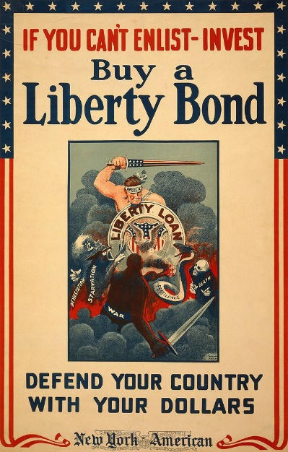
TOPICS
- Mobilization
- Selective Service
- Conscientious Objectors
- Expansion of Government
- Propaganda
- Espionage & Sedition Acts
- Organized Labor
- Women, African Americans
BIG IDEA: World War I had profound impacts on the United States. Although there was never any fighting on American soil, it led to the expansion of the government, new opportunities for women and African Americans, as well as regrettable restrictions of the freedom of speech.
Jon’s Teaching Tips:
This lesson is a chance to incorporate art and music as a way to reveal wartime attitudes. The Schenk v. US case also presents an opportunity to have the students engage in debate.
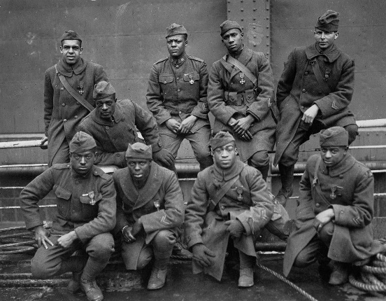
THE LESSON BY THE NUMBERS
Reading Level: 12.3
Audio Time: 20:59
Vocabulary Terms: 23

Harder but shorter than most.

VOCABULARY

IDEAS
Draft
Daylight Savings Time
Propaganda
Eight-Hour Day

PEOPLE & GROUPS
Conscientious Objectors
Herbert Hoover
Bernard Baruch
George Creel
Harlem Hellfighters

LAWS
Selective Service Act
Lever Act/Food and Fuel Control Act
Liberty Loan Act
Espionage Act
Sedition Act

COURT CASES
Schenck v. United States

SONGS
Over There

GOVERNMENT AGENCIES
Fuel Administration
Food Administration
War Industries Board
U.S. Railway Administration
Committee on Public Information
National Labor War Board
Women’s Land Army

LESSON SUMMARY
Americans were enthusiastic about joining the army. For many recent immigrants and their children, joining the fight was a way to demonstrate their love for their new country. A draft was implemented. There were a few conscientious objectors.
Anti-German feelings were common. There were many German immigrants and they faced discrimination. Schools stopped teaching German and German foods were renamed at restaurants.
The federal government gained in both size and power during the war. Business leaders and government officials collaborated to set prices and organize railroad schedules in support of the war effort. Future president Herbert Hoover organized the food industry and the United States fed both its own people and the people of Europe during the war.
To pay for the war, the government raised money by selling liberty bonds.
One of the dark sides to World War I were laws passed to limit First Amendment freedoms. The Espionage and Sedition Acts made criticizing the government and the war effort illegal. In the case of Schenck v. United States, the Supreme Court upheld these restrictions.
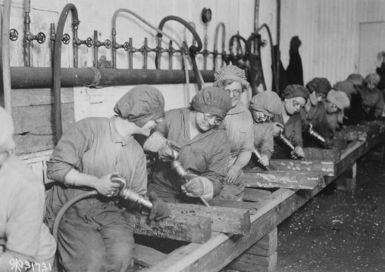
The war effort was good for organized labor. Labor unions worked closely with government officials who wanted to avoid strikes. It was during the war that the 8-hour workday was implemented. Pay went up as well.
Women took some jobs in factories and supported the war effort as nurses and secretaries.
For African Americans, the war was a chance to demonstrate their bravery in battle. Although they served in segregated units, African Americans were fighting against both Germany and discrimination back home. During the war, the need for factory workers in the North increased and thousands of African American families moved out of the rural South to the cities of the North to find work. This Great Migration significantly changed the racial makeup for the country.
11b-3: THE END OF WORLD WAR I & ISOLATIONISM
Should America be involved in the world or isolationist?
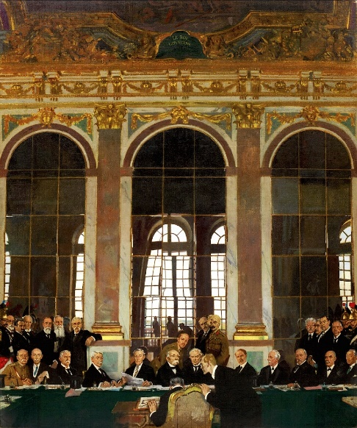
BIG IDEA: America joined World War I at the very end and American troops saw limited fighting, but President Wilson took a key role in the peace negotiations afterward. The Treaty of Versailles that formally concluded the war included his idea for a League of Nations, although the Senate refused to ratify the treaty and the nation moved toward isolationism in the 1920s.
TOPICS
- America’s role in fighting the war
- Flu Pandemic
- Treaty of Versailles
- Debate over ratification
- Sacco & Vanzetti
- First Red Scare
- Immigration Act of 1924
Jon’s Teaching Tips:
Students may have a hard time understanding the details of the Treaty of Versailles and League of Nations, but readily understand the idea of being committed to the world order or isolationist. Tying all aspects of the topic back to this central theme is helpful.
THE LESSON BY THE NUMBERS
Reading Level: 13.7
Audio Time: 24:08
Vocabulary Terms: 16

Harder but about as long as most.

VOCABULARY

IDEAS
Armistice
Fourteen Points
Reparations

PEOPLE & GROUPS
Vladimir Lenin
American Expeditionary Force (AEF)
John “Blackjack” Pershing
League of Nations
Henry Cabot Lodge
Irreconcilables
Reservationists
Edith Wilson

TREATIES
Treaty of Versailles
Article X of the League of Nations Covenant

EVENTS
Armistice Day
1918 Influenza Pandemic
Paris Peace Conference

LESSON SUMMARY
The United States entered the fighting in the last year of World War I. Germany had been suffering under a terrible blockade and was short on food and supplies. Russia had already exited the war and was in the middle of a civil war. American commanders refused to let their troops be split up and insisted on fighting together as one large group. They were still a tiny fraction of all the men on the battlefields of Europe.
The end of the war came on November 11, 1918. The European powers had lost millions of men in battle, as well as civilians. A flu pandemic swept the world in 1918 killing millions more.
President Woodrow Wilson went to Europe after the war had finished to negotiate a peace deal. He believed it was an opportunity to forge an international system for a lasting peace. He described his vision for a peaceful world in a speech entitled the Fourteen Points. The most important of these was the creation of a League of Nations in which future conflicts could be resolved without war.
The result of the negotiations was the Treaty of Versailles. Wilson succeeded in getting the Europeans to create a League of Nations, although they also imposed a harsh punishment on Germany. Germany was forced to admit that the war had been their fault and pay enormous reparations. This punishing element of the treaty would be used later by Hitler to blame Germany’s problems on its neighbors.
Wilson’s efforts to join the new League of Nations faced a major challenge. The Constitution gives the Senate the authority to ratify all treaties signed by the president. One element of the League of Nations was a commitment by every nation to defend any nation under attack. In theory, this would deter nations from going to war since they risked punishment from the entire world. In reality, Republicans in the Senate feared that this would mean the United States would be forced to join wars that were not really its business.
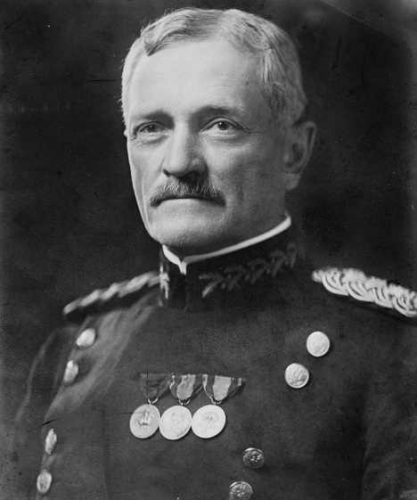
When it looked like the Senate was going to reject the Treaty, Wilson travelled the nation giving speeches to build public support. This also failed and the Senate voted against the treaty. Without the United States, the League of Nations was seriously weakened. It is possible that if America had been at the table, World War II might have been avoided, but we can never know.
By rejecting the Treaty of Versailles and membership in the League of Nations, the United States also rejected Wilson’s dream of internationalism. Instead, for the next twenty years the nation pursued a policy of isolationism.
In keeping with that new idea, Congress passed the Immigration Act of 1924, cutting off almost all immigration from Europe and ending immigration entirely from Asia.
A fear of foreigners and dangerous foreign ideas swept the nation. With the success of the communist revolution in Russia, a Red Scare started. Immigrant anarchists Sacco and Vanzetti were convicted in a deeply flawed trial that many saw as evidence of a national eagerness to root out dangerous ideas.
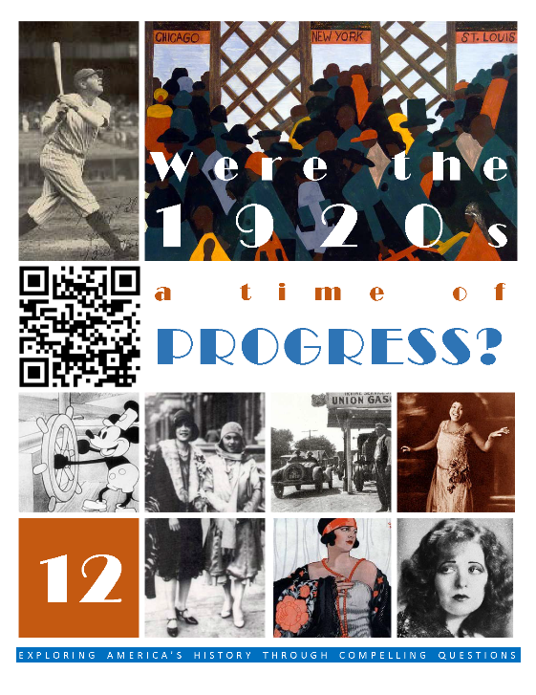  HCSSS STANDARDS  - SS.US.6.11.1 Assess how innovations in transportation, communication, and finance changed American society  - SS.US.6.18.2 Compare rival perspectives on economic, social, and religious conflicts in the 1920s  - SS.US.6.17.3 Analyze the cultural contributions of modernism, the Harlem Renaissance, and the New Woman  TESTED TOPICS  - Politics - Normalcy  - Mass Production  - Influence of Automobiles  - Lost Generation  - National Culture  - Charlie Chaplain  - Flappers  - Phonograph  - Art Deco  - Plessy v. Ferguson  - Washington & Du Bois  - New Negro  - Great Migration Causes  - Harlem Renaissance  - Modernism vs. Traditionalism  - Scopes Trial  - KKK  - Prohibition | UNIT 12
 | Four Lessons
1: BUSINESS & GOVERNMENT
Is consumerism an essential element of America’s identity?
- Laissez Faire
- Teapot Dome
- The Automobile, Airplanes
- Consumerism, Credit
- The Lost Generation

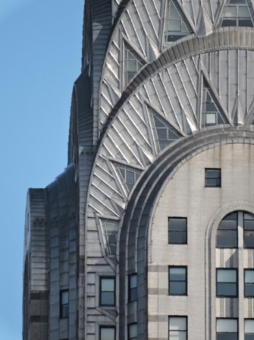
2: POPULAR CULTURE
Is popular culture a distraction?
- Radio
- Sports
- Hollywood
- Jazz
- Flappers
- Teenagers
- Art

3: THE HARLEM RENAISSANCE
What did it mean to be a New Negro?
- Life after Reconstruction
- Booker T. Washington
- Niagara Movement
- Great Migration
- Harlem Renaissance

4: CULTURAL CONFLICTS
Can laws make us moral?
- Racism
- KKK
- Christian Fundamentalism
- Scopes Trial
- Prohibition
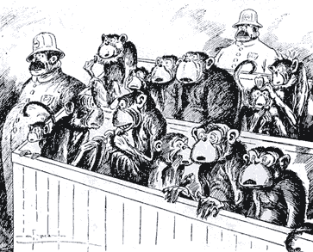
- Organized Crime

THE 1920s

Were the 1920s a time of progress?

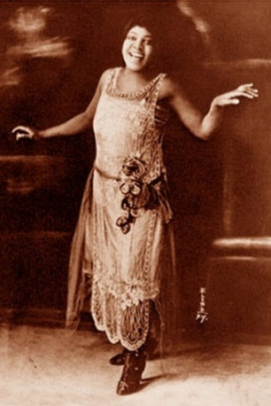
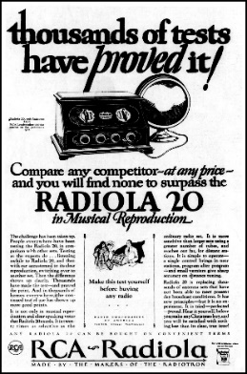
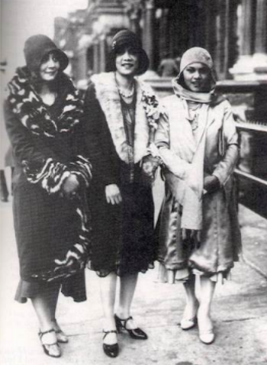
12-1: BUSINESS & GOVERNMENT
Is consumerism an essential element of America’s identity?
TOPICS
- Laissez Faire
- Teapot Dome
- The Automobile
- Airplanes
- Consumerism
- Credit
- The Lost Generation

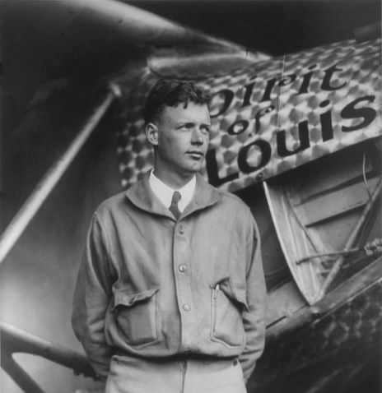
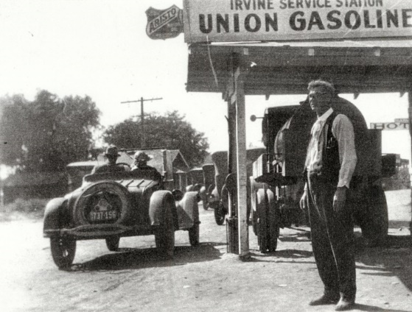
BIG IDEA: The 1920s was a time when the economy was good for most people and having the latest thing was important.
Jon’s Teaching Tips:
This is a challenging topic for the students since the nuances of government economic policy are not easy to connect with. Wanting new things and buying on credit, however, are much easier to understand. This may be a good chance to introduce photographs as primary sources.
THE LESSON BY THE NUMBERS
Reading Level: 10.4
Audio Time: 24:10
Vocabulary Terms: 33

Easier and about as long as most.

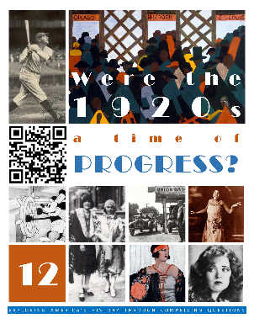
VOCABULARY

IDEAS
Laissez-Faire
Return to Normalcy
The Business of America is Business

PEOPLE & GROUPS
Warren G. Harding
Ohio Gang
Calvin Coolidge
Henry Ford
Barnstormer
Charles Lindbergh
Lost Generation
Ernest Hemingway
Gertrude Stein
F. Scott Fitzgerald
T.S. Eliot
Sinclair Lewis

EVENTS
Teapot Dome Scandal

LITERATURE
The Great Gatsby
The Waste Land
Main Street

LAWS
Federal Highway Act of 1921

ECONOMIC CONCEPTS
Line of Credit
Installment Plan
Buying on Margin

LESSON SUMMARY
During the 1920s, three Republican presidents pursued laissez-faire policies by reducing taxes and regulation. The result was an increase in business activity. Higher wages led to higher spending and people remember the decade as a time of wealth and plenty.
The administration of President Harding however was plagued by scandal, including the Teapot Dome Scandal.
The 1920s were the first decade in which many Americans were able to own automobiles, especially due to innovations in production implemented by Henry Ford. Cars had the effect of changing America. Gas stations, paved roads, motels, and kissing in cars were all things that were new because of the availability of the automobile.
Airplanes were new in the 1920s. Most famously, Charles Lindbergh became the first person to fly non-stop from New York to Paris, becoming a great hero in the United States.
America became a consumer culture. Having the latest thing became an important part of life, especially new electronic inventions such as refrigerators and vacuum cleaners.
When they were unable to buy such things, Americans borrowed money. Being in debt became common.
This was a time when average Americans began buying stocks in the stock market. Some made the risky choice of borrowing money to buy stocks. However, since business was good during most of the decade, even investors who borrowed usually made money in the end.
Not all Americans believed this new emphasis on having things and making money was a good idea. A group of writers known as the Lost Generation felt that Americans had lost their sense of what was good and true and wrote novels focused on these themes.

TECHNOLOGY
Assembly Line
Model T
Electric Refrigerator
Washing Machine
Iron
Supermarket
Spirit of St. Louis
Vacuum Cleaner
12-2: POPULAR CULTURE
Is popular culture a distraction?
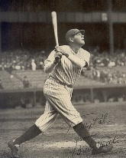
TOPICS
- Radio
- Sports
- Hollywood
- Jazz
- Flappers
- Teenagers
- Art

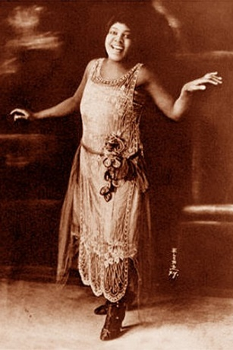
BIG IDEA: Radio, phonographs and movies made it possible for everyone in America to share the same ideas for the first time.
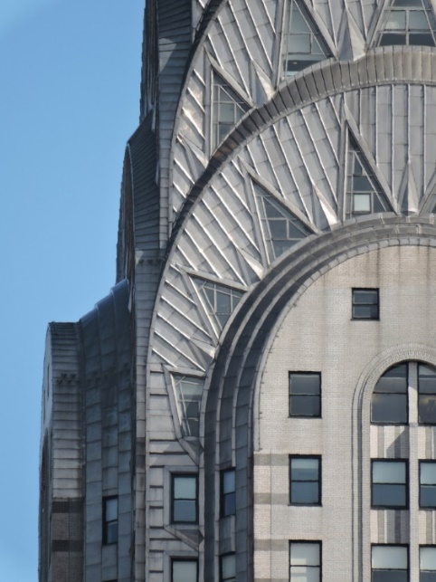
Jon’s Teaching Tips:
This is the first time that popular culture akin to what the students are familiar with emerges. It might be a good chance to show a Charlie Chaplin movie or do some comparison between the past and present. Students may realize how much they are similar to people from the distant past.
THE LESSON BY THE NUMBERS
Reading Level: 10.6
Audio Time: 25:17
Vocabulary Terms: 43

Easier and about as long as most.

VOCABULARY

IDEAS
Dance Marathon
Miss America Pageant
Flagpole Sitting
Charleston
Consolidated High School
School Athletics
Extracurricular Activities

PEOPLE & GROUPS
Guglielmo Marconi
Jim Thorpe
Gertrude Ederle
Helen Wills
“Big Bill” Tilden
Harold “Red” Grange
Babe Ruth
Rudolph Valentino
Clara Bow
Charlie Chaplin
D. W. Griffith
Walt Disney
Duke Ellington
Louis Armstrong
Jelly Roll Morton
Bessie Smith
Ella Fitzgerald
Billie Holiday
Flappers
Sigmund Freud
Le Corbusier
Salvador Dali

LOCATIONS
Hollywood
Cotton Club
Apollo Theater
Chrysler Building
Empire State Building

LESSON SUMMARY
During the 1920s, as more and more Americans had electricity in their homes and could afford radio sets, radio became an important form of entertainment. For the first time, Americans could all listen to the same radio shows, or listen to live sports broadcasts.
Baseball, football, swimming, tennis, and boxing were popular sports.
Fads such as flagpole sitting, dance marathons, and beauty pageants became popular across the nation.
Hollywood and the movie industry were born in the 1920s. The first movies had no sound, but eventually “talkies” were invented. Just like today, movie stars were fashion idols. The first cartoons also were born in the 1920s, including Walt Disney’s Mickey Mouse.
Jazz was a new American form of music that became popular in the 1920s. Based on old African-American musical traditions, Jazz became popular in the North and among White audiences.
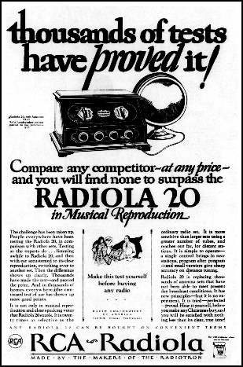
Some middle-class and upper-class young women rejected traditional gender roles and the fashion sense of their mothers and embraced a new style. These flappers went out without chaperones, smoked, drank, danced, and dressed in shocking new ways (at least shocking for the 1920s).
The idea of the teenager was born in the 1920s. High schools added sports, extracurricular activities, and many young Americans waited longer to get married or start working.
BUSINESSES
Radio Corporation of America (RCA)
National Broadcasting Company (NBC)

THE ARTS
The Jazz Singer
Steamboat Willie
Jazz
Art Deco
Surrealism

TECHNOLOGY
Silent Movie
Talkie
New forms of art became popular in the 1920s. Art deco used bold colors, repeated patterns, and geometric shapes. Both artists and architects used this new style. Alternatively, some artists embraced surrealism, which included the painting of fantastic, dream-like images.
12-3: THE HARLEM RENAISSANCE
What did it mean to be a New Negro?
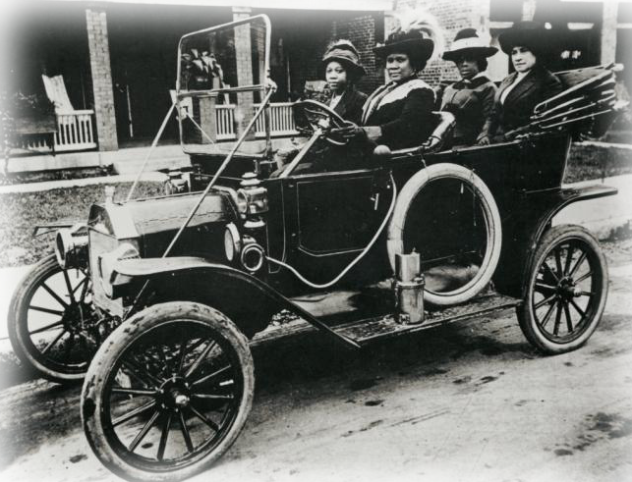
TOPICS
- Life after Reconstruction
- Booker T. Washington
- Niagara Movement
- Great Migration
- Harlem Renaissance
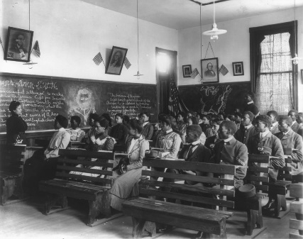
BIG IDEA: The 1920s marked a time when African-Americans were moving and changing their ideas about themselves and their place in American society.
Jon’s Teaching Tips:
Understanding the progression between the post-Reconstruction South symbolized by BT Washington and the New Negro of WEB Du Bois is critical since it is the intellectual underpinning of the later Civil Rights Movement. The poetry of the Harlem Renaissance may be a good avenue into this new way of thinking and a good way to engage students who like literature.
THE LESSON BY THE NUMBERS
Reading Level: 12.6
Audio Time: 19:49
Vocabulary Terms: 24

Harder but shorter than most.

VOCABULARY

IDEAS
Atlanta Compromise
Niagara Movement
Talented Tenth
Redlining
New Negro
Back to Africa

PEOPLE & GROUPS
Booker T. Washington
W. E. B. Du Bois
National Association for the Advancement of Colored People (NAACP)
Claude McKay
Zora Neale Hurston
James Weldon Johnson
Alain Locke
Langston Hughes
Marcus Garvey
Universal Negro Improvement Association (UNIA)
Madam C. J. Walker

EVENTS
Great Migration
Harlem Renaissance

LOCATIONS
Tuskegee Institute
Harlem

LAWS & COURT CASES
Jim Crow
Plessy v. Ferguson
Declaration of Principles

LESSON SUMMARY
After the end of Reconstruction, White leaders in the South established the Jim Crow system of segregation, which recreated the social order of the pre-Civil War Era with African Americans stuck firmly at the bottom.
The most prominent African American leader in the late 1800s was Booker T. Washington. He ran the Tuskegee Institute and argued that African Americans should find ways to become educated so that they could be productive members of society. He did not emphasize fighting for equality or equal rights.
In 1905, a group of African Americans formed the Niagara Movement. They wanted equal rights and founded the NAACP to fight for equality in the courts. Their leader was W. E. B. Du Bois, who offered a contrast to Booker T. Washington.
During WWI, thousands of African Americans moved out of the South to find jobs in factories in the North. This movement of people is called the Great Migration. They mostly settled in urban centers such as New York City, Chicago or Detroit. Although they did find higher paying jobs, they also found that segregation still existed in the North in the form of limits on where they could live and what jobs they could have.
A large number of the most creative and important leaders of the African American community settled in the Harlem neighborhood of New York City during the 1920s. They made music, wrote poetry and novels, danced, created artwork, and advocated for new political rights. This period of intense racial pride and activism was the Harlem Renaissance.
12-4: CULTURAL CONFLICTS
Can laws make us moral?
TOPICS
- Racism
- KKK
- Christian Fundamentalism
- Scopes Trial
- Prohibition
- Organized Crime
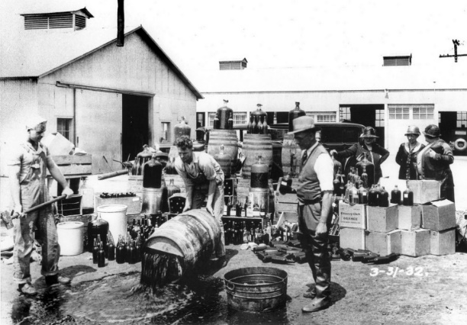
BIG IDEA: The 1920s was a time when there were major conflicts between Americans about what was right and wrong.
Jon’s Teaching Tips:
Conflict is interesting. Debates are interesting. Just be careful to not step on any toes. Many of these issues are very much relevant today, which makes them all the more interesting.
THE LESSON BY THE NUMBERS
Reading Level: 12.6
Audio Time: 21:02
Vocabulary Terms: 24

Harder but shorter than most.
VOCABULARY

IDEAS
Lynching
Theory of Evolution

PEOPLE & GROUPS
Ku Klux Klan (KKK)
Anti-Defamation League
Modernists
Traditionalists
Charles Darwin
Fundamentalists
American Civil Liberties Union (ACLU)
John Scopes
William Jennings Bryan
Clarence Darrow
Billy Sunday
Aimee McPherson
Dries
Wets
Al Capone

MOVIES
The Birth of a Nation

LOCATIONS
Speakeasy

LAWS & COURT CASES
Butler Act
Scopes “Monkey” Trial
18th Amendment
Volstead Act
21st Amendment

LESSON SUMMARY
Fueled partly by the popularity of a movie celebrating the Ku Klux Klan in the immediate aftermath of the Civil War, the KKK became popular and quite common in the 1920s. They targeted their hatred on African Americans, immigrants, Catholics and Jews. Although the Klan’s leaders promised to be non-violent, in reality the members of the Klan carried out numerous lynchings and other forms of terrorism.
The 1920s saw the rise of Christian Fundamentalists who reacted to new inventions and excitement about science by teaching that truth can be found in the Bible. Most importantly, they focused on preventing Darwin’s Theory of Evolution from being taught in public schools because it conflicted with the Biblical story of creation.
Although some Americans wanted their children to learn the Bible’s version of creation in public school, others did not like it that Christian teachings were being enacted into law. In 1925, a great court case showed off the conflict between these modernists and traditionalists. In Tennessee, the Butler Act had made it illegal to teach any version of creation other than the story found in the Bible. When John Scopes taught Darwin’s theory he was arrested.
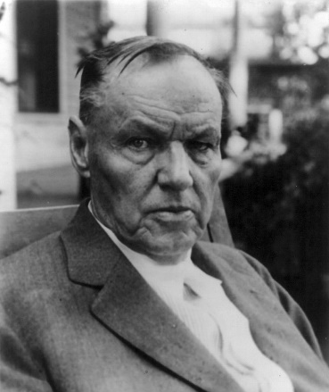
Great lawyers came to try the case, and although Scopes lost (it was obvious he had broken the law), the nation watched with great interest as the Bible itself seemed to be on trial.
Other leaders tapped into a growing interest in traditional religion. Billy Sunday and Aimee Semple McPhereson both built large followings as they toured the nation speaking to large audiences.
The 1920s are also remembered as the era of Prohibition. Beginning in 1919, alcohol was illegal in the United States. Preventing people from making, selling, buying and drinking alcohol was incredibly difficult. Although Prohibition was supposed to reduce crime, crime actually became more common as gangs fought each other over control of the making and distribution of illegal alcohol. Most famous of these was Al Capone’s gang in Chicago. Police forces, who were supposed to enforce the laws, often were paid by bar owners to look the other way, or simply ignored the law since they wanted to drink also. Finally, after 14 years, the 21st Amendment made alcohol legal again.
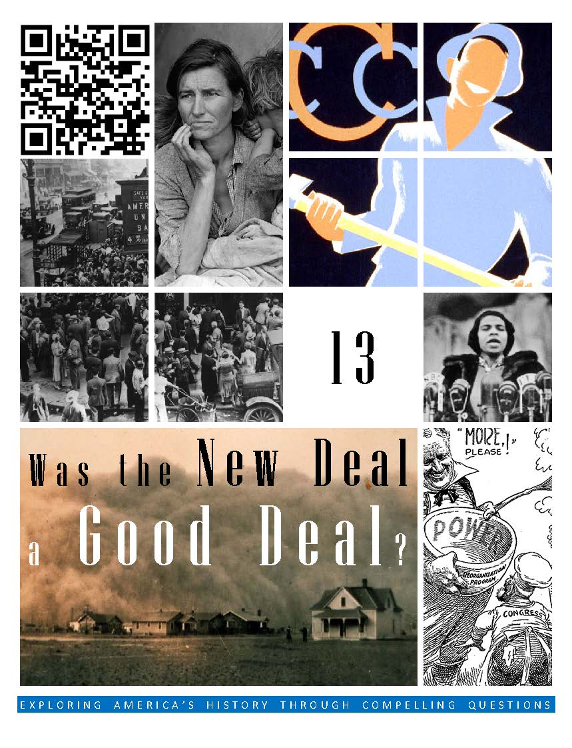  HCSSS STANDARDS  - SS.US.7.19.1 Analyze the conditions and policies that led to the Great Depression  - SS.US.7.11.2 Analyze how the decline in production and spending affected Americans during the Great Depression  - SS.US.7.10.3 Assess the impact and legacy of New Deal relief, recovery, and reform programs  TESTED TOPICS  - Causes of the Depression  - The Federal Reserve  - Keynesian Economics  - Bonus Army  - Dust Bowl  - Hoovervilles  - Okies  - New Deal (as a group of programs)  - AAA  - CCC  - FDIC  - SEC  - WPA  - Court Packing  - Social Security  - Wagner Act  - New Deal’s effect on Government | UNIT 13
 | Four Lessons
1: THE START OF THE DEPRESSION
To what extent does money control our lives?
- President Hoover
- The Crash
- Farmers
- Bank Failures
- Cause of the Depression
- Supply-Side vs. Demand-Side Solutions

2: LIFE IN THE DEPRESSION
Did President Hoover deserve to lose his bid for reelection?
- Effects on Families and Farmers
- The Dust Bowl
- African Americans
- Organized Labor
- The Bonus Army
- Hobos
- Crime
- Hoover’s Response
- Movies
- Election of 1932

3: THE FIRST NEW DEAL
Should the government be responsible for the welfare of everyone?
- FDR’s Inauguration
- Bank Relief
- Homeowners
- Jobs
- Farmers
- Communication
- First 100 Days

4: THE SECOND NEW DEAL
Was President Franklin Roosevelt liberal?
- TVA
- Organized Labor
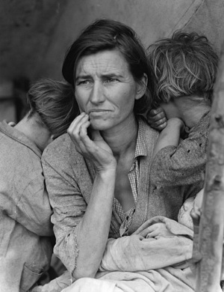
- Wagner Act
- Social Security
- Opposition
- Court Packing
- Effect on Minorities
- Women
- African Americans

THE GREAT DEPRESSION & NEW DEAL

Was the New Deal a good deal?

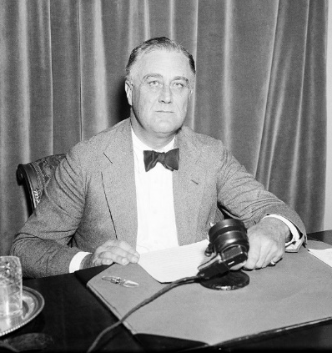
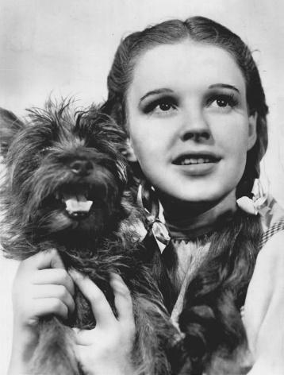
13-1: THE START OF THE DEPRESSION
To what extent does money control our lives?
TOPICS
- President Hoover
- The Crash
- Farmers
- Bank Failures
- Cause of the Depression
- Supply-Side vs. Demand-Side Solutions

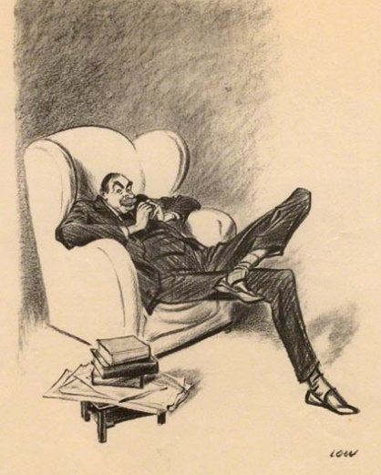
BIG IDEA: Poor economic decisions in the 1920s led to a financial crisis in 1929, and poor decisions by government officials made the problem worse and turned the crisis into the Great Depression.
Jon’s Teaching Tips:
This topic is difficult for students to understand. Make sure to focus on the role the Fed played in making banking failures worse by restricting the monitory supply. It is a good chance for students to think about their own personal political views by asking them to consider the options FDR had and which one makes most sense to them.
THE LESSON BY THE NUMBERS
Reading Level: 10.7
Audio Time: 19:12
Vocabulary Terms: 7

Shorter and easier than most.

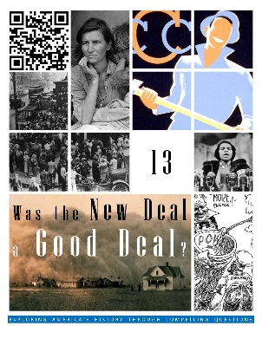
VOCABULARY

IDEAS
Foreclosure
Bank Run

PEOPLE & GROUPS
Milton Friedman
Anna J. Schwartz
John Maynard Keynes

EVENTS
Black Thursday

GOVERNMENT AGENCIES
Federal Reserve Board (Fed)

LESSON SUMMARY
President Hoover had been a popular public servant during the 1920s. He was the third Republican president during the 1920s and it seemed like he would be popular as president as well.
When the stock market was doing well in the 1920s, people thought that prices would only go up. To cash in on the opportunity to make money, some investors borrowed money to buy stocks, thinking that they could pay back the money later when the stock price went up. Eventually stock prices fell and these investors lost all their money. Although participation in the stock market increased during the 1920s, only 10% of all Americans had purchased stock. The failure of the stock market in 1929 made the Great Depression worse, but did not cause the Great Depression.
The 1920s was not a good decade for farmers. They had taken out loans to buy new equipment and open up new land for farming during World War I, and when demand fall after the war, they could not pay back their loans.
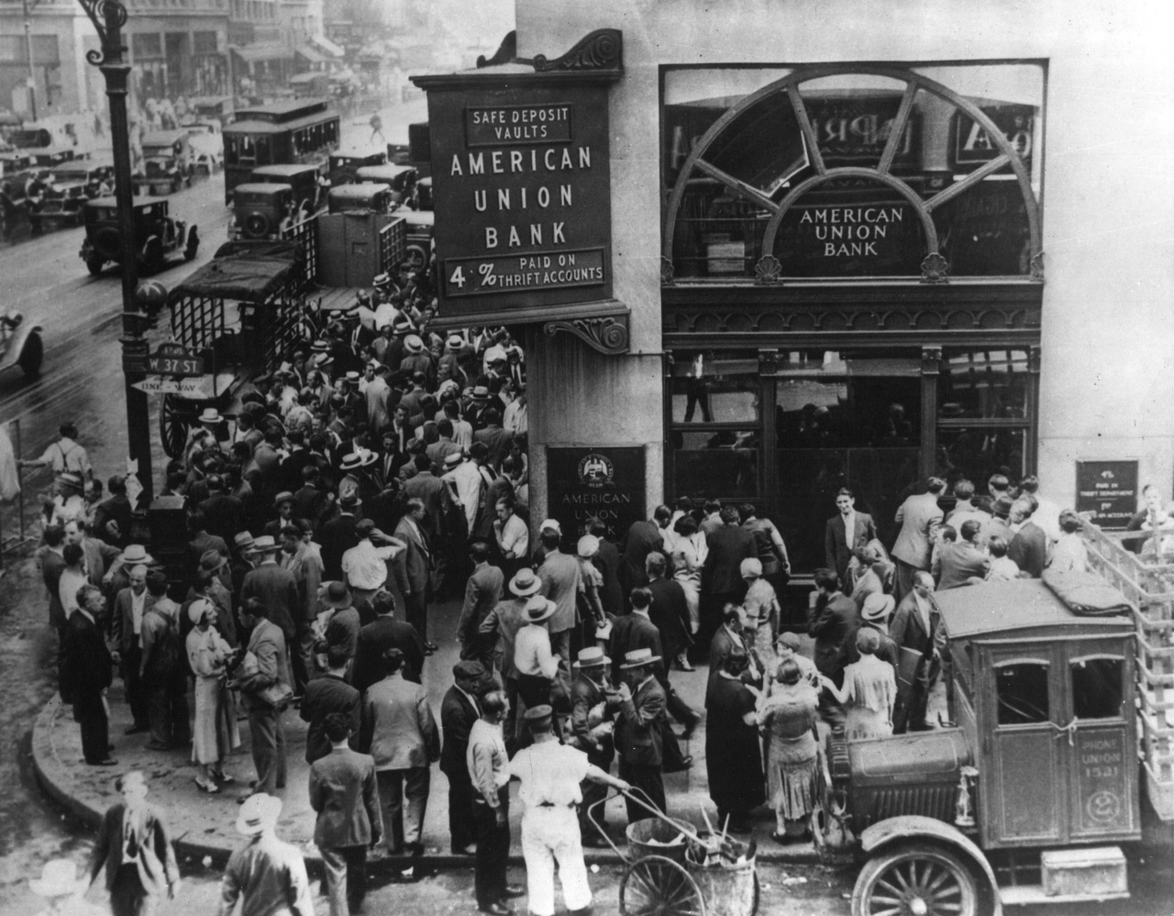
Some banks began to fail. They made loans that borrowers could not pay. Sensing that a bank was in trouble, people who had depositors ran to a bank to withdraw all their savings. This sort of bank run ruined both well-run and poorly-run banks. When bank failures spread to New York City, the economy failed.
The real cause of the disaster was a failure of the Federal Reserve to respond to the crisis. Instead of supplying banks with funds to continue operation, the Fed held back and the nation fell into the Great Depression.
13-2: LIFE IN THE DEPRESSION
Did President Hoover deserve to lose his bid for reelection?
TOPICS
- Effects on Families and Farmers
- The Dust Bowl
- African Americans
- Organized Labor
- The Bonus Army
- Hobos
- Crime
- Hoover’s Response
- Movies
- Election of 1932

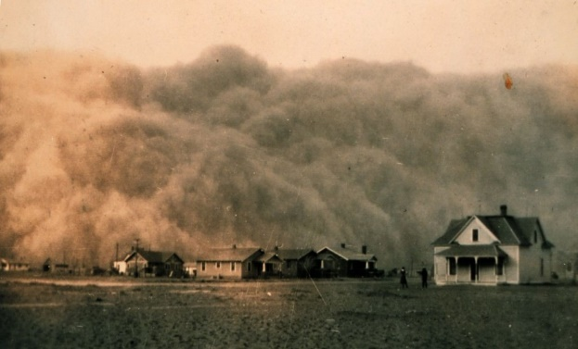
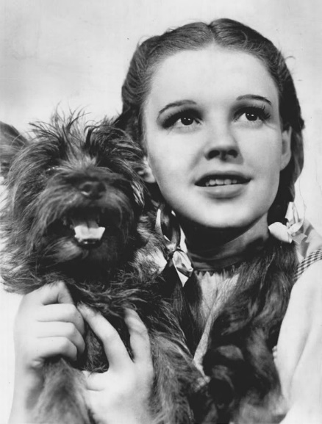
BIG IDEA: The Great Depression was the worst economic disaster in the nation’s history and life was hard for all Americans, especially minorities. In the end, people turned to Franklin Roosevelt who promised new ideas.
Jon’s Teaching Tips:
There is a lot of material here. I have found that focusing on teenagers and families is a good way to maintain interest. Thousands of teenagers were homeless and road the rails during the Depression. One good activity has been to ask the students to imagine they were hobos and to write a letter home.
THE LESSON BY THE NUMBERS
Reading Level: 11.1
Audio Time: 39:59
Vocabulary Terms: 25

Harder and longer than most.

VOCABULARY

IDEAS
Crop Rotation
Lie Fallow
Riding the Rails
Volunteerism

PEOPLE & GROUPS
Okies
John Steinbeck
Scottsboro Boys
Bonus Army
Douglas MacArthur
Hobo
Marx Brothers
Shirley Temple
Fred Astaire
Ginger Rogers
Judy Garland
Mickey Rooney
Franklin Delano Roosevelt

EVENTS
Ford Hunger March

LITERATURE
The Grapes of Wrath

LAWS & GOVERNMENT PROGRAMS
Reconstruction Finance Corporation (RFC)
Hawley-Smoot Tariff

LOCATIONS
Dust Bowl
Hooverville

COURT CASES
Powell v. Alabama
Patterson v. Alabama

LESSON SUMMARY
The Great Depression affected everyone. Even people who did not lose their jobs usually had their pay lowered. Hungry, jobless, homeless people became a common sight on the streets of American cities. Even the government struggled. With fewer people working, fewer people were paying taxes, and politicians struggled with hard decisions about how to solve the crisis.
Farmers who had bad loans from the 1920s lost their farms as banks foreclosed. In the middle of the country, a drought and poor farming techniques combined to form the Dust Bowl. People whose farms had been ruined by the dust fled to California and elsewhere looking for a chance to start over.
The Depression was especially hard for African Americans. The few jobs that were available were given to Whites first. In some places, anger and frustration boiled over and African Americans were targeted. Lynching increased. In one famous case, the Scottsboro Boys were tried for a crime that never happened. The experience of surviving the Great Depression inspired African Americans to begin the community organizing necessary for the later Civil Rights Movement.
Organized labor suffered during the Depression. In Detroit, hungry workers marched to a Ford factory and clashed violently with police.
Millions of Americans were left homeless. Many rode the rails looking for work. Among these, tens of thousands were teenagers. It was a dangerous life.
Families were hit especially hard. Divorce and separation increased. Birth rates fell. More women began looking for work in order to support their families. Many children dropped out of school.
During the Depression, Americans loved going to the movies. It was a chance to escape the hardships of daily life.
President Hoover tried to address the crisis by encouraging businesses not to raise prices or lower wages. In order to help the millions who were suffering, he encouraged churches and other civil groups to operate shelters and soup kitchens. This failed to solve the problem, simply because the problem was so large.
In Washington, DC, an army of World War I veterans gathered to demand early payment of a bonus. President Hoover ordered their camp cleared. It was a decision that cemented his unpopularity.
In 1932, Democrat Franklin D. Roosevelt won the presidential election. He promised voters a new deal.
13-3: THE FIRST NEW DEAL
Should the government be responsible for the welfare of everyone?
TOPICS
- FDR’s Inauguration
- Bank Relief
- Homeowners
- Jobs
- Farmers
- Communication
- First 100 Days

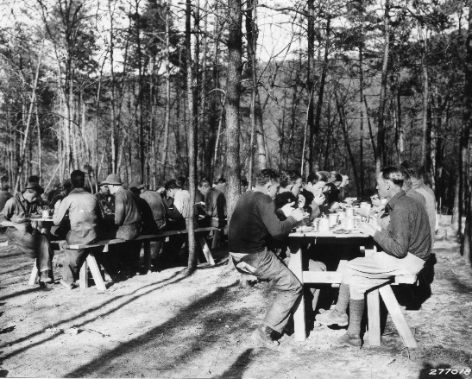
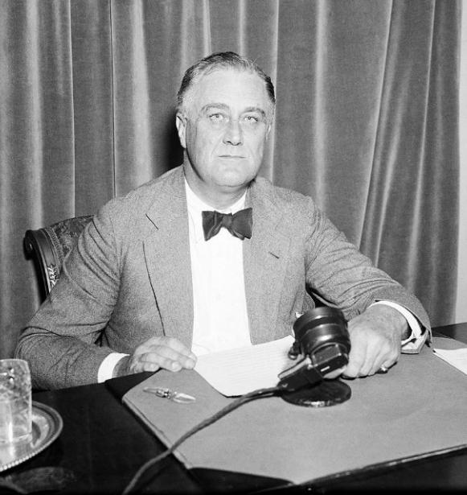
BIG IDEA: FDR tried to deal with the immediate problems facing the country by creating many new government programs. These stabilized the banking system, gave people jobs and addressed food shortages.
Jon’s Teaching Tips:
The most difficult part about this entire unit is keeping the alphabet soup of the New Deal organized. Some sort of graphic organizer or game is helpful here. Also interesting to the students is the impact programs like the FDIC or SEC continue to have today.
THE LESSON BY THE NUMBERS
Reading Level: 11.1
Audio Time: 24:18
Vocabulary Terms: 20

Harder but about as long as most.

VOCABULARY

IDEAS
Pump Priming
Fireside Chat

PEOPLE & GROUPS
Harry Hopkins
Harold Ickes
Brain Trust

EVENTS
FDR’s First Inaugural Address
First Hundred Days

LITERATURE
The Great Gatsby
The Waste Land
Main Street

LAWS
Emergency Banking Act
Glass-Steagall Act
Federal Emergency Relief Act (FERA)

GOVERNMENT PROGRAMS & AGENCIES
Federal Deposit Insurance Corporation (FDIC)
Federal Housing Authority (FHA)
Civilian Conservation Corps (CCC)
Works Progress Administration (WPA)
Public Works Administration (PWA)
Rural Electrification Authority
Agricultural Adjustment Administration (AAA)
LESSON SUMMARY
President Franklin Roosevelt told Americans the only thing they had to fear was fear itself. He implemented many new programs to try to solve the problem. Most involved spending large amounts of government money to jumpstart the economy.
His programs became known as the New Deal. In the first 100 days of his presidency, FDR implemented programs to help solve the banking crisis, to give people jobs, and to support farmers. Many of the New Deal programs are known by their acronyms. (FDIC, FHA, CCC, WPA, AAA, etc.)
FDR was an excellent communicator. He was known for his speeches on the radio in which he explained his ideas in simple terms that regular Americans could understand.
Part of the New Deal were laws to fix the banking system. One program gives insurance to people who deposit money in banks so they will not lose it if their bank fails. This program prevents bank runs. Other financial programs provided regulation for the stock market.
New government programs helped people get loans to buy houses.
To help people find jobs, FDR created programs building roads, bridges, dams, parks, trails, painting murals, writing, acting, and much more.
For farmers, FDR signed laws paying farmers to grow less. This stabilized food prices. The New Deal also included programs to provide electricity to rural areas.
13-4: THE SECOND NEW DEAL
Was President Franklin Roosevelt liberal?
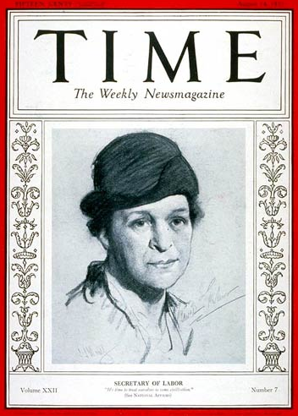
TOPICS
- TVA
- Organized Labor
- Wagner Act
- Social Security
- Opposition
- Court Packing
- Effect on Minorities
- Women
- African Americans
BIG IDEA: Later in the 1930s, FDR tried to fix long-term problems such as chronic poverty, security for seniors and racial inequality. Although the New Deal was generally popular, it didn’t solve all of the problems of the Depression and there were critics of FDR and his ideas.
Jon’s Teaching Tips:
It is critically important that students understand the basics of how Social Security works and the guarantees of the Wagner Act because both will have an impact on their lives. Perhaps evaluating the balance of power debate inherent in the Court Packing debate would also be valuable because similar power struggles have been in the news in recent years.
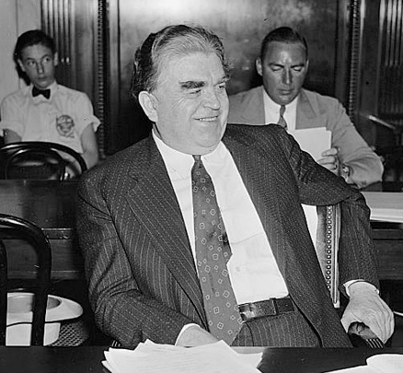
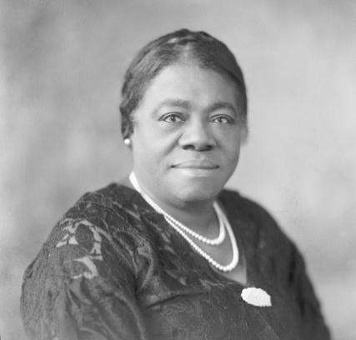
THE LESSON BY THE NUMBERS
Reading Level: 13.8
Audio Time: 34:41
Vocabulary Terms: 25

Harder and longer than most.

VOCABULARY

IDEAS
Pension
Townsend Plan
Share Our Wealth
Court Packing

PEOPLE & GROUPS
John L. Lewis
Congress of Industrial Organizations (CIO)
Frances Perkins
Robert Taft
Charles Coughlin
Huey “Kingfish” Long
Black Cabinet
Mary McLeod Bethune
Eleanor Roosevelt
Marian Anderson

LAWS & COURT CASES
Wagner Act / National Labor Relations Act
Social Security Act
United States v. Butler
Carter v. Carter Coal Company
Morehead v. New York
Schechter Poultry Corp. v. United States

GOVERNMENT PROGRAMS & AGENCIES
Tennessee Valley Authority (TVA)
National Recovery Administration (NRA)
National Labor Relations Board (NLRB)
Social Security
Indian New Deal
LESSON SUMMARY
FDR supported unions. The Wagner Act guaranteed the right of unions to organize. It was the first time that government firmly sided with workers in their struggle with company owners. The 1930s was a time of growth for labor union membership and power.
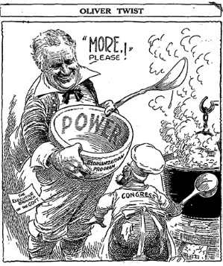
Social Security is the most important program to come out of the New Deal. It provides benefits for retired Americans. The money is taken from working younger people and redistributed to the elderly.
Not everyone liked the New Deal. Some liberals thought that it did not do enough to redistribute wealth down to the lower classes. Republicans thought that too much government intervention in the economy and in people’s lives would stifle entrepreneurship, innovation, and self-reliance.
The Supreme Court ruled that many of the New Deal programs were unconstitutional because the Constitution did not give the government the authority to intervene in the economy by dictating prices, wages, etc. FDR tried to add justices to the Court, but was blocked by Congress, which correctly saw it as an attempt by one branch of government to inappropriately influence another.
Native Americans and African Americans were helped by the New Deal. FDR had a group of African American advisors, and the Indian New Deal ended a policy of assimilation that was destroying Native American culture and communities.
Women also benefited from the New Deal. First Lady Eleanor Roosevelt especially championed civil rights and women’s rights while her husband was in office.
Ultimately, the New Deal did not end the Great Depression, but it helped. It also gave the federal government more power and gave Americans the idea that it is the job of their government to look out for the people and protect them from economic hardship.
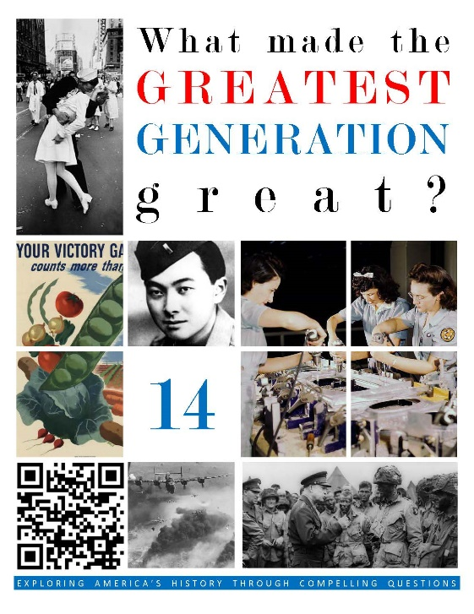  HCSSS STANDARDS  - SS.US.8.19.1 Explain the historical developments and policies that resulted in the United States entering WWII  - SS.US.8.19.3 Analyze the role of the United States in the outcome of WWII in the European and the Pacific theaters  - SS.US.8.17.2 Assess the social, political, and economic transformation of the United States during WWII  TESTED TOPICS  - Tripartite Pact  - Aid to Britain  - Lindbergh/America First  - Neutrality Acts  - Pearl Harbor  - Turning Points  - Saturation Bombing  - Atomic Bomb Decision  - Propaganda  - Arsenal of Democracy  - Bracero Program  - Zoot Suit Riots  - Women’s Roles  - A. Philip Randolph  - Japanese Interment  - 442nd  - Korematsu v. US | UNIT 14
 | Three Lessons
1: NEUTRALITY & PEARL HARBOR
Was America right to try to stay out of World War II?
- Isolationism
- Fascism
- Japan in Asia
- American Neutrality
- War in Europe
- Battle of Britain
- Atlantic Charter
- Pearl Harbor

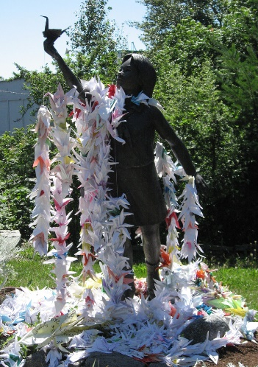
2: WINNING THE WAR
Why did the Allies win World War II?
- Strategy
- D-Day
- V-E Day
- War in the Pacific
- Manhattan Project
- End of the War
- Criticism of Truman

3: THE WORLD WAR II HOMEFRONT
Did World War II make life in America better?
- Mobilization
- Population Changes
- Big Government
- Arsenal of Democracy
- Entertainers
- Women
- African Americans
- Native Americans
- Hispanics
- Japanese American Internment
 | 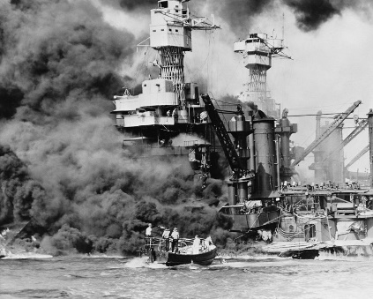

WORLD WAR II

What made the Greatest Generation great?

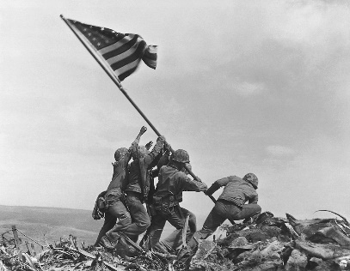
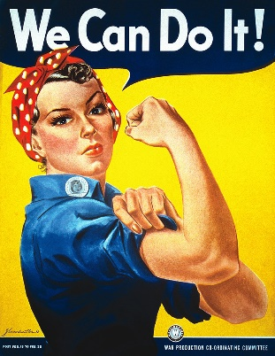
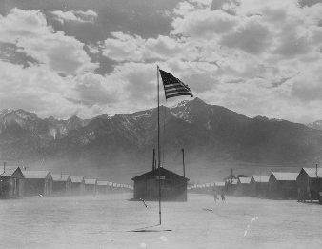
14-1: NEUTRALITY & PEARL HARBOR
Was America right to try to stay out of World War II?
TOPICS
- Isolationism
- Fascism
- Japan in Asia
- American Neutrality
- War in Europe
- Battle of Britain
- Atlantic Charter
- Pearl Harbor

BIG IDEA: America tried to maintain its isolation from a growing war in Europe and Asia in the late 1930s. At first, the United States tried to use economic pressure to limit Japanese expansion and provided material support to Great Britain’s fight against Nazi Germany, but Japan’s attack on Pearl Harbor brought America into the conflict as a full combatant.
Jon’s Teaching Tips:
Fascism is a difficult concept for many students to understand since it is a government system they are not familiar with. It can be helpful to show how similar economic challenges in the 1930s in America and Germany led to different outcomes: Hitler’s use of blame vs. FDR’s hopeful messages. Knowing that the United States had already taken sides before Pearl Harbor is also new information to most students.
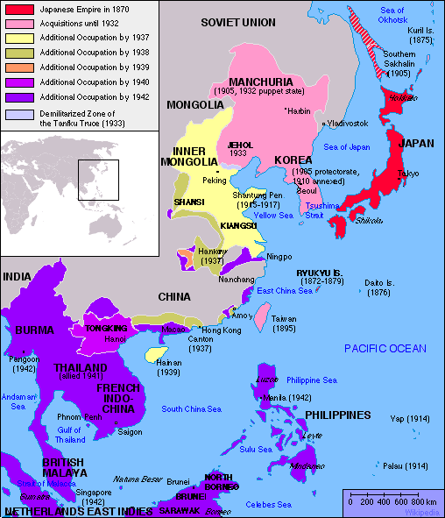
THE LESSON BY THE NUMBERS
Reading Level: 10.4
Audio Time: 24:10
Vocabulary Terms: 28

Easier and about as long as most.

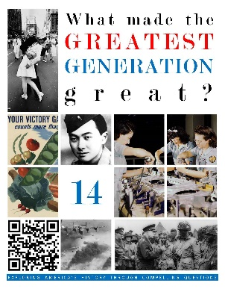
VOCABULARY

IDEAS
Isolationism
Fascism
Appeasement
Blitzkrieg

PEOPLE & GROUPS
Benito Mussolini
Adolf Hitler
Nazi Party
Joseph Stalin
America First Committee
Chiang Kai-shek
Winston Churchill
Hideki Tojo

EVENTS
Washington Naval Conference
Marco Polo Bridge Incident
Rape of Nanjin
Battle of Britain
Attack on Pearl Harbor

PLACES
The Great Gatsby
The Waste Land
Main Street

SPEECHES
A date that will live in infamy…

POLICIES, LAWS & AGREEMENTS
Good Neighbor Policy
Munich Pact
Stimson Doctrine
Neutrality Acts
Cash and Carry
Lend Lease
Atlantic Charter

LESSON SUMMARY
During the two decades that followed World War I, the United States maintained an attitude of isolationism. The nation had refused to join the League of Nations. As Europe was collapsing into turmoil with communism arising in the Soviet Union and Fascism in Spain, Italy and Germany, most Americans were happy to be far away and uninvolved.
The United States was not entirely isolationist. We cultivated better relationships with the nations of Latin America through Roosevelt’s Good Neighbor Policy and tried to limit the size of the world’s navies by participating in the Washington Naval Conference. However, organizations like the America First Committee had widespread public support and isolationism was popular.
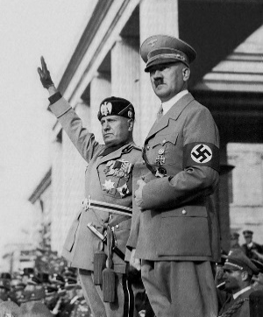
Fascism, a system of government in which the leader and the nation become synonymous, was established by Mussolini in Italy and then by Hitler in more populous and economically powerful Germany. Hitler used anti-Semitism as a tool manipulate public opinion, gain support, win elections, and eventually take total control.
European leaders tried to appease Hitler by offering him control over some territories in exchange for promises of peace, but it did not work. After signing a secret peace deal with Joseph Stalin of the Soviet Union, Hitler invaded Poland in 1939, and then France. By 1940, only the United Kingdom was still holding out against Hitler.
Most Americans did not like the Nazis but wanted to remain neutral. To support the United Kingdom, President Roosevelt implemented Cash and Carry and Lend Lease programs to supply war materials to the British without declaring war. During this time, Roosevelt met with Winston Churchill of the United Kingdom to conclude the Atlantic Charter, which described how their two nations promised to offer a democratic alternative to Fascism. Roosevelt expressed his goals as Four Freedoms.
In Asia, Japan had been expanding into China. The United States opposed this expansion, especially after Japanese troops committed war crimes against Chinese civilians. In response, the United States instituted an embargo on war material to Japan. Under pressure to find an alternative source for oil, rubber, and other raw materials, the Japanese military command decided to attack the Dutch East Indies (now Indonesia), British and French Indochina (now Vietnam, Laos, Cambodia, Malaysia and Singapore), and the Philippines, which was an American territory.
In order to prevent the United States from entering the war, Japanese commanders decided to destroy the entire American fleet in one surprise attack on Pearl Harbor. Although the strike on December 7, 1941 was a tactical success, it was a strategic failure. The United States entered the war rather than suing for peace.
14-2: WINNING THE WAR
Why did the Allies win World War II?
TOPICS
- Strategy
- D-Day
- V-E Day
- War in the Pacific
- Manhattan Project
- End of the War
- Criticism of Truman

BIG IDEA: Good leadership, economic power, and the use of total war eventually helped the Allies defeat both Germany and Japan. In the end, President Truman’s use of the atomic bomb prevented the need for a full invasion of Japan.
Jon’s Teaching Tips:
Although it can be tempting to focus on the conduct of the war and recount the many heroic battles, it is more important for students to understand the overall progress of the war and especially to understand the importance of Truman’s decision to use the atomic bomb. The winning side and the fact that the war ended with nuclear weapons is a critical setup to the next unit about the Cold War.
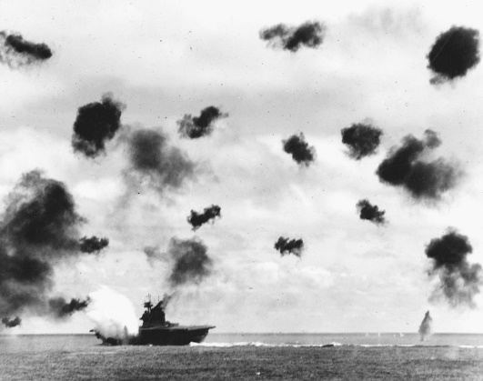
THE LESSON BY THE NUMBERS
Reading Level: 10.4
Audio Time: 24:10
Vocabulary Terms: 32

Easier and about as long as most.

VOCABULARY

IDEAS
Firebombing
Island Hopping
Kamikaze

PEOPLE & GROUPS
Bernard Montgomery
Erwin Rommel
Dwight Eisenhower
Douglas MacArthur
Harry Truman
Albert Einstein
Enrico Fermi
Robert Oppenheimer

EVENTS
North Africa Campaign
Invasion of Italy
Battle of Stalingrad
Operation Overlord
D-Day
Battle of the Bulge
Holocaust
V-E Day
Corregidor
Bataan Death March
Battle of Midway Island
Battle of Iwo Jima
Battle of Okinawa
V-J Day

PLACES
Los Alamos, NM
Trinity Site
Hiroshima
Nagasaki

GOVERNMENT PROGRAMS
Manhattan Project

AIRCRAFT
Enola Gay
Installment Plan
Buying on Margin

LESSON SUMMARY
As the war began, Hitler broke his nonaggression pact with Stalin and invaded the Soviet Union. This resulted in an unusual alliance between the communist Soviets and the democracies of the United States, United Kingdom, as well as the Chinese, who had briefly ended their civil war to fight the Japanese.
The Allies concentrated their efforts first in Northern Africa, and after winning there, invaded Italy. The turning points of the war in Europe came on June 4, 1944 (when the British, Americans, free French, and Canadians landed at Normandy on D-Day) and at the Battle of Stalingrad when the Soviets turned back Hitler’s invasion of the Soviet Union.
Intensive bombing campaigns over Germany slowly weakened the enemy as Allied forces pushed inward from both East and West. Eventually Germany collapsed, Hitler committed suicide, and the war in Europe ended.
In the Pacific, the United States suffered humiliating defeats in the early months of the war. After the attack on Pearl Harbor, the Americans were forced to surrender the Philippines to the invading Japanese. The turning point came at the Battle of Midway when the United States was able to sink critical aircraft carriers from the Japanese fleet. Without the resources to rebuild or resupply, the war in the Pacific was a long, slow struggle to recapture tiny islands held by the Japanese. This process resulted in some of the most deadly, but celebrated battles of the Marine Corps’ history.
After retaking the Philippines, the Americans launched an invasion of Okinawa, the last island stronghold before a full invasion of the Japanese mainland would begin. It was one of the most deadly of the entire war. The Japanese used suicide airplane attacks and the Americans devastating the islands with an enormous bombardment.
Meanwhile, Albert Einstein had warned President Roosevelt that Hitler’s scientists might be trying to develop a nuclear bomb and encourage the Americans to create such a weapon first. This top-secret Manhattan Project was a success, and the first atomic bomb was tested in New Mexico.
President Truman took office when Roosevelt died in 1944 and decided to use the atomic bomb to force Japan to surrender. The Americans bombed the Japanese cities of Hiroshima and Nagasaki. There is still debate about the morality of using atomic weapons on cities with large civilian populations. Japan’s surrender in 1945 brought the war to an end. It was the most deadly conflict in human history.
DOCUMENTS
Einstein’s Letter to Roosevelt
14-3: THE WORLD WAR II HOMEFRONT
Did World War II make life in America better?
TOPICS
- Mobilization
- Population Changes
- Big Government
- Arsenal of Democracy
- Entertainers
- Women
- African Americans
- Native Americans
- Hispanics
- Japanese American Internment
BIG IDEA: The war affected the daily lives of almost all Americans and had lasting effects for many people. Women and African Americans had new opportunities and made advancements toward equality, but Japanese Americans were interned, marking one of the nation’s darkest moments of racial injustice.
Jon’s Teaching Tips:
The impacts of the war at home are enormous and the number of questions on the test reflects that. So many social, demographic, and economic changes resulted from this war that they students may find it fascinating to learn just how much of modern life (or at least the events they have heard of such as the Civil Rights Movement) were outgrowths of changes that the war brought about.
THE LESSON BY THE NUMBERS
Reading Level: 10.4
Audio Time: 24:10
Vocabulary Terms: 23

Easier and about as long as most.
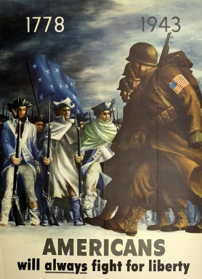

VOCABULARY

IDEAS
Rationing
Scrap Drives
War Bonds
Victory Garden
Arsenal of Democracy
Newsreel
Double V Campaign

PEOPLE & GROUPS
Conscientious Objector
Rosie the Riveter
A. Philip Randolph
WASPs
WAVES
Tuskegee Airmen
Code Talkers
442nd Regimental Combat Team

EVENTS
Zoot Suit Riots

GOVERNMENT PROGRAMS & AGENCIES
Office of Price Administration
Office of War Information
War Production Board
Bracero Program

LAWS
Executive Order 8802
Executive Order 9066

COURT CASES
Korematsu v. United States
LESSON SUMMARY
World War II had an enormous impact on the United States. The government spent previously unheard of amounts of money on the war and the size and scope of the federal government grew tremendously. Government offices produced propaganda to encourage support for rationing, scrap drives, war bond sales, and participation in efforts such as victory gardens.
Populations shifted, especially to California, which became a center for war production and troop deployments.
American industry transformed itself and produced supplies for the war in record numbers. Government officials and industrial tycoons collaborated and led the celebrated Arsenal of Democracy.
When men left to fight, women stepped up to fill in. The famous Rosie the Riveter symbolized all the women who worked in factories and on farms. For many American women, it was the first time they took jobs outside the home or earned a paycheck. Some women joined the fight as delivery pilots, nurses, or support personnel in government offices. Although most went back to being housewives after the war, it was an important psychological step toward gender equality.
Although African Americans still were relegated to segregated units, they served in an effort to both defeat discrimination and the Axis. A. Philip Randolph convinced President Roosevelt to order an end to discrimination in industries that contracted with the government, and groups like the Tuskegee Airmen won praise for their skill and bravery.
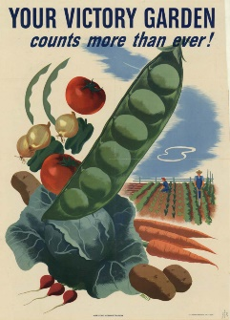
Native Americans served as code talkers, using their native language as an unbreakable code in the Pacific.
Mexican immigrants were welcomed into the country to work in fields left empty by Americans who had joined the military. In Los Angeles, the Zoot Suit Riots showed the level of racial animosity that existed between White servicemen on leave and the city’s Hispanic community.
The minority who suffered the most were Japanese Americans. Roosevelt signed an executive order that led to the internment of the entire Japanese American population of the West Coast. The Supreme Court upheld this clear violation of their civil rights. In the face of such mistreatment, young Japanese American men formed the 442nd and fought with incredible bravery in Italy against the Nazis. Eventually in 1988, the government apologized for the internment and paid reparations to those who had suffered.
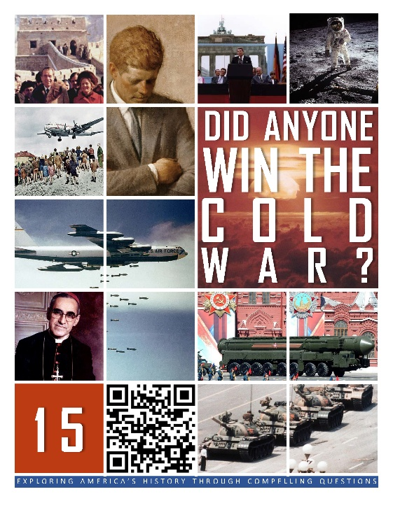  HCSSS STANDARDS  - SS.US.9.19.1 Explain how political ideology shaped the post-war order and led to the Soviet-U.S. arms race  - SS.US.9.17.2 Analyze how U.S. foreign policy during the Cold War shaped conflicts in Asia and the Americas  - SS.US.9.7.3 Analyze how anti-communism and the Cold War affected civil liberties, labor, and technology  TESTED TOPICS  - Communist Economic System  - Iron Curtain  - United Nations  - Containment  - Marshall Plan  - Berlin Airlift  - Chinese Revolution  - Domino Theory  - Korean War  - Arms Race  - Sputnik  - Kennedy  - Cuban Missile Crisis  - McCarthyism  - Military Industrial Complex  - Détente  - Arms Reduction Treaties  - Proxy Wars  - Fall of the Berlin Wall  - Tiananmen Square Massacre | UNIT 15
 | Six Lessons
1: ORIGINS OF THE COLD WAR
Was the Cold War unavoidable?
- Communism
- WWII Conferences
- Decolonization
- United Nations
- Iron Curtain

2: CONTAINMENT
Was containment the right way to deal with the spread of communism?
- Containment
- Marshall Plan
- Berlin Airlift
- NATO & Warsaw Pact
- Chinese Communism
- Korean War
- Domino Theory

3: THE ARMS RACE
Did American leaders respond wisely to the threat of communism?
- Nuclear Proliferation
- Arms Race
- Fallout Shelters etc.
- MAD
- Weapons Testing
- Space Race
- 1960 Election
- Flexible Response
- Peace Corps
- Cuban Revolution
- Bay of Pigs
- Cuban Missile Crisis

4: THE COLD WAR AT HOME
Did the Cold War hurt America?
- Red Scare
- Atoms for Peace
- Military Industrial Complex
- Missile Gap
- Education

THE COLD WAR

Did anyone win the Cold War?

5: THE LATER COLD WAR
Was the Soviet Union really an evil empire?
- Kitchen Debate
- Hungary
- Czechoslovakia
- Police State
- Détente
- Proxy Wars

6: THE END OF THE COLD WAR
Why did the Cold War end?
- Nixon in China
- Reagan’s Evil Empire
- Star Wars
- Iran-Contra Scandal
- Reagan & Gorbachev
- Solidarity
- Tiananmen Square
- Sinatra Doctrine
- Fall of the Berlin Wall
- Fall of the Soviet Union
- Communism Today

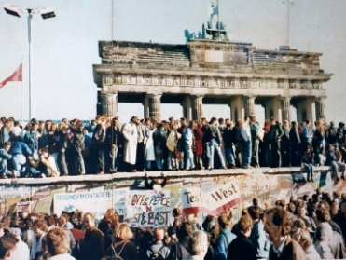
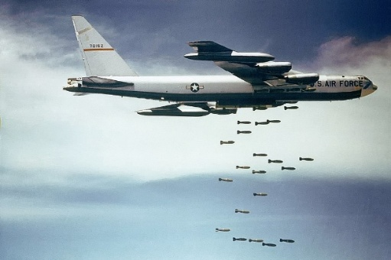
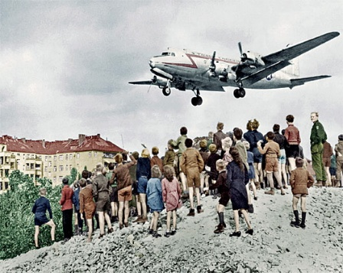
15-1: ORIGINS OF THE COLD WAR
Was the Cold War unavoidable?

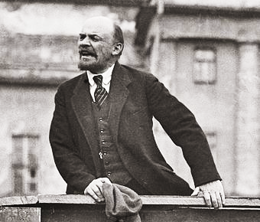
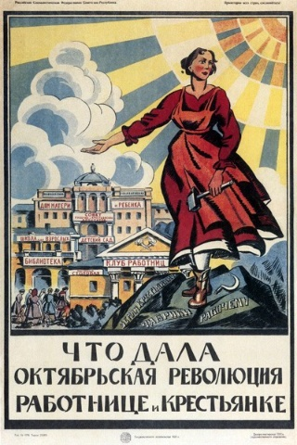
BIG IDEA: The Cold War was a conflict about what was the best economic system and split the world between the Soviet Union and the United States and the allies of these two superpowers. Many of the alliances, geographic divisions, and international systems of the Cold War are the results of the way World War II ended.
Jon’s Teaching Tips:
Key to this lesson is for the students to understand that the Cold War was a conflict over ideology, and that control of land and resources was second to that larger struggle. Most students do not understand the difference between communism and capitalism, so time spent on this big idea is well spent.
TOPICS
- Communism
- WWII Conferences
- Decolonization
- United Nations
- Iron Curtain
THE LESSON BY THE NUMBERS
Reading Level: 11.0
Audio Time: 23:44
Vocabulary Terms: 26

About as hard and as long as most.

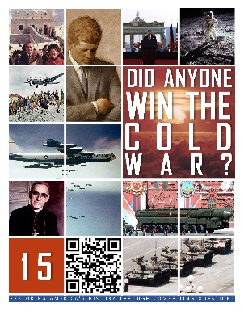
VOCABULARY

IDEAS
Capitalism
Capital
Free Market Economy
Communism
From everyone according to his ability, to everyone according to his need
Veto

PEOPLE & GROUPS
Karl Marx
Frederich Engels
Nicolas II
Vladimir Lenin
Bolsheviks
Josef Stalin
Franklin D. Roosevelt
United Nations
Security Council
General Assembly
Secretary General

EVENTS
Yalta Conference
Potsdam Conference
Decolonization

PLACES
USSR
Israel
Third World
Iron Curtain
Berlin Wall

TEXTS
The Communist Manifesto
LESSON SUMMARY
The Cold War was a 50-year struggle between the United States and the Soviet Union. The two superpowers and their allies were trying to spread their ideas about the best way to run nations. The Soviet Union was the first communist nation and wanted to spread communism. The United States believed communism was wrong and wanted to promote a free market system.
Communism, which is now almost entirely gone in the world, is a system in which everyone works, and everyone shares in the wealth of the nation. The problem is that choice is taken out of the system, and therefore, incentive is also lost. People do not work hard, and the government becomes a dictatorship.
Before World War II ended, the leaders of the United States, United Kingdom and Soviet Union met multiple times to plan what the world would look like after the fighting ended.
After World War II, most of the nations in Africa and Asia that had been European colonies became independent. Many of these nations were poor, and both the United States and Soviet Union tried to win them as allies during the Cold War. Sometimes, this led to violence.
After World War I, Woodrow Wilson had tried to create a League of Nations to help prevent future war. After World War II, the United Nations was created. This time, the United States did join, and the UN has played an important role in the world as a peacekeeper and a forum for debate.
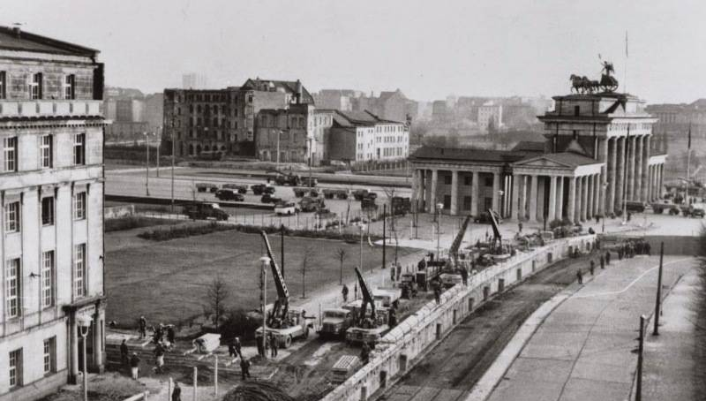
When Germany fell and the war ended in Europe, the Americans, French, British and Soviets divided up Europe into East and West. In the lands in the East that the Soviet armies had occupied, communist governments were supported. In the West, democratic governments were encouraged. This led to a division of the continent that would last throughout the Cold War. Germany itself was divided into East and West, as was Berlin, its capital city.

15-2: CONTAINMENT
Was containment the right way to deal with the spread of communism?
TOPICS
- Containment
- Marshall Plan
- Berlin Airlift
- NATO & Warsaw Pact
- Chinese Communism
- Korean War
- Domino Theory
BIG IDEA: Rather than fighting another war to defeat communist nations, Americans chose to try to stop the spread of communism. This led the United States into conflicts in Korea and Vietnam, and also led to standoffs in Europe, especially related to the status of the city of Berlin.
Jon’s Teaching Tips:
Most of the events of the early Cold War are entirely unknown to the students and what seems like a long list of unimportant dates can frustrate them. Instead, try to help them see how each event or policy connects back to the larger idea of containment.
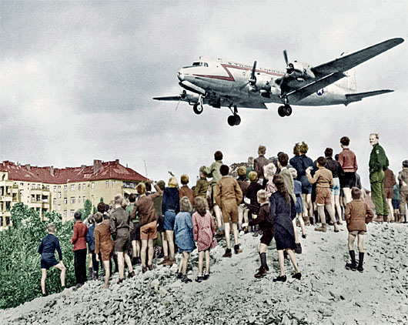
THE LESSON BY THE NUMBERS
Reading Level: 11.1
Audio Time: 28:01
Vocabulary Terms: 38

About as difficult and long as most.

VOCABULARY

IDEAS
Collective Security
Stalemate
Armistice
PEOPLE & GROUPS
George Kennan
George Marshall
William Turner
NATO
Warsaw Pact
Sun Yat-sen
Chiang Kai-shek
Mao Zedong
Syngman Rhee
Kim Il-Sung
Douglas MacArthur
Kim Jong-Il
Kim Jong-un
Ho Chi Minh
Viet Minh
Vo Nguyen Giap
Ngo Dihn Diem
Viet Cong

EVENTS
Berlin Airlift
Long March
Dien Bien Phu

PLACES
Baltic States
Berlin
People’s Republic of China
Republic of China
Taiwan
38th Parallel
Demilitarized Zone (DMZ)
Indochina
Hanoi
Saigon

LESSON SUMMARY
Americans did not want to continue fighting to stop communism. They had just finished fighting the Germans and Japanese and fighting the Soviets to stop communism would have been unpopular with voters. Instead, leaders like President Truman decided to prevent communism from spreading to new places. This was called containment.
Americans were afraid that poverty and political instability in Europe would give communists an opportunity to win over the hearts and minds of people in many countries, not just the nations that were occupied by Soviet troops. A solution was to promote economic recovery. In theory, if people had jobs and the economy was doing well, they would not want to give up prosperity to experiment with communism. To do this, the United States gave billions of dollars to places like France, West Germany, Greece and Japan to help them rebuild.
Stalin was angry that the city of Berlin was divided and wanted to unite the city under communist rule. To force the Americans, British and French out, he blockaded the city, preventing fuel and food from being brought in. He believed that the allies would give up the city rather than fight. Truman saw the conflict as a test of his willingness to stand up to stop the spread of communism and organized an airlift to supply everything the people of West Berlin needed by air transport. After more than a year, Stalin gave up and allowed ground transport into the city again. It was an important early victory for containment.
Both the United States and Soviet Union wanted allies. The United States and its allies in Western Europe formed NATO. The Soviet Union and its allies in Eastern Europe formed the Warsaw Pact. Both alliances were for mutual defense. If any country was attacked, everyone would join the fight in their defense.
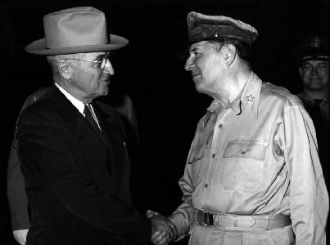
In China, the civil war that had been raging before the Japanese invaded reignited. Communists and nationalists fought in the late 1940s, and communists under Mao Zedong won, driving the nationalists to the island of Taiwan. The United States did not want to fight another war so soon after World War II and did not directly join the fighting. This was a failure to contain the spread of communism.
At the end of World War II, Korea had been divided between communists in the North and non-communists in the South. In 1950, the communists invaded the South and the United States led a fight to defend them. Korea was another important test of containment. The war was long and ended in a stalemate. Today Korea is still divided between a communist North and non-communist South. During the Korean War, General MacArthur wanted to expand the war into China and defeat communism once and for all, but President Truman fired him. The Cold War would be a long conflict, but always limited.
In the end, American leaders came to believe in a domino theory. They thought that if one nation became communist, its neighbors would also soon become communists. In order to prevent the spread of communism, every country, no matter how small, would need to be defended. Presidents Truman, Eisenhower, Kennedy, and Johnson all decided to support the anti-communists in Vietnam for this reason.
POLICIES
Containment
Truman Doctrine
Marshall Plan
Domino Theory

15-3: THE ARMS RACE
Did American leaders respond wisely to the threat of communism?
TOPICS
- Nuclear Proliferation
- Arms Race
- Fallout Shelters etc.
- MAD
- Weapons Testing
- Space Race
- 1960 Election
- Flexible Response
- Peace Corps
- Cuban Revolution
- Bay of Pigs
- Cuban Missile Crisis
BIG IDEA: The Soviet Union and United States developed huge numbers of extremely dangerous nuclear weapons as they raced to outdo the other side. This competition for military dominance extended even into space and nearly led to nuclear war over Cuba.
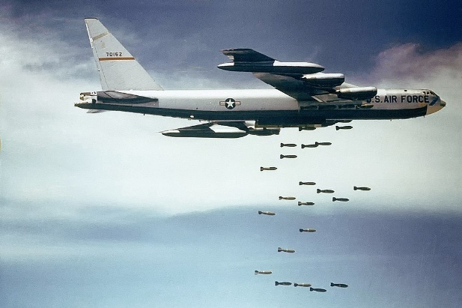
Jon’s Teaching Tips:
This lesson is long. I suggest breaking it up so the students can develop and understanding of the nuclear standoff and the idea of MAD, before delving into the Cuban Missile Crisis. Without the prior understanding, they are unlikely to grasp how pivotal and important the Crisis was.
THE LESSON BY THE NUMBERS
Reading Level: 11.9
Audio Time: 46:31
Vocabulary Terms: 57

About as hard but longer than most.

VOCABULARY

PEOPLE & GROUPS
Curtis LaMay
Nuclear Club
Captain America
Superman
Laika
Yuri Gargarin
Alan Shephard
Valentina Tereshkova
John F. Kennedy
Neil Armstrong
Lyndon B. Johnson
New Frontiersmen
Fulgencio Bautista
Fidel Castro
Nikita Khrushchev
Adlai Stevenson
Robert Kennedy
Ex-Comm
Politburo
Leonid Breshnev
Raul Castro

POLICIES, LAWS & AGREEMENTS
Compact of Free Association
New Frontier
Flexible Response

PLACES
Bikini Atoll
Enewetak

EVENTS
Castle Bravo
1960 Presidential Election
Kennedy-Nixon Debates
Cuban Revolution
Bay of Pigs Invasion
Cuban Missile Crisis

GOVERNMENT & MILITARY AGENCIES
Strategic Air Command
Civil Defense
Apollo Program
Peace Corps
Central Intelligence Agency

SPEECHES
Kennedy’s Inaugural Address
We Choose to Go to the Moon
One small step for man…

TECHNOLOGIES
B-52 Stratofortress
Thermonuclear Warhead
Tactical Nuclear Weapons
ICBM
SLBM
Nuclear Triad
MIRV
Fallout Shelter
Sputnik
Explorer 1
U-2
Red Telephone

IDEAS
Proliferation
Nuclear Winter
Mutually Assured Destruction
Blockade
Embargo

LESSON SUMMARY
When World War II ended, the United States was the only country with an atomic bomb. Within a few years, the Soviet Union, Great Britain, France and China had also developed nuclear weapons.
Since the Cold War was essentially a long face off, both sides wanted to be prepared with the most powerful weapons. This led to an arms race in which the United States and Soviet Union tried to outdo each other to develop more powerful and more plentiful nuclear bombs, missiles, tanks, and airplanes. Both superpowers ended up having nuclear weapons mounted on missiles, in bombs delivered by airplanes, and missiles launched from submarines.
In the United States, people were terrified of the possibility of death from sudden, unpredictable nuclear attack. Many Americans built fallout shelters. Students practiced “duck and cover” drills at school, and superheroes fought communists in comic books.
By the end of the arms race, both nations had enough nuclear weapons to destroy the other many times over. However, both sides were afraid to shoot first, for fear of a retaliatory attack. This mutually assured destruction prevented nuclear war.
All nuclear nations tested their weapons. The United States and France tested weapons in the islands of the Pacific, with disastrous results for the health of the islanders.
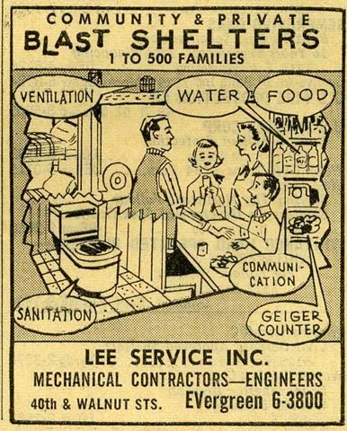
The race for technological superiority extended into space. The Soviet Union launched the first satellite, first animal, and first person into space, but the United States was first to send a man to the Moon.
In 1960, John F. Kennedy was elected president in a close election over Vice President Richard Nixon. It was the first election that featured televised debates.
Kennedy wanted more conventional weapons so he would have other options besides nuclear war. He also wanted Americans to travel abroad to help other nations so that people around the world would think positively about the United States.
In 1959, communists took over the island nation of Cuba. Americans tried to help anti-communist Cubans retake the island, but their invasion failed and Kennedy refused to help. This was embarrassing for Kennedy and made the Soviets think Kennedy was weak.
In 1962, Soviet leader Khrushchev placed nuclear missiles in Cuba. The 13 days of standoff between Khrushchev and Kennedy were the closest the two superpowers ever came to nuclear war. After the crisis, both sides decided to try to talk more and find ways to reduce their nuclear arsenals.
15-4: THE COLD WAR AT HOME
Did the Cold War hurt America?
TOPICS
- Red Scare
- Atoms for Peace
- Military Industrial Complex
- Missile Gap
- Education
BIG IDEA: Fear of communism led Americans to turn on one another and changed the relationship between the military, government and defense contractors. However, the Cold War also led to improvements in education and new technologies for civilian use.
Jon’s Teaching Tips:
Most students find McCarthyism easy to understand and it is an opportunity to engage in a debate or other form of interactive activity. In addition, the effects of the Cold War on education are evident at most American schools in the form of science labs built during the 50s.
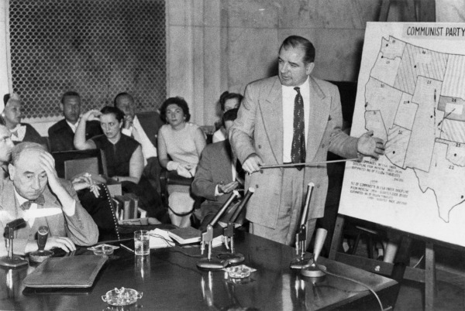

THE LESSON BY THE NUMBERS
Reading Level: 11.4
Audio Time: 24:19
Vocabulary Terms: 19

About as hard and as long as most.
VOCABULARY

IDEAS
Bomber Gap
Missile Gap
Bomb Shelters
Military Industrial Complex

PEOPLE & GROUPS
Alger Hiss
Julius and Ethel Rosenberg
Joseph McCarthy
Reds
Hollywood 10

EVENTS
Second Red Scare
McCarthyism

GOVERNMENT & INTERNATIONAL AGENCIES
House Un-American Activities Committee
International Atomic Energy Agency

SPEECHES
McCarthy’s 205 Communists
Have you no sense of decency?
Atoms for Peace
Eisenhower’s Farewell Address

LAWS & TREATIES
Nuclear Non-Proliferation Treaty
National Defense Education Act
LESSON SUMMARY
In the late 1940s and early 1950s, a second Red Scare swept the United States. People in both the House of Representatives and especially Senator Joseph McCarthy investigated suspected communists. Many people’s careers were ruined by false accusations since few real communists were ever found. Those that did, such as spies who had given nuclear secrets to the Soviet Union, fueled fears that gave power to the accusers.
President Eisenhower wanted to find ways to use nuclear power for good, not just for weapons of destruction. His Atoms for Peace program encouraged the sharing of nuclear technology to support things such as medicine and nuclear power stations to generate electricity.
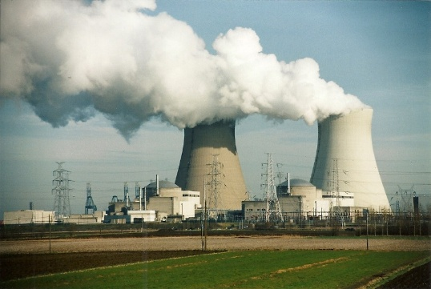
When he left office, Eisenhower warned America about the danger posed by the Cold War’s long period of military readiness. Unlike past wars that ended, the Cold War was always about to begin. This meant that the government was always spending money to have the latest military technology, and the companies and workers that supplied those weapons relied on tax money being spent for their jobs. Eisenhower warned that this would lead to unnecessary spending in the future, which has turned out to be true.
In fact, during the election campaign of 1960, Kennedy encouraged this sort of spending by claiming that the United States had fewer missiles than the Soviet Union. This missile gap did not actually exist, but many people were so afraid of communists that they believed it anyway and their fear encouraged politicians to vote to spend money on the military.
Fear that the communists might be more advanced in the fields of science and math, and therefore might be able to surpass the United States in weapon design, led to spending in education. Science education became important again and many colleges and high schools built new science labs and hired science teachers.
15-5: THE LATER COLD WAR
Was the Soviet Union really an evil empire?
TOPICS
- Kitchen Debate
- Hungary
- Czechoslovakia
- Police State
- Détente
- Proxy Wars

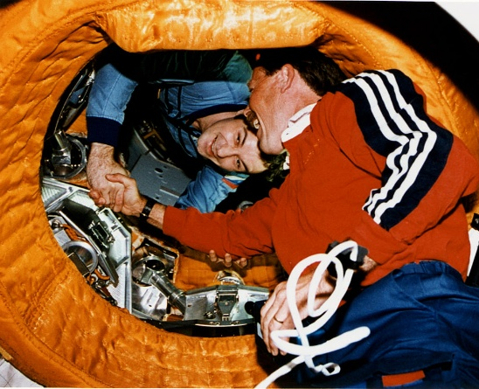
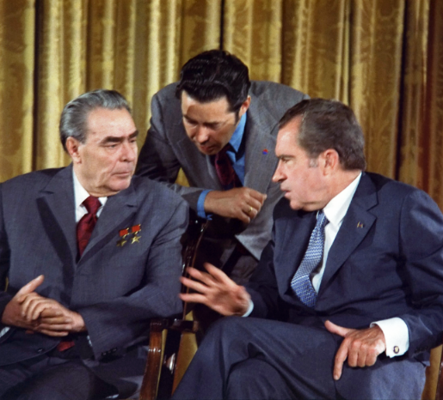
BIG IDEA: While communist nations used fear to manipulate and control their people, the desire to prevent the spread of communism led the United States to side with dictators in the Third World who violated human rights. Beginning in the 1970s, American and Soviet leaders tried to relax tensions.
Jon’s Teaching Tips:
While arms reduction negotiations are simple to understand for most students. It is worth spending some time helping the students develop and understanding of the proxy wars, both their causes and effects. I personally recommend the story of Oscar Romero as an illustration. These stories help students understand the reason why the United States sometimes allied with terrible dictators during the Cold War.
THE LESSON BY THE NUMBERS
Reading Level: 12.7
Audio Time: 40:27
Vocabulary Terms: 37

Harder and longer than most.

VOCABULARY

IDEAS
Realpolitik
Proxy Wars
PEOPLE & GROUPS
Alexandr Solzhenitsyn
Dr. Henry Kissinger
Strongman
Salvador Allende
Agosto Pinochet
Manuel Noriega
Sandinistas
Contras
PMLN
Oscar Romero
Gamal Abdel Nasser

EVENTS
Kitchen Debate
Hungarian Uprising
Prague Spring
Soviet Invasion of Afghanistan
Assassination of Oscar Romero
Suez Crisis

PLACES
Israel

TEXTS
The Gulag Archipelago

POLICIES & TREATIES
Partial Test Ban Treaty
Outer Space Treaty
Nuclear Non-Proliferation Treaty
SALT I & SALT II
Biological Weapons Convention
Anti-Ballistic Missile Treaty
Helsinki Accords
Détente
LESSON SUMMARY
There were few chances for the United States and Soviet Union to actually meet face to face and debate their ideas. Once chance was the Kitchen Debates between then-Vice President Richard Nixon and Soviet Premier Nikita Khrushchev in 1959. Nixon showed off a model American kitchen and all the good things that capitalism allowed people to buy. Khrushchev was impressed, but did not change his mind about the benefits of communism.
Twice, people in Eastern Europe tried to fight to get rid of their communist governments. In 1959, people in Hungary rebelled and in 1968, people in Czechoslovakia rebelled. In both cases, the Soviet Union sent its own troops to put down the rebellions and restore communists to power.
One way communist governments maintained control was through fear. People who disagreed or tried to organize opposition to the government were arrested, thrown in jail, or sometimes they simply disappeared. People knew that the secret police might appear at any moment and had power to kidnap political opponents, so most people tried to avoid criticizing their leaders or doing anything that might put themselves in danger. The result was an obedient and unhappy people.
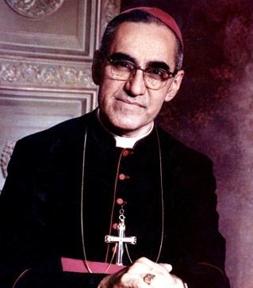
In the 1970s, American leaders decided that there was little chance of getting rid of communism. The initial worries about communism spreading had ended. Therefore, they decided, they should try to find ways to get along and coexist peacefully. The United States and Soviet Union signed a series of treaties to ban the testing of nuclear weapons, and to start to reduce their total number of warheads. The two nations even worked together to have their spacecraft dock in orbit and their astronauts shake hands in space. This period of cooling tensions was called Détente, but ended when the Soviets invaded their neighbor Afghanistan.
Both the United States and Soviet Union tried to convince other nations to join their side. This meant that Americans supported anti-communists governments around the world. Sometimes, we supported people who were dictators and terrible leaders, such as in Chile and Panama, simply because they were anti-communist. These conflicts were proxy wars, because they stood in for actual fights between the superpowers.
In Central America, when the poor started a revolution against the wealthy landowners, the Soviet Union supported the poor and the United States ended up supporting the rich people who controlled the government. Because both superpowers were giving money and weapons to their side, the civil wars lasted a long time and thousands of people died who might have lived if the Cold War had not been raging. Similar problems happened in the Middle East. In Afghanistan, the United States gave weapons to the same people who we eventually had to fight after 9/11.
GOVERNMENT ORGANIZATIONS
KGB
Stasi
Juntong
State Security Department
Gulag
Troika
Apollo-Soyuz Test Project
School of the Americas
15-6: THE END OF THE COLD WAR
Why did the Cold War end?
TOPICS
- Nixon in China
- Reagan’s Evil Empire
- Star Wars
- Iran-Contra Scandal
- Reagan & Gorbachev
- Solidarity
- Tiananmen Square
- Sinatra Doctrine
- Fall of the Berlin Wall
- Fall of the Soviet Union
- Communism Today
BIG IDEA: The Cold War ended without the massive military conflict between East and West that the two sides had prepared for. Instead, the leaders in communist countries allowed greater economic freedom, and responding to social pressure in the case of the Soviet Union and Eastern Europe, greater political freedom.
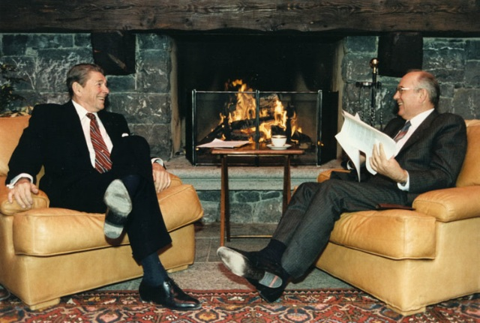
Jon’s Teaching Tips:
The impact of Nixon’s visit to China is something they are usually unaware of and find interesting. In addition, the fall of communism is a chance to reaffirm the power of humanity’s good side at the end of a unit that focuses a great deal on our ability to do great harm. For example, the Tank Man video from the Tiananmen Square protests or images of Germans tearing down the Berlin Wall are enormously uplifting.
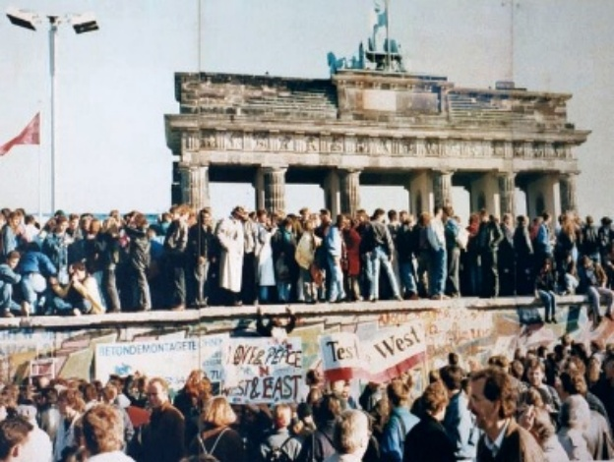
THE LESSON BY THE NUMBERS
Reading Level: 12.6
Audio Time: 43:00
Vocabulary Terms: 33

Harder and longer than most.

VOCABULARY

IDEAS
Vietnam Syndrome

PEOPLE & GROUPS
Ronald Reagan
Margaret Thatcher
Mikhail Gorbachev
Solidarity
Lech Walesa
Pope John Paul II
Erich Honecker
Boris Yeltsin

EVENTS
Nixon’s Visit to China
Iran-Contra Scandal
Reykjavik Summit
Tiananmen Square Massacre
Fall of the Berlin Wall
Reunification of Germany
1991 Coup
Fall of the Soviet Union

PLACES
People Republic of China
Republic of China
Alexanderplatz

SPEECHES
Evil Empire Speech
Tear Down This Wall

POLICIES,
Rapprochement
Ping Pong Diplomacy
One China Policy
Reagan Doctrine
Perestroika & Glasnost
Sinatra Doctrine
Brezhnev Doctrine
LESSON SUMMARY
As part of his effort to reduce Cold War tensions, Richard Nixon decided to formally recognize the communist government of China and visited Beijing in 1972. This led to an opening up of China, as well as the sharing of goodwill gestures such as ping-pong matches and a gift of panda bears.
When Ronald Reagan became president in 1980, he decided to challenge communist leaders. He called the Soviet Union an “evil empire” and built up the American military. He disagreed with the idea of détente.
Reagan proposed a new strategy that would upend the system of mutually assured destruction. He wanted to build a system that could shoot down incoming Soviet missiles. The plan was not technologically possible, but it threatened to undo the delicate balance of power that had prevented war for decades.
Reagan was weakened as president by the Iran-Contra Scandal, which showed Americans how much he did not know about what his aides were doing. He survived, however, and started working with Soviet leaders.
Reagan met multiple times with Mikhail Gorbachev to try to reduce nuclear weapons. In fact, his second term was almost the opposite of his first. Instead of building up the military, Reagan started to reduce nuclear weapons. He wanted to give Gorbachev a chance to start reforms inside the Soviet Union.
Communism started to fall in Europe beginning in Poland. Workers there formed a union that conducted a non-violent resistance against the communist leadership. Pope John Paul II, originally from Poland, was an important voice around the world against communism.
In 1989, students organized a mass protest in Tiananmen Square in Beijing, China. They wanted democracy and an end to communist rule. However, the communist government of China sent in the army to end the protest.
Growing protests in Eastern Europe were different, however. The Soviet government under Gorbachev refused to intervene the way that had in Hungary and Czechoslovakia in the 1950s and 1960s. Instead, they allowed pro-democracy demonstrations and permitted their Eastern European allies to open up the borders with the West.
In 1989, people in Berlin tore down the Berlin Wall. This most potent symbol of the division between East and West fell peacefully when the Soviets decided to let communism in East Germany end.
Gorbachev had hoped that by allowing people the freedom to vote, he might save communism, but that plan failed and in 1991, army officers staged a coup and tried to overthrow his government. However, the army itself did not follow the coup’s leaders. Eventually, the destruction of Gorbachev’s authority led to the splitting up of the Soviet Union and the end of communist governments in all the newly independent nations and in the former communist nations of Eastern Europe.
TEXTS
Shanghai Communique

GOVERNMENT PROGRAMS & AGENCIES
Strategic Defense Initiative
Missile Defense Agency
Communist governments continue in Cuba and North Korea. In China and Vietnam, the communist leaders gave up communism as an economic system, but continue to rule without elections.
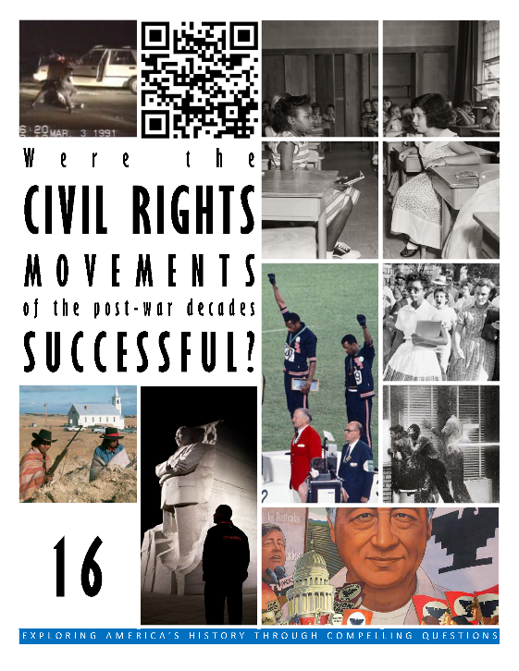  HCSSS STANDARDS  - SS.US.10.6.1 Evaluate the effectiveness of civil rights organizations and actions in overcoming racial segregation  - SS.US.10.6.4 Examine other movements that emerged in the late civil rights era  - SS.US.11.17.1 Analyze the rise of modern conservatism in the United States  - SS.US.12.8.1 Evaluate popular and government responses to emerging domestic challenges  TESTED TOPICS  - Jim Crow  - Segregation  - Little Rock Nine  - Pace of School Desegregation  - MLK’s Strategies  - SNCC  - Freedom Rides  - Birmingham  - March on Washington  - Civil Rights Act  - Freedom Summer  - Voting Rights Act  - 1960s Urban Riots  - Black Panthers  - Affirmative Action  - Mass Incarceration  - 1992 LA Riots  - Cesar Chavez  - ADA  - Stonewall Inn  - Obergefell v. Hodges | UNIT 16
 | Four Lessons
1: SCHOOL INTEGRATION
How did individuals advance the Civil Rights Movement?
- 1950s Civil Rights
- Brown v. Board of Education
- Little Rock Nine
- Ruby Bridges
- James Meredith
- University of Alabama

2: NARCHES & SUCCESSES
How did people work together to advance the Civil Rights Movement?
- Montgomery Bus Boycott
- Sit-ins
- Freedom Rides
- Albany
- Birmingham
- March on Washington
- Freedom Summer
- Selma

3: FRUSTRATION & VIOLENCE
Was violence an inevitable part of the Civil Rights Movement?
- Urban Riots
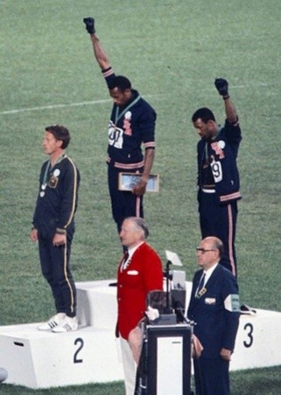
- Malcolm X
- Black Power
- Death of MLK
- Southern Strategy
- Bussing
- Affirmative Action
- War on Drugs
- Mass Incarceration
- Rodney King
- OJ Simpson

4: OTHER MOVEMEMNTS
What makes a movement successful?
- Chicano Movement
- Cesar Chavez
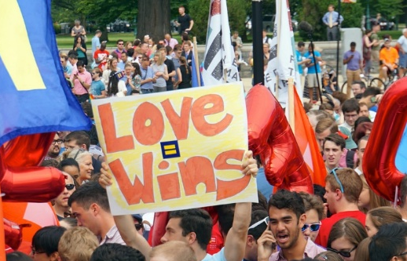
- AIM
- ADA
- Gay Rights Movement

THE CIVIL RIGHTS MOVEMENTS

Were the civil rights movements of the post-war decades successful?

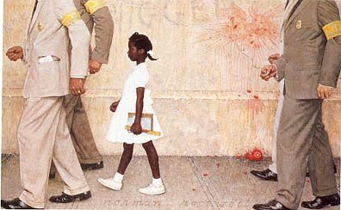
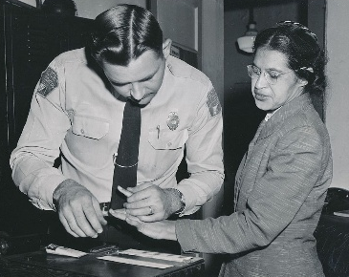
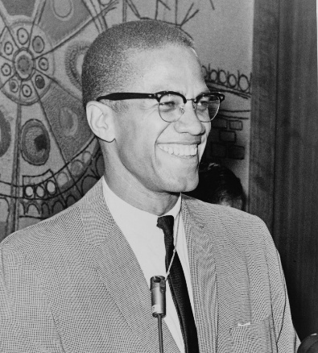
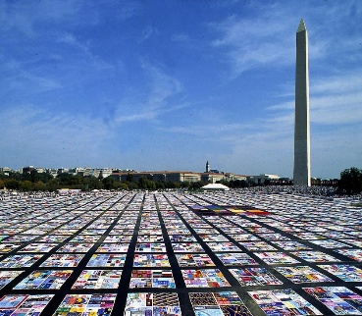
16-1: SCHOOL INTEGRATION
How did individuals advance the Civil Rights Movement?
TOPICS
- 1950s Civil Rights
- Brown v. Board of Education
- Little Rock Nine
- Ruby Bridges
- James Meredith
- University of Alabama

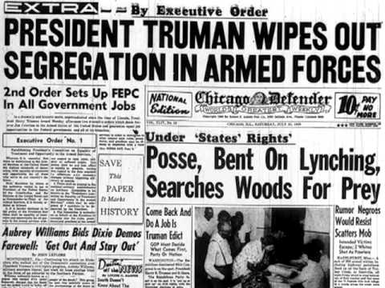
BIG IDEA: The Civil Rights Movement began slowly after WWII with the first big successes coming when the Supreme Court and then a few brave individuals ended school segregation.
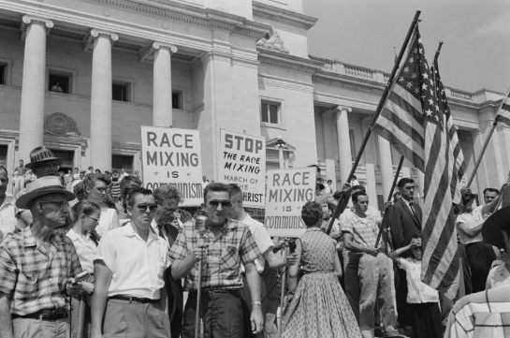
Jon’s Teaching Tips:
The idea that students might be prohibited from going to school because of race is strange to most of our current students. This is a great chance to explore some primary sources in order to build up this understanding. It is also a good opportunity to delve into the power of government to perpetuate injustice or promote justice.
THE LESSON BY THE NUMBERS
Reading Level: 11.1
Audio Time: 19:28
Vocabulary Terms: 15

Shorter and about as hard as most.

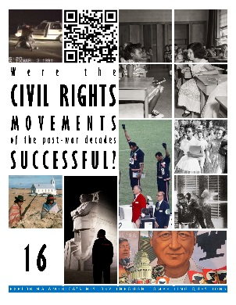
VOCABULARY

EVENTS
Battle of Oxford

PEOPLE & GROUPS
Jackie Robinson
Emmitt Till
National Association for the Advancement of Colored People (NAACP)
Thurgood Marshall
Earl Warren
Little Rock nine
Ruby Bridges
James Meredith
George Wallace

COURT CASES
Plessy v. Ferguson
Brown v. Board of Education of Topeka

LAWS
Jim Crow
Executive Order 9981
Separate but Equal
LESSON SUMMARY
African Americans have been working for their civil rights for generations. When slavery ended after the Civil War in 1865, three amendments to the Constitution were ratified that ended slavery, granted former slaves citizenship, and guaranteed voting rights to all men. However, a new system of laws was established in the South by White leaders who blocked these rights. African Americans lived as second-class citizens with no vote.
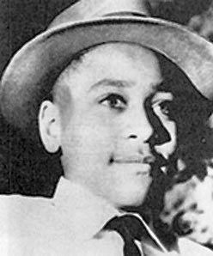
Segregation was a way of life in the South. African Americans could not eat in restaurants, go to movie theaters, or even drink from the same drinking fountains as Whites. Their children went to segregated schools and they rode in the back of city busses. This system was nicknamed Jim Crow.
In the early 1900s, African Americans had started working against this system, especially during the Harlem Renaissance of the 1920s.
Some progress was made in the 1940s after World War II. The first African Americans began playing for major league baseball teams. Also, President Truman desegregated the military and eliminated blacks-only units. However, when a young African American boy was murdered in the South, an all-White jury set his White killers free, and it was clear that segregation in the South would be hard to change.
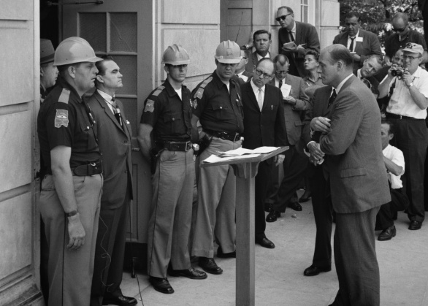
In 1954, the Supreme Court ruled that segregated schools were unconstitutional. This undid an older ruling. Despite their decision, most White leaders in the South refused to integrate their schools.
In Little Rock, Arkansas, nine African American students tried to enroll in high school. When mobs of Whites were going to attack them, President Eisenhower ordered the national guard to escort them to school.
Ruby Bridges became the first African American girl to attend her school when she enrolled in kindergarten. Federal marshals had to escort her to school so she would not be hurt by White mobs.
James Meredith became the first African American to attend the University of Mississippi. President Kennedy ordered the National Guard to escort him to school. For three days there was rioting as Whites tried to keep him out.
At the University of Alabama, the governor tried to stand in the doorway and prevent African Americans from enrolling.
16-2: MARCHES & SUCCESSES
How did people work together to advance the Civil Rights Movement?
TOPICS
- Montgomery Bus Boycott
- Sit-ins
- Freedom Rides
- Albany
- Birmingham
- March on Washington
- Freedom Summer
- Selma
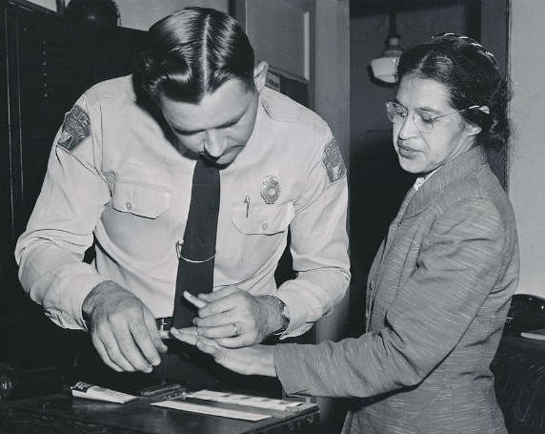
BIG IDEA: The Civil Rights Movement had its greatest successes in the early 1960s with mass demonstrations, marches and when Congress passed laws that ended Jim Crow segregation and voting restrictions.
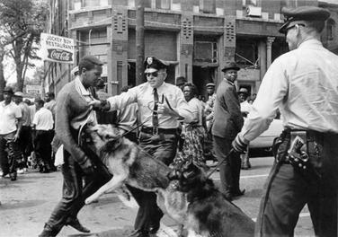
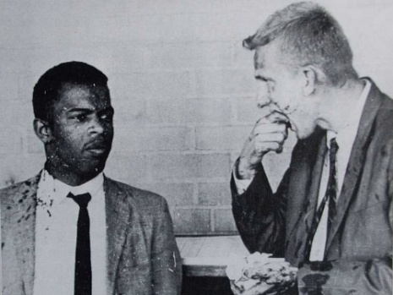
Jon’s Teaching Tips:
Many of these events are familiar to the students. It is important to delve into specific details and avoid mythologizing heroes. Students also don’t usually recognize the connects between the movements of the 50s and 60s and previous groundwork laid by the Niagara Movement, which is worth emphasizing because it helps them contextualize the events of the 60s into a larger story of African Americans.
THE LESSON BY THE NUMBERS
Reading Level: 11.7
Audio Time: 22:04
Vocabulary Terms: 27

Shorter and about as hard as most.

VOCABULARY

IDEAS
Nonviolence
Civil Disobedience
Sit-In
Open Letter

PEOPLE & GROUPS
Rosa Parks
Martin Luther King, Jr.
Coretta Scott King
Ralph Abernathy
Southern Christian Leadership Conference (SCLC)
Student Nonviolent Coordinating Committee (SNCC)
Congress of Racial Equality (CORE)
“Bull” Connor
Medgar Evers

EVENTS
Montgomery Bus Boycott
Civil Rights Movement
Freedom Rides
Albany Campaign
Birmingham Campaign
16th Street Baptist Church Bombing
March on Washington for Jobs and Freedom
Freedom Summer
Murder of Chaney, Goodman and Schwerner
Bloody Sunday

LETTERS & SPEECHES
Letter from a Birmingham Jail
I Have a Dream Speech

LAWS
Civil Rights Act of 1964
Voting Rights Act of 1965
LESSON SUMMARY
African Americans in the city of Montgomery, Alabama boycotted the city bus system for over a year to protest segregated seating on the busses. The boycott started when Rosa Parks was arrested for refusing to move to the back of the bus. Martin Luther King, Jr. became famous as the leader of the boycott. Eventually they won and the city ended segregation on the busses.
Martin Luther King, Jr. believed in nonviolence and civil disobedience. He founded SCLC to organize other protests. Other groups such as SNCC and CORE also were created and used nonviolence and civil disobedience.
Students staged sit-ins at lunch counters to protest Jim Crow laws that prevented them from eating at restaurants with Whites.
Freedom Riders rode busses through the South to protest segregated waiting rooms at bus stations. They were attacked in Alabama and the KKK bombed their bus. However, their protest convinced President Kennedy to call for a law to protect civil rights.
Martin Luther King, Jr. led a campaign in Albany, Georgia to desegregate the city. Large numbers of people marched and were arrested. Their effort failed, but they learned new strategies.
In Birmingham, Alabama, the White police chief ordered dogs and fire hoses to be used against civil rights marchers. Images of police brutality convinced many Americans that segregation was wrong and that they should support the civil rights marchers.
In 1963, Martin Luther King, Jr. gave a speech during a march in Washington, DC. He described a future for the United States when segregation and racism had been eliminated. He used the famous phrase “I have a dream.” The march convinced Congress to pass the Civil Rights Act.
In 1964, activists tried to register many African Americans in Mississippi to vote. Their activities were called Freedom Summer, but they faced extreme violence from Whites. When the KKK killed White supporters of the Civil Rights Movement, President Johnson ordered the FBI to investigate.
In 1965, Martin Luther King, Jr. led a march from the city of Selma, Alabama to the capital of Montgomery to protest for voting rights. Police officers attacked the marchers. Finally, President Johnson ordered the National Guard to protect the marchers and the protest convinced Congress to pass the Voting Rights Act.
16-3: FRUSTRATION & VIOLENCE
Was violence an inevitable part of the Civil Rights Movement?
TOPICS
- Urban Riots
- Malcolm X
- Black Power
- Death of MLK
- Southern Strategy
- Bussing
- Affirmative Action
- War on Drugs
- Mass Incarceration
- Rodney King
- OJ Simpson
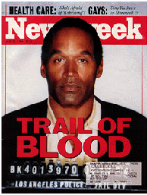
BIG IDEA: In the later 1960s African Americans grew impatient with the slow pace of change and riots and violent confrontations became more common. With the death of Martin Luther King Jr. in 1968 the Civil Rights Movement lost much of its energy. Events in the 1980s and 1990s showed just how much work was still left undone.
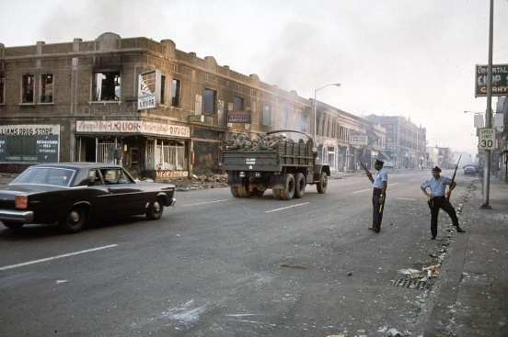
Jon’s Teaching Tips:
The urban riots of the 60s, Malcom X, Black Power, and the death of MLK are commonly found in textbooks and frequently taught. Connecting these events to the LA Riots and OJ Simpson Trial can be enlightening because the events of the 90s illustrate how little attitudes about race had changed and can lead to interesting questions about the impact of the celebrated events of the 60s.
THE LESSON BY THE NUMBERS
Reading Level: 11.3
Audio Time: 29.58
Vocabulary Terms: 27

About as long and as hard as most.

VOCABULARY

IDEAS
Black is Beautiful
Black Power
Southern Strategy
PEOPLE & GROUPS
Kerner Commission
Malcolm X
Nation of Islam
Black Muslims
Elijah Muhammad
Stokely Carmichael
James Brown
Huey Newton
Bobby Seale
Black Panther Party
Richard Nixon
Rodney King
OJ Simpson

EVENTS
The Long, Hot Summer
Black Power Salute at the 1968 Olympics
Assassination of Martin Luther King, Jr.
1968 Presidential Election
War on Drugs
1992 Los Angeles Riots
Trial of the Century

SPEECHES
I’ve Been to the Mountaintop
Can we all just get along?

GOVERNMENT POLICIES
Bussing
Affirmative Action
LESSON SUMMARY
African Americans in northern and western cities had suffered for decades. Their neighborhoods were poor and they had few job opportunities. Although they did not live in the South, their children attended poor schools and they faced discrimination when looking for jobs. Frustration boiled over in the 1960s and there were riots in cities such as Detroit, Los Angeles, and Newark.
A government commission studied the riots to understand what caused them and to make recommendations to prevent future riots. In the end, however, elected leaders did not implement the commission’s recommendations.
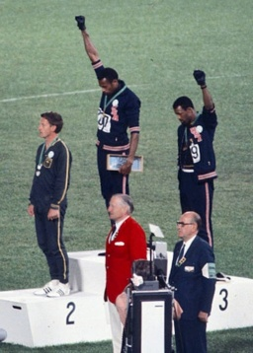
Malcolm X was a leader of the Nation of Islam, an organization of African American Muslims. He believed that African Americans and Whites could not live together and that the best way to improve their lives was to become self-reliant. After he went on a pilgrimage to Mecca and left the Nation of Islam, he began preaching a more inclusive message, but was killed by members of the Nation of Islam.
Some African Americans started to advocate Black Power in the later 1960s. They wanted African Americans to become self-reliant and to be proud. Some rejected nonviolence. One group, the Black Panthers, carried guns and promised to defend their neighborhoods from White police officers. The Black Power movement scared many Whites.
In 1968, Martin Luther King, Jr. was killed. Riots broke out in many cities as the news spread. King is remembered as one of America’s greatest leaders.
President Richard Nixon won election in 1968 by promising Whites in the South that he would not use the power of the federal government to promote civil rights. This was different from Democrats Kennedy and Johnson who had promoted new civil rights laws and had used the courts and National Guard to enforce civil rights. Nixon was not totally opposed to civil rights. He opposed bussing but promoted affirmative action.
In the 1980s, drug use increased and politicians promised to crack down. They passed strict laws and people arrested for selling and possessing drugs ended up in jail with long sentences. These laws affected African American neighborhoods much more so than Whites.
In 1991, Rodney King was beaten by Los Angeles police when he was arrested. The attack was captured on video, however, the police officers were acquitted when they were put on trial. When the verdict was announced, a long riot broke out.
In 1995, football star OJ Simpson was put on trial in Los Angeles for murder. He was also acquitted. The OJ Trial was a media obsession. Many African Americans celebrated the outcome, even though they believed he was guilty, since it seemed like the first time one of their own could win in the justice system that had been biased toward Whites for so long.
16-4: OTHER MOVEMENTS
What makes a movement successful?
TOPICS
- Chicano Movement
- Cesar Chavez
- AIM
- ADA
- Gay Rights Movement

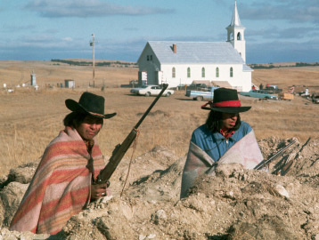
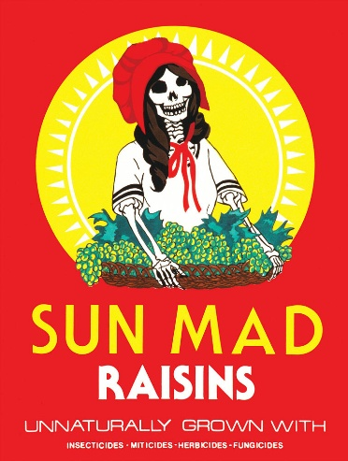
BIG IDEA: Other groups were inspired by the African Civil Rights Movement and worked to improve their own standing in society. Hispanics, disabled and LGBTQ Americans all worked successfully to advance their rights. While these movements were mostly peaceful, the American Indian Movement included violent confrontations with government.
Jon’s Teaching Tips:
These other movements provide an opportunity to compare motivations, strategies and outcomes and help the students see that not every movement is the same. They will be especially interested in the Gay Rights Movement since it is so recent.
THE LESSON BY THE NUMBERS
Reading Level: 13.2
Audio Time: 32:37
Vocabulary Terms: 36

Harder and longer than most.

VOCABULARY

IDEAS
Aztlán
Civil Union

PEOPLE & GROUPS
Cesar Chavez
Dolores Huerta
Larry Itliong
United Farm Workers
Delano Grape Strike and Boycott
La Raza Unida
Reies López Tijerina
Rodolfo “Corky” Gonzales
Dennis Banks
George Mitchell
American Indian Movement (AIM)
Russell Means
Leonard Peltier
Harvey Milk

EVENTS
Chicano Movement
Occupation of Alcatraz Island
Trail of Broken Treaties
Occupation of Wounded Knee
Capitol Crawl
Lavender Scare
Stonewall Inn Riots
AIDS Memorial Quilt

SPEECHES
Evil Empire Speech
Tear Down This Wall

LAWS & POLICIES
Indian Self-Determination and Education Assistance Act of 1975
Americans with Disabilities Act (ADA)
Don’t Ask, Don’t Tell
Defense of Marriage Act (DOMA)
LESSON SUMMARY
Hispanic Americans had won important victories in the court system in the 1940s and 1950s similar to victories won by African Americans. However, the biggest victories were because of the work of Cesar Chavez and the United Farm Workers in California. They led a strike and boycott against grape growers and eventually won using nonviolence.
The Chicano Movement was a broader nationwide effort to promote Hispanic rights, identity and pride. It included organizing political groups, fighting for rights in the courts, and new music and art.
Native American activists formed AIM in 1968 to campaign for their rights. AIM occupied Alcatraz Island, led a march to Washington, DC where they occupied the offices of the Bureau of Indian Affairs and also led a standoff at Wounded Knee. In each of these cases, their movement was more violent than the African American and Hispanic efforts. However, laws were passed that gave Native American tribes more control over their land and finances, and the movement led to an increased sense of pride.
Disability rights activists worked to pass the Americans with Disabilities Act (ADA). They succeeded in 1990 and now business and organizations have to ensure that their buildings and services are accessible to people with disabilities. There is still some opposition to the law from groups who believe the requirements (such as installing elevators) are too expensive.
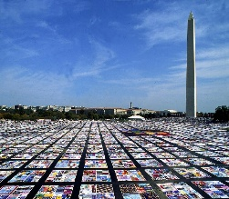
The gay rights movement stated in 1968 when police raided a gay bar in New York City and the customers fought back. The movement gained momentum due to the AIDS crisis in the 1980s when the disease first spread among gay men.
During the Red Scare of the 1950s, a law was passed to prohibit homosexuals from working for the government. In the 1990s, President Clinton implemented “don’t ask, don’t tell” which allowed homosexual Americans to serve in the military so long as they did not reveal their sexual orientation. This policy did not end until 2011. Today homosexual Americans can serve openly in the military and government.
COURT CASES
Mendez v. Westminster
Hernandez v. Texas
Madrigal v. Quilligan
Obergefell v. Hodges

SCIENCE
AIDS
Also during the 1990s, Americans started to debate gay marriage. Some states began allowing gay marriage while others banned it. A federal law allowed states to ignore gay marriages passed in other states. Eventually in 2015, the Supreme Court ruled that gay marriage was a constitutional right.
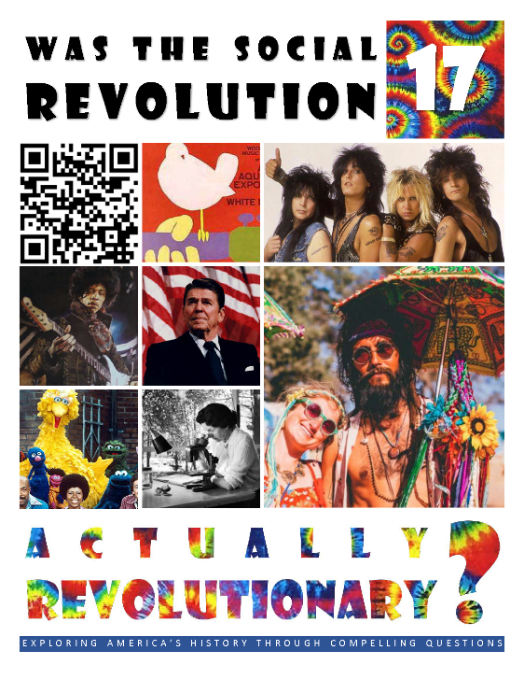  HCSSS STANDARDS  - SS.US.10.6.3 Assess the impact of student movements and counter culture on American politics and society  - SS.US.10.11.2 Evaluate the impact of Great Society-era policies in addressing economic, social, and environmental conditions  - SS.US.11.17.1 Analyze the rise of modern conservatism in the United States  - SS.US.11.8.2 Assess the social and political impact of conservatism in the United States  TESTED TOPICS  - 1950s Characteristics  - Rock and Roll  - Television  - Beatniks  - San Francisco as the center of the Counterculture  - Johnson and Congress  - Medicare  - War on Poverty  - Great Society Limitations  - Immigration Changes  - Warren Court  - Silent Spring  - Climate Change Treaties  - Opposition to Environmentalism  - Betty Friedan  - ADA Debate  - Glass Ceiling  - Title IX  - Roe v. Wade  - Reaganomics  - Culture Wars | UNIT 17
 | Six Lessons
1: The 1950s
Can we be happy if we’re all the same?
- Economic Boom
- Medical Advances
- Political Stability
- GI Bill
- Baby Boom
- Suburbs
- Religious Participation
- TV
- Rock and Roll
- Groups Left Out
- Social Critics (Beatniks, Hollywood Rebels, Artists)

2: THE COUNTERCULTURE
Was the counterculture un-American?
- Summer of Love
- Free Love
- Drugs
- Hippie Style
- Merry Pranksters
- Communes
- Music
- Woodstock
- Altamont
- Legacy

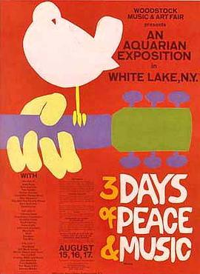
3: THE GREAT SOCIETY
Can we end poverty?
- Death of JFK
- LBJ
- Great Society
- War on Poverty
- Immigration Law
- Warren Court

4. ENVIRONMENTALISM
Can we save the Earth?
- Rachel Carson
- LBJ
- Earth Day
- Champions of Environmentalism
- Climate Change

THE SOCIAL REVOLUTION

Was the Social Revolution actually revolutionary?
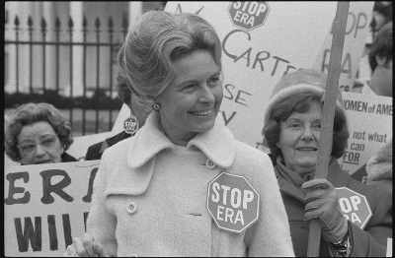
5: THE FEMINIST MOVEMENT
Can men and women be equal?
- Civil Rights Act
- ERA
- Radical Feminism
- Birth Control
- Abortion
- Divorce
- Title IX
- Glass Ceiling
- Women in the Armed Forces

6: THE CONSERVATIVE REVOLUTION
Why did Americans turn away from liberalism?
- New Right
- Heritage Foundation
- Religious Right
- Reagan Coalition
- Reaganomics
- Culture Wars
- Judiciary
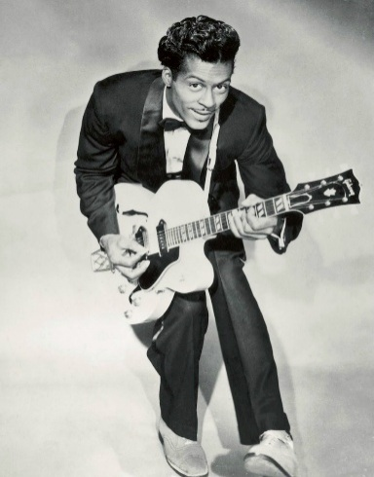
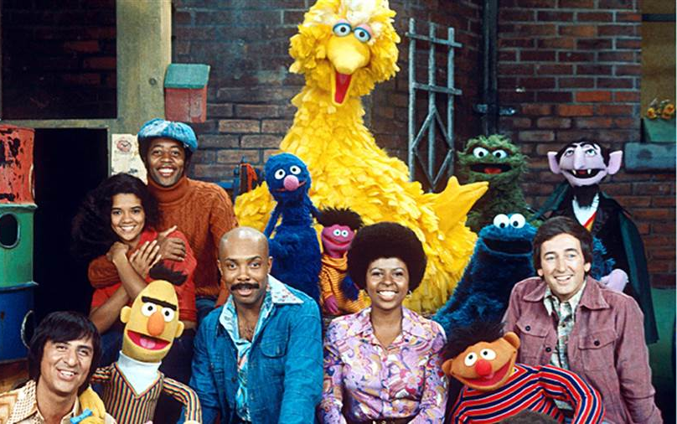
17-1: THE 1950s
Can we be happy if we’re all the same?
TOPICS
- Economic Boom
- Medical Advances
- Political Stability
- GI Bill
- Baby Boom
- Suburbs
- Religious Participation
- TV
- Rock and Roll
- Groups Left Out
- Social Critics (Beatniks, Hollywood Rebels, Artists)
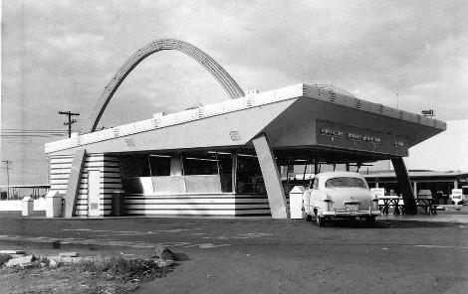
BIG IDEA: The 1950s are remembered as a good time for most Americans. The economy was doing well, and people were happy to have new houses, cars, and modern appliances. However, there were underlying problems for some groups who were left out of these happy days, and because happiness also meant conformity.
Jon’s Teaching Tips:
This unit tells the story of a shift from conservatism to liberalism and back again. Without teaching the 50s, that story is lost. The conformity that characterized the 50s is interesting to the students and is easily demonstrated with photographs or television clips from the era.
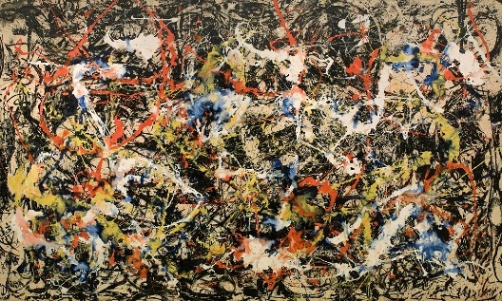
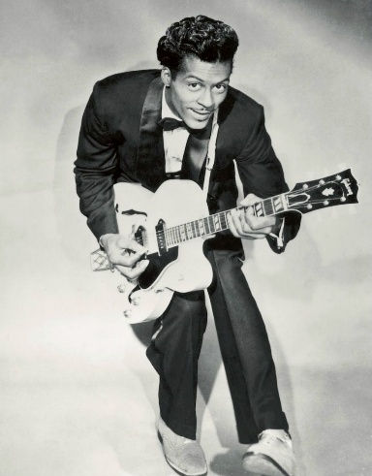
THE LESSON BY THE NUMBERS
Reading Level: 11.6
Audio Time: 40:48
Vocabulary Terms: 26

About as hard but longer than most.

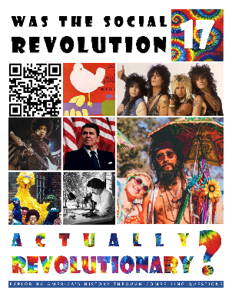

IDEAS
Middle Class
Green Revolution
Corporatization
Consolidation
Modern Republicanism
Mortgage
Tuition
American Dream
Urban Sprawl
1950s Ideal Family

PLACES
Suburbs
Levittown
Interstate Highway System
Shopping Center
Fast Food Restaurant

ARTS
I Love Lucy
Westerns
Gunsmoke
Rhythm and Blues (R&B)
Rock and Roll
Dick Clark’s American Bandstand
The Ed Sullivan Show
Bebop
Abstract Expressionism

LITERATURE
Invisible Man
Howl
On the Road
The Catcher in the Rye

LAWS & POLICIES
G.I. Bill
Operation Wetback

LESSON SUMMARY
VOCABULARY

PEOPLE & GROUPS
Blue-Collar Workers
Dr. Jonas Salk
Dwight Eisenhower
Baby Boomers
William Levitt Billy Graham
Elvis Presley
Ralph Ellison
Beatnik
John Coltrane
Charlie Parker
Dizzy Gillespie
Thelonious Monk
Dave Brubeck
Allen Ginsberg
American Civil Liberties Union (ACLU)
Jack Kerouac
Willem de Koonigh
Hans Hoffman
Mark Rothko
Jackson Pollock
Marlon Brando
James Dean
J.D. Salinger
Edward Hopper

COURT CASES
Everson v. Board of Education
Engel v. Vitale

SCIENCE
Polio
Penicillin
Most Americans have happy memories of the 1950s. During the 1950s, the economy boomed. Middle class and blue-collar workers all did well. For the first time ever, most Americans could afford houses, cars, and new inventions like televisions. The interstate highway system was built, encouraging automobile purchasing, and the use of fertilizers led to abundant harvests. New advances in medicine helped people live longer.
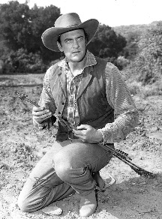
Politically, the 1950s were stable. Eisenhower was president and he kept the government from spending too much, while also not reducing popular programs like Social Security. Although it was the height of the Cold War arms race, Eisenhower ended the Korean War and kept the nation out of any hot conflicts.
The G.I. Bill helped veterans of World War II buy houses and attend college. For the first time, both became common. Those same veterans came home and started families. Their children, the Baby Boomers, are one of the nation’s largest generations ever. To house these families, suburbs were built. Cities grew, shopping malls, and fast food restaurants sprung up. It was a time of huge population growth in California.
People in the 1950s became more religious. More Americans went to church. However, the Supreme Court also limited the influence of religion in schools, banning school prayer for example.
In the 1950s, there was tremendous pressure for people to live up to an ideal. Families were supposed to have married parents, with a dad who worked and a mom who stayed home to raise polite children. They were supposed to have a house in the suburbs and a car.
Television was new and promoted this idealized version of family. Sitcoms were popular. Westerns were also popular in which good could always triumph over evil.
Rock and roll was new in the 1950s. Although based on African American traditions like rhythm and blues, it was first popularized by Elvis Presley.
Not everyone enjoyed the prosperity of the 1950s. The elderly, women, African Americans and other minorities did not benefit from the G.I. Bill.
The Beatniks rejected the conformity of the 1950s. Centered in San Francisco and New York City, they preferred a new form of jazz called bebop and criticized mainstream culture. The Beat Generation created some of the best literature of the 1950s. Those who did not want to conform also popularized abstract expressionism, a new style in art. Some movies of the 1950s similarly portrayed the darker side of society.

17-2: THE COUNTERCULTURE
Was the counterculture un-American?

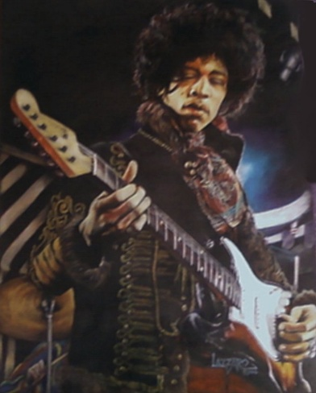
BIG IDEA: The Counterculture of the 1960s was a youth movement that focused on finding oneself and breaking social rules, especially related to love, music, fashion and drugs. It was centered in San Francisco, influenced by the anti-war movement, and fueled by new music.
TOPICS
- Summer of Love
- Free Love
- Drugs
- Hippie Style
- Merry Pranksters
- Communes
- Music
- Woodstock
- Altamont
- Legacy
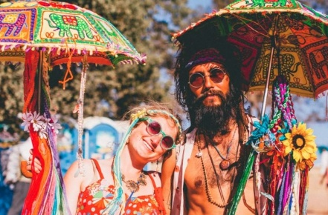
Jon’s Teaching Tips:
This topic is fascinating to most students. Especially important is the conflict between the Greatest Generation and the Baby Boomers since it will reappear again when the students study the Vietnam War. Like with the 50s, primary sources are a great way to build understanding.
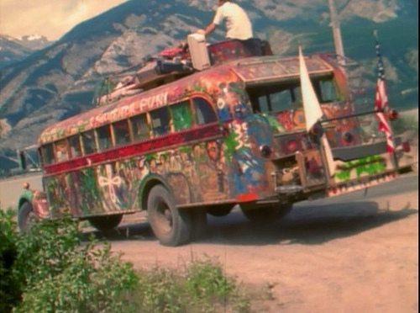
THE LESSON BY THE NUMBERS
Reading Level: 10.8
Audio Time: 26:05
Vocabulary Terms: 30

Easier but about as long as most.

VOCABULARY

IDEAS
Free Love

PEOPLE & GROUPS
Hippies
Diggers
Timothy Leary
Merry Pranksters
Grateful Dead
Jefferson Airplane
The Doors
The Beatles
Bob Dylan
Janice Joplin
The Mamas & the Papas
Simon & Garfunkel
Sonny & Cher
Peter, Paul & Mary
Jimi Hendrix

EVENTS
Summer of Love
Love-In
Woodstock
Altamont

PLACES
Haight-Ashbury
Communes
The Farm

BOOKS
The Electric Kool-Aid Acid Test
Whole Earth Catalogue

ARTS
Psychedelic Art
Psychedelic Rock
Folk Rock

SCIENCE
Marijuana
LSD
LESSON SUMMARY
The counterculture refers to a time during the 1960s when many young Americans rebelled against the traditional rules of society. The idea of rebellion was not new. In some way, they were continuing the legacy of the Beat Generation of the 1950s. However, the hippies of the counterculture were much more widely known and far more influential.
Fueled by the emergence of the Baby Boomer generation as teenagers, the counterculture, its music, art, fashion, and political ideas shaped the entire generation.
The counterculture was centered in the Haight-Ashbury neighborhood of San Francisco. The climax of the entire movement was during the summer of 1967.
Hippies rebelled against many social norms. They experimented with new drugs, especially marijuana and LSD.
The hippies broke social rules about sex and marriage. They practiced free love and participated in love-ins.
The Merry Pranksters were a group of hippies who travelled from California to New York in an old school bus. Joined by popular musicians, they tried to demonstrate the ideas of the counterculture and recorded their experience.
Some hippies rejected modern life all together and tried to create perfect societies in communes where they shared property, and sometimes, sexual partners.
Rock and roll changed with the counterculture. Psychedelic rock became popular, as did folk rock. Music was an important part of the identity of the decade and the movement. For some, the climax of the counterculture was the Woodstock Music Festival in 1969.
The Altamont Music Festival in 1969 was the opposite of the Woodstock Festival and showed all of the dark sides of the counterculture. The organizers hired a biker gang to run security, drug use was rampant, and violence ensued.

17-3: THE GREAT SOCIETY
Can we end poverty?

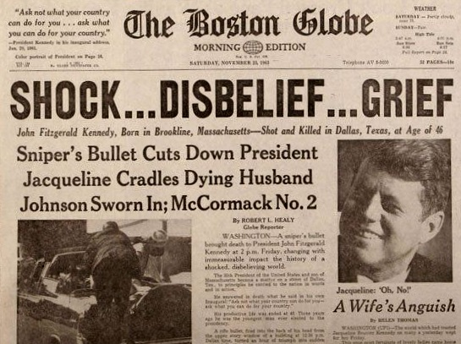
BIG IDEA: The federal government joined in the efforts to remake American society in the 1960s. President Lyndon Johnson's Great Society programs were meant to end poverty, protect healthcare and protect the environment. The Supreme Court handed down important rulings about civil rights and criminal justice and the immigration system was significantly changed.
TOPICS
- Death of JFK
- LBJ
- Great Society
- War on Poverty
- Immigration Law
- Warren Court
Jon’s Teaching Tips:
The Great Society and Warren Court include so many topics, dates, cases, etc. that it can feel overwhelming for many students. Focus on the overall idea that they represent the height of liberalism in government. This also provides an opportunity to ask the students what they believe is the appropriate role of government in society.
THE LESSON BY THE NUMBERS
Reading Level: 12.4
Audio Time: 33:56
Vocabulary Terms: 20

Harder and longer than most.

VOCABULARY

IDEAS
Miranda Warning

PEOPLE & GROUPS
Lee Harvey Oswald
Warren Commission
Earl Warren
Warren Court
Public Defender

EVENTS
Assassination of John F. Kennedy

PLACES
Dealey Plaza

LAWS
Elementary and Secondary Education Act (ESEA)
Immigration and Nationality Act of 1965

COURT CASES
Gideon v. Wainwright
Miranda v. Arizona

GOVERNMENT PROGRAMS & AGENCIES
The Great Society
War on Poverty
Jobs Corps
Head Start
Medicare
Medicaid
National Endowment for the Arts
Corporation for Public Broadcasting
LESSON SUMMARY
In 1963, President John F. Kennedy was assassinated by Lee Harvey Oswald while riding through Dallas, Texas in an open limousine. A man seeking to avenge the president’s death killed Oswald a few days later. The Warren Commission investigated the killing and found that Oswald had acted alone, but Kennedy’s death remains the subject of conspiracy theories.
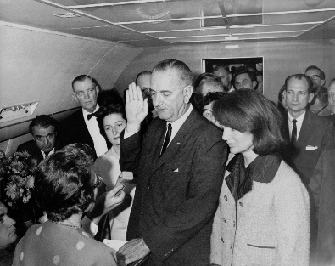
The new president was Lyndon Johnson from Texas. Johnson was a long-time member of Congress and a master at convincing others to agree with him.
Johnson continued many of Kennedy’s programs. He also wanted to improve the nation and believed America should be a Great Society.
Johnson declared a War on Poverty. He signed many laws that were designed to end poverty, mostly by giving people the education or support they needed to find jobs, rather than just by giving away money.
Johnson signed the ESEA, which provided federal funding for education. This was the first time the federal government got involved in funding local schools. He also created Head Start for low-income preschoolers and increased federal scholarships and loans for college.
Johnson created Medicare to cover health insurance for the elderly and Medicaid to provide health insurance for the poor. Both programs remain popular and account for about a quarter of the entire federal budget.
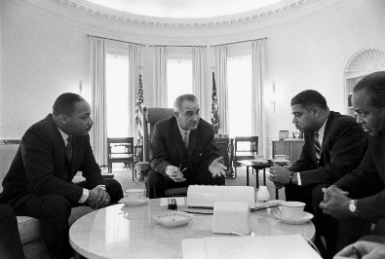
Johnson’s Great Society included federal funding for the arts, including funding for public radio and television.
Johnson also passed laws to protect consumers, such as regulations on automobile safety, truth in packaging, and financial disclosures.
Johnson signed the Immigration and Nationality Act, which ended national quotas for immigration and implemented a family reunification policy. This greatly increased immigration from Asia and Africa.
The Great Society and Johnson’s War on Poverty were limited because Johnson was also spending money to fight the Vietnam War. Conservatives criticize the Great Society programs as excessive government.
During the 1960s, the Supreme Court under Chief Justice Earl Warren ruled on multiple cases that expanded civil rights, including Brown v. Board of Education, as well as cases that led to the creation of the Miranda Warning.
17-4: ENVIRONMENTALISM
Can we save the Earth?

BIG IDEA: The environmental movement as we know it today started in the 1960s. Over time the focus has shifted from preserving natural wonders to preventing pollution to mitigating the effects of climate change. In recent decades, significant opposition to the environmental movement has emerged.
TOPICS
- Rachel Carson
- LBJ
- Earth Day
- Champions of Environmentalism
- Climate Change
- Critics and Opponents
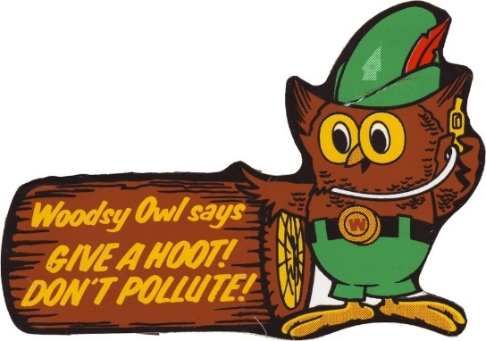
Jon’s Teaching Tips:
This lesson encompasses a long stretch of history. Rather than splitting the contemporary environmental movement from the efforts of the past, it is included here, so help the students see how the movement changed over time. But watch out, the recent debates about climate change are politically charged!
THE LESSON BY THE NUMBERS
Reading Level: 13.6
Audio Time: 29:08
Vocabulary Terms: 19

Harder but about as long as most.

VOCABULARY

EVENTS
Cuyahoga River Fires
Earth Day

PEOPLE & GROUPS
Rachel Carson
Lady Bird Johnson
Woodsy Owl
Greenpeace
World Wildlife Fund (WWF)
Al Gore

LAWS & TREATIES
Clean Air Act
Clean Water Act
Kyoto Protocol
Paris Agreement

BOOKS
Silent Spring
An Inconvenient Truth

SCIENCE
DDT
Greenhouse Gas
Global Warming
Climate Skepticism

GOVERNMENT AGENCIES
Environmental Protection Agency (EPA)
LESSON SUMMARY
Americans have been concerned with preserving the environment since the Progressive Era when President Theodore Roosevelt launched the National Park Service and John Muir founded the Sierra Club.
During the Great Depression FDR implemented the CCC and dealt with the Dust Bowl and during the 1950s people worked to stop construction of a dam that would have partially filled in the Grand Canyon.
The modern environmental movement started when Rachel Carson wrote Silent Spring and helped Americans become aware of the dangers of the pesticide DDT. Her work led to the creation of the Environmental Protection Agency.
President Johnson and his wife Lady Bird Johnson both cared about the environment and the Clean Air and Clean Water Acts were part of Johnson’s Great Society.
During the 1960s and 1970s the environmental movement grew. Earth Day was started and new non-governmental organizations were founded to fight for conservation.
In modern times, climate change is the most pressing concern. International agreements such as the Kyoto Protocol and Paris Agreement have implemented goals for carbon emission reduction. Different presidents have chosen to join or withdraw from these agreements.
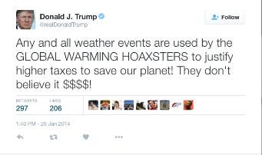
Some people reject the overwhelming science that supports human-induced climate change. These climate skeptics were originally funded by business groups who will lose money if carbon emissions are reduced. Republican politicians, including President Trump, promote the ideas of climate skeptics and work to block environmental regulation. Most Democrats, like former Vice President Al Gore, advocate for regulations to limit climate change.
17-5: THE FEMINIST MOVEMENT
Can men and women be equal?
TOPICS
- Civil Rights Act
- ERA
- Radical Feminism
- Birth Control
- Abortion
- Divorce
- Title IX
- Glass Ceiling
- Women in the Armed Forces
BIG IDEA: The fight for women's rights is as old as the United States itself. At different periods there has been more excitement and successes. In the 1960s and 70s another wave of feminist zeal emerged. This Third Wave Feminism correlated with changes in reproductive rights and social expectations, especially related to the workplace.
Jon’s Teaching Tips:
Your female students will be very happy to have their story once again reappear in the class. It’s useful and revealing to help everyone realize just how many of the things they take for granted, such as no-fault divorce and girls sports and recent developments. Be careful not to let your own beliefs and biases influence your teaching when it comes to abortion. Remember, this is a class about history and it’s up to the students to decide what they believe is right and wrong, not for us to indoctrinate.
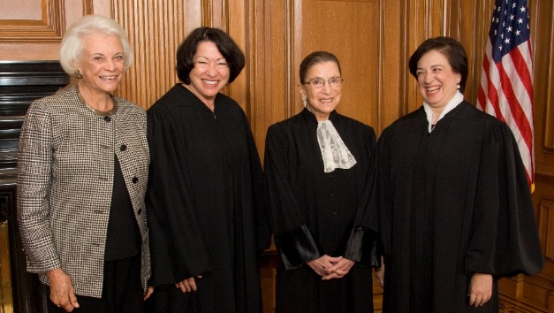
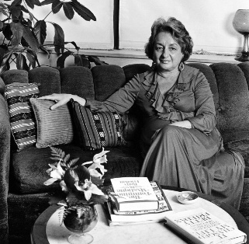
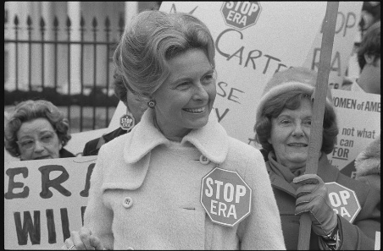
THE LESSON BY THE NUMBERS
Reading Level: 11.4
Audio Time: 42:53
Vocabulary Terms: 41

About as hard but longer than most.

VOCABULARY

IDEAS
Cult of Domesticity
Sexism
Pro-Life
Pro-Choice
Litmus Test
Glass Ceiling

EVENTS
Seneca Falls Convention
Second Wave Feminism
Miss America Pageant
Bra Burning

PEOPLE & GROUPS
Abagail Adams
Betty Friedan
Gloria Steinem
Germaine Greer
National Organization for Women (NOW)
Alice Paul
Phyllis Schlafly
Margaret Sanger
National Right to Life Committee
National Abortion Rights Action League
Planned Parenthood
Hillary Clinton
Sandra Day O’Connor

COURT CASES
Griswold v. Connecticut
Eisenstadt v. Baird
Roe v. Wade
Kirchberg v. Feenstra

SCIENCE3
Birth Control
Birth Control Pill
Abortion
LESSON SUMMARY
Women have been fighting for equal rights since before the United States existed. In the early 1800s, women met at the Seneca Falls Convention and started working for the right to vote. However, at the same time the industrial revolution gave rise to the Cult of Domesticity, which established different roles for men and women in society. Women were supposed to stay at home to cook, clean, and care for children. Women finally won the right to vote in 1920 with the passage of the 19th Amendment.
In the 1960s, Second Wave Feminism started with the publication of Betty Friedan’s book The Feminine Mystique. She criticized the Cult of Domesticity and challenged the idea that women should be happy as homemakers and mothers.
Laws such as the Civil Rights Act and Equal Pay Act gave women more rights. The National Organization for Women (NOW) started working to pass a constitutional amendment to guarantee women equal rights. The Equal Rights Act (ERA) was never ratified because Phyllis Schlafly organized a movement to stop it. She argued that equal rights would hurt women.
Some radical feminists demonstrated by burning bras or protesting at the Miss America Pageant.
A major change for women in the 1950s was the legalization of birth control. This helped contribute to the sexual revolution of the counterculture and made sex outside of marriage much more common.
The legalization of abortion with the Roe v. Wade Supreme Court ruling in 1973 was another major turning point for women. Abortion is still controversial and pro-life and pro-choice organizations and politicians continue to fight about it.
In the 1960s and 1970s, divorce laws changed so that women could divorce and maintain control of property and child custody. This greatly increased the rates of divorce since women could escape bad relationships and not have to leave their children or be cast into poverty.
Title IX guaranteed equal opportunities for girls in schools that received federal funding. This led to an increase in school sports for girls.
LAWS & POLICIES
19th Amendment
Equal Pay Act of 1964
Civil Rights Act of 1964
Maternity Leave
Equal Rights Amendment (ERA)
Right-to-Life Amendment
Hyde Amendment
No-Fault Divorce
Title IX
LETTERS & BOOKS
“Remember the Ladies”
The Feminine Mystique
The glass ceiling is an imaginary boundary women cannot pass in government and politics. So far, no woman has ever been president, only five have been on the Supreme Court, and few have ever been company CEOs.
Women can now serve in any role in the armed forces, but this is a recent change. The role women played in the 1991 Persian Gulf War helped break down these barriers.
17-6: THE CONSERVATIVE REVOLUTION
Why did Americans turn away from liberalism?

BIG IDEA: There was a backlash in the 1970s and 80s to the extreme liberalism of the 1960s. Americans elected conservative politicians and the culture wars emerged as an element of partisan politics.
TOPICS
- New Right
- Heritage Foundation
- Religious Right
- Reagan Coalition
- Reaganomics
- Culture Wars
- Judiciary
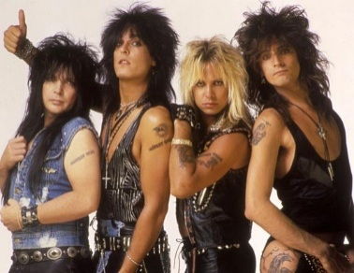
Jon’s Teaching Tips:
The rise of conservativism is best understood as a reaction to the liberalism and sweeping changes of the 60s. Make sure to spend some time explaining Reaganomics since most students have no understanding of this. If they remember the New Deal, you can use a compare/contrast strategy here. Also, it is a good chance to have your students do one of the many online political party surveys to help them find out where they fall on the political spectrum.
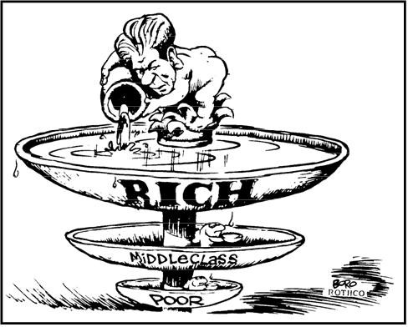
THE LESSON BY THE NUMBERS
Reading Level: 11.9
Audio Time: 25:29
Vocabulary Terms: 35

About as hard and as long as most.

VOCABULARY

IDEAS
Liberal
Big Government
Left
Conservative
Small Government
Right
New Right
Religious Right
Liberal Media

PEOPLE & GROUPS
Barry Goldwater
Heritage Foundation
William Buckley
Pat Robertson
Jerry Falwell
Moral Majority
Values Voters
Law and Order Candidate
Yuppie
Reagan Democrats
The Great Communicator
Pat Buchanan
William Rehnquist
Antonin Scalia
Anthony Kennedy

EVENTS
Vatican II
Firing of the Air Traffic Controllers
Culture Wars

ECONOMIC CONCEPTS
Reaganomics
Supply-side Economics
Trickledown Economics
Voodoo Economics
Deregulation

LESSON SUMMARY
The Great Society programs were examples of the liberal idea that government should do a lot to fix problems in society. Also, during the 1960s, the counterculture was challenging traditional social norms. In the 1970s, Americans turned away from these liberal extremes and embraced ideas that are more conservative. This was the Conservative Revolution.
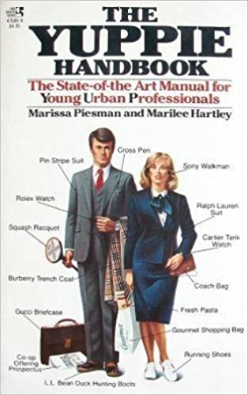
The first champions of conservative ideas were academics and Senator Barry Goldwater who lost his campaign for president in 1964. They started the New Right. In 1980, Ronald Reagan won the presidency. He was a champion of conservative ideas about taxes, government spending, and social norms.
Reagan was supported by traditional Republican voters as well as some former Democrats who were upset about high crime, the poor economy, and the counterculture.
Reagan promoted trickle-down economics. He wanted tax breaks for the wealthy and businesses. He believed this would create economic growth because businesses would have more to spend to hire workers and that eventually everyone would benefit. Reagan also cut government spending and regulation.
In the 1980s, culture wars raged. Social conservatives tried to censor music and promoted conservative candidates in elections.
LAWS & POLICIES
Economic Recovery Tax Act

SPEECHES
Government is not the solution to our problem; government is the problem
Reagan nominated conservatives to the Supreme Court.
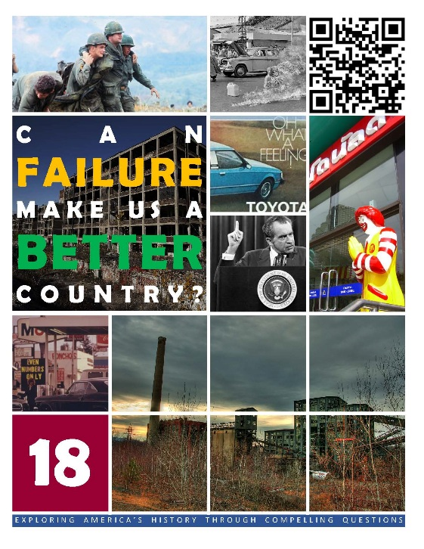  HCSSS STANDARDS  - SS.US.9.17.2 Analyze how U.S. foreign policy during the Cold War shaped conflicts in Asia and the Americas  - SS.US.10.6.3 Assess the impact of student movements and counter culture on American politics and society  - SS.US.11.17.1 Analyze the rise of modern conservatism in the United States  - SS.US.11.8.2 Assess the social and political impact of conservatism in the United States  - SS.US.12.8.1 Evaluate popular and government responses to emerging domestic challenges  TESTED TOPICS  - Vietnam and Containment  - Debate about Vietnam  - Tet Offensive  - Anti-war Movement  - MLK Anti-war Movement  - Vietnam on Television  - Kent State Massacre  - My Lei  - Vietnamization  - Vietnamese Boat People  - 26th Amendment  - Pentagon Papers  - The Plumbers and CREEP  - Watergate  - Trust in Government  - Iran Hostage Crisis  - Globalization  - Anti-Globalization  - NAFTA  - Outsourcing | UNIT 18
 | Three Lessons
1: VIETNAM
Why didn’t we win our war in Vietnam?
- Domino Theory
- French Decolonization
- Gulf of Tonkin
- Opposition
- 1968 Election
- My Lai
- Americanization
- End of the War
- Effects

2: SCANDALS
Should we trust our nation’s leaders?
- Pentagon Papers
- Nixon’s Reelection
- Watergate
- Iran Hostage Crisis
- Three Mile Island

3: GLOBALIZATION
Is it bad for America that so few of the things we buy are made here?
- Nixon Shock
- Stagflation
- Imported Cars
- Energy Crisis
- The Great Malaise
- Globalization
- Rust Belt
- Trade Treaties and Organizations
- Anti-Globalization
 | 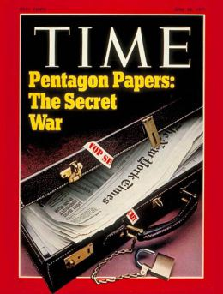

FAILURES

Can failure make us a better country?

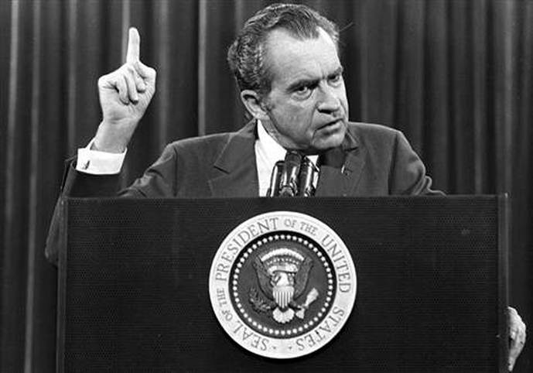
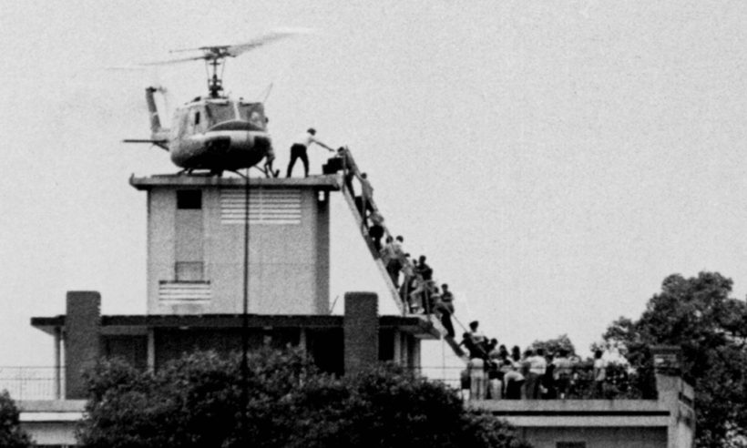
18-1: VIETNAM
Why didn’t we win our war in Vietnam?

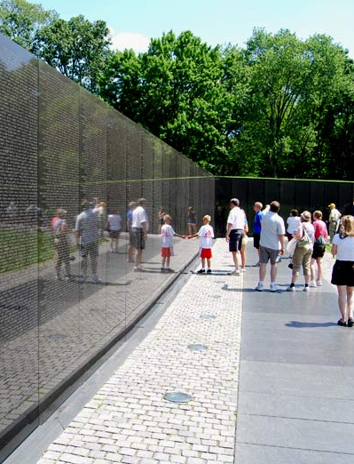
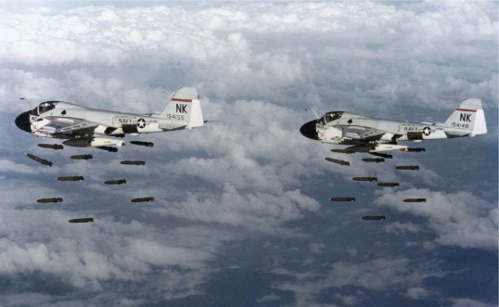
BIG IDEA: The United States first became involved in the Vietnam War because of Cold War fears about the spread of communism. Over time it became harder and harder to exit the conflict and eventually it led to major civil unrest at home as a youth-driven anti-war movement grew. America had to exit the conflict without winning.
TOPICS
- Domino Theory
- French Decolonization
- Gulf of Tonkin
- Opposition
- 1968 Election
- My Lai
- Americanization
- End of the War
- Effects

Jon’s Teaching Tips:
This is a big topic and it is tempting to spend a lot of time on the Vietnam War. But remember, for our students, this conflict is 50 years in the past and more recent conflicts in Iraq and Afghanistan overshadow it in importance to their lives. Looking at the war as a noble cause gone wrong and at the social impacts is helpful. It is also a good chance to have the students explore the challenges of nation-building since it previews more recent wars.
THE LESSON BY THE NUMBERS
Reading Level: 11.3
Audio Time: 37:05
Vocabulary Terms: 34

About as hard but longer than most.

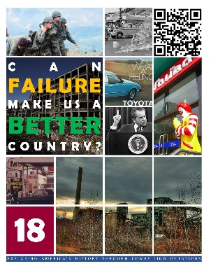
VOCABULARY

IDEAS
Baby Killer
Vietnam Syndrome
Rich man’s war and a poor man’s fight

PEOPLE & GROUPS
Ho Chi Minh
Viet Minh
Ngo Dinh Diem
Thich Quang Duc
Robert McNamara
Viet Cong
William Westmoreland
Walter Cronkite
Students for a Democratic Society
Muhammad Ali
Vietnamese Boat People
Maya Lin

EVENTS
Assassination of Diem
Operation Rolling Thunder
Tet Offensive
1968 Democratic Primary
My Lai Massacre
Invasion of Cambodia
Columbia University Protest
Kent State Shooting
Jackson State Shooting
Operation Frequent Wind
Surrender of South Vietnam

PLACES
Free-Fire Zones
Ho Chi Minh Trail
Vietnam War Memorial

SCIENCE
Agent Orange

LESSON SUMMARY
The United States initially became involved in Vietnam because of Cold War fears about the spread of communism. Most American leaders saw Vietnam as another Korea. That is, the United States would have to fight to prevent Vietnam from falling to communists or else neighboring countries such as Cambodia, Laos, or even the Philippines might fall to communists as well. This was the Domino Theory.
Although American advisors had been in South Vietnam for years, Americans did not become heavily involved in fighting until 1964 when Congress passed the Gulf of Tonkin Resolution and gave President Johnson authority to carry out combat operations.
Vietnam turned out to be more complicated than Korea. The Vietnamese were fighting a war for independence and American soldiers were often viewed as foreigners to be expelled rather than as protectors. Furthermore, Ngo Dinh Diem, the leader of non-communist South Vietnam was an unpopular leader for a variety of reasons, whereas Ho Chi Minh, the communist leader of North Vietnam was beloved.
To make matters worse, the Americans faced an enemy that used guerilla warfare. Unable to adapt, the Americans ended up doing significant harm to the civilian population, further alienating potential allies.
As the war dragged on through the later 1960s and into the 1970s, Americans began to doubt the rationale for fighting the war and a vocal anti-war movement emerged, especially on college campuses. Violent clashes between protesters and police focused attention on the divide between the people and political and military leaders.
Eventually, President Nixon adopted a strategy of Vietnamization in which American forces left and responsibility was transferred to the South Vietnamese army. In reality, this was a dignified way to surrender. In 1975, Vietnam fell to the communists as the last Americans left.
Americans who lived through that time continue to struggle with difficult memories of conflicts on the battlefield and at home..
TREATIES, LAWS & POLICIES
Geneva Accords
Gulf of Tonkin Resolution
Vietnamization
26th Amendment
18-2: SCANDALS
Should we trust our nation’s leaders?
BIG IDEA: The 1970s was a period when Americans lost faith and trust in their leaders. Politicians were exposed as liars. The economy failed and leaders were not able to repair the damage, and the celebrated American industrial economy started to crumble.
TOPICS
- Pentagon Papers
- Nixon’s Reelection
- Watergate
- Iran Hostage Crisis
- Three Mile Island
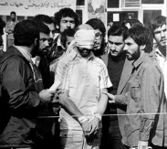
Jon’s Teaching Tips:
Students are familiar with skepticism and mistrust of politicians and are surprised to learn that it wasn’t always this way. These stories help them see how things change over time.
THE LESSON BY THE NUMBERS
Reading Level: 12.1
Audio Time: 29:48
Vocabulary Terms: 32

Harder but about as long as most.

VOCABULARY

IDEAS
Impeachment
Obstruction of Justice
Theocracy
Anti-Nuclear Movement

PEOPLE & GROUPS
Daniel Ellsberg and Anthony Russo
The Plumber
George McGovern
Committee to Re-Elect the President (CREEP)
G. Gordon Liddy
Bob Woodward and Carl Bernstein
Deep Throat
John Dean, H.R. Halderman, John Ehrlichman and John Mitchell
Archibald Cox
Alexander Butterfield
Gerald Ford
Ayatollah Ruholla Khomeini

EVENTS
Watergate Scandal
Watergate Hearings
Saturday Night Massacre
Nixon’s Resignation
Pardon of Nixon
Iranian Revolution
Iranian Hostage Crisis
Operation Eagle Claw

PLACES
Watergate Complex
Three Mile Island
Chernobyl

DOCUMENTS
The Pentagon Papers

SPEECHES
“I am not a crook”

LESSON SUMMARY
The 1970s were a time when some of America’s most important leaders failed. In the case of the Pentagon Papers, reporters revealed that the Presidents of the 1950s and 1960s had lied to the American people about their real reasons for fighting the war in Vietnam, and about how the war was progressing.
President Nixon was forced to resign in 1974 when it became clear that he had abused his authority in an attempt to hide crimes committed by his supporters. The Watergate Scandal, named after the Watergate Hotel and Office Complex, along with the Pentagon Papers, marked a change in America. After the early 1970s, many fewer Americans trust presidents and other powerful leaders.
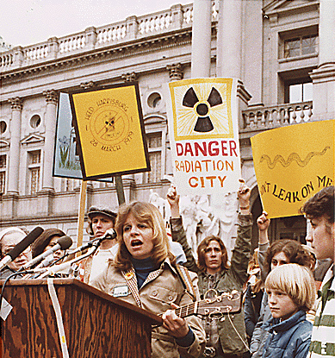
In the later decade, President Carter faced his own challenges. Although he was not corrupt like Nixon, he was unable to solve significant problems. Most embarrassingly, revolutionaries in Iran held 52 Americans hostage. Carter could not negotiate their release and a military rescue mission failed.
A meltdown at the Three Mile Island nuclear power plant showed Americans that its top scientists, engineers and business leaders were also imperfect.
COURT CASES
New York Times Co. v. United States
United States v. Nixon

LAWS
25th Amendment
18-3: GLOBALIZATION
Is it bad for America that so few of the things we buy are made here?

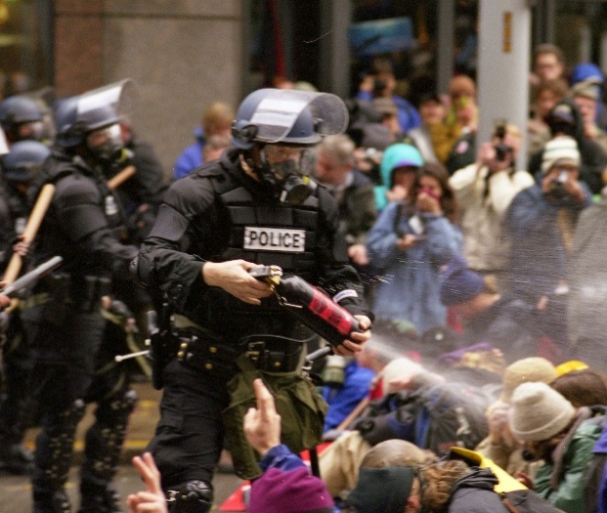
BIG IDEA: Beginning in the 1970s, American manufacturing started to move overseas as businesses looked for ways to lower production costs. Although globalization has been good for many, it has not been good for all Americans and has major critics.
TOPICS
- Nixon Shock
- Stagflation
- Imported Cars
- Energy Crisis
- The Great Malaise
- Globalization
- Rust Belt
- Trade Treaties and Organizations
- Anti-Globalization
Jon’s Teaching Tips:
Early in the course, we taught lessons about the growth of American industry. It is time to help them see why our economy is no longer based on manufacturing. The details of the economic problems of the 70s may be complicated, but the big picture idea globalization is usually not hard to grasp.
THE LESSON BY THE NUMBERS
Reading Level: 11.2
Audio Time: 34:23
Vocabulary Terms: 28

About as hard but longer than most.

VOCABULARY

IDEAS
Bretton Woods System
Gold Standard
Inflation
Staglfation
Globalization
Outsource
McWorld

PEOPLE & GROUPS
Jimmy Carter
Big Three
Ronald Reagan
Anti-Globalization Movement
Social Justice Movement

PLACES
Rust Belt

EVENTS
Nixon Shock
1973 Oil Embargo
Battle in Seattle
Washington DC Protests

GOVERNMENT AGENCIES, PROGRAMS & INTERNATIONAL ORGANIZATIONS
World Trade Organization (WTO)
International Monetary Fund (IMF)
World Bank
Group of Seven (G7)
Organization of Petroleum Exporting Countries (OPEC)
Whip Inflation Now (WIN)
Strategic Petroleum Reserve
North American Free Trade Agreement (NAFTA)

BOOKS
No Logo

LESSON SUMMARY
The 1970s are remembered as a decade of difficult economic times. The United States abandoned the Bretton Woods system of international monetary policy and the gold standard.
An oil embargo forced Americans to pay higher prices for gasoline and other goods. A combination of high unemployment, low growth and high inflation ensued. Called stagflation, American political and financial leaders were unable to turn things around.
Imported cars that were more fuel-efficient made a significant impact on the American automobile industry and imported products became familiar sights on store shelves.
Global trade was increasing and in response, some Americans looked to their government for protection. These anti-globalists oppose trade for a variety of reasons and have sometimes mobilized huge rallies and during the Trump presidency, found some success in changing trade policy.
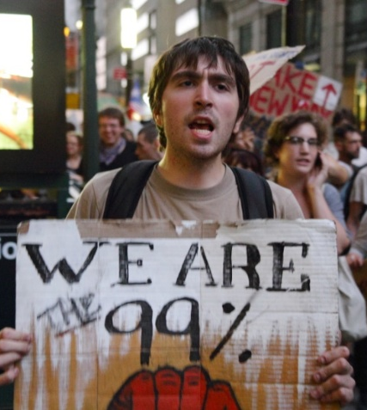
Globalization has hurt some Americans, especially in the Rust Belt of the Northeast and Midwest where manufacturing dried up and workers lost their jobs. On the other hand, globalization has resulted in lower prices and a higher overall standard of living.
COURT CASES
Citizens United v. FCC

SPEECHES
Malaise Speech
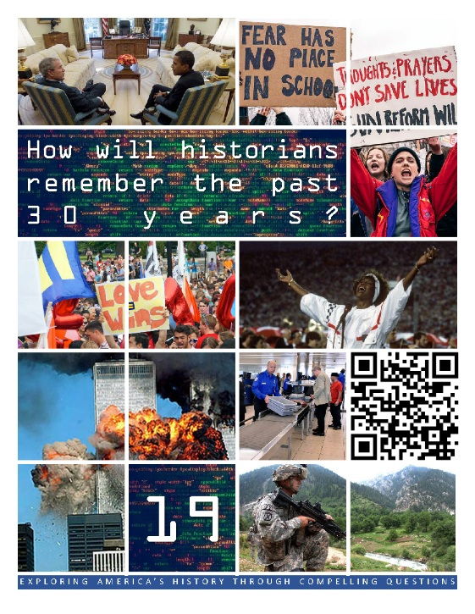  HCSSS STANDARDS  - SS.US.12.8.1 Evaluate popular and government responses to emerging domestic challenges  - SS.US.12.16.2 Analyze U.S. responses to global challenges and crises  TESTED TOPICS  - First Gulf War  - Putin’s Russia  - Serbia  - Bush Doctrine  - Invasion of Afghanistan  - Iraq War  - Patriot Act  - Obama & the War on Terror  - Gun Rights Debate  - Shelby County v. Holder  - Confederate Flag Debate  - Hands Up, Don’t Shoot  - 2000 Election  - Republican Tax Cuts  - Great Recession  - Obamacare  - Tea Party  - Trump Supporters  - Electoral College Debate | UNIT 19
 | Six Lessons
1: THE POST-COLD WAR WORLD
Can the United States be the world’s police officer?
- First Gulf War
- Middle East Peace Negotiations
- The Balkan Wars
- Somalia, Rwanda
- Arab Spring
- Putin’s Russia

2: THE WAR ON TERROR & GUN VIOLENCE
Is the war on terror worth the cost?
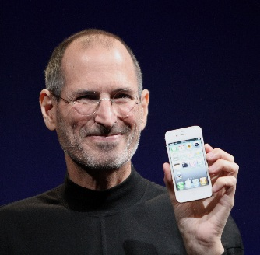
- Domestic Terrorism
- 9/11
- Afghanistan & Iraq
- Patriot Act
- Mass Shootings
- The Second Amendment

3: THE AMERICAN PEOPLE
Who are the American people?
- Immigration Trends & Debate
- Sun Belt
- Growing Minority Populations
- Generations: Boomers, X, Millennials & Z

4: RACE IN CONTEMPORARY AMERICA
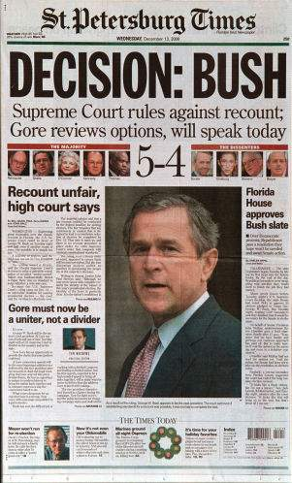
Will there ever be a post-racial America?
- Segregation Today
- Obama
- BLM during Obama’s Presidency
- Confederate Symbols
- BLM and Sports
- #SayHerName & AAPI Hate
- BLM & Trump
- George Floyd Protests
- Voting Rights

 | 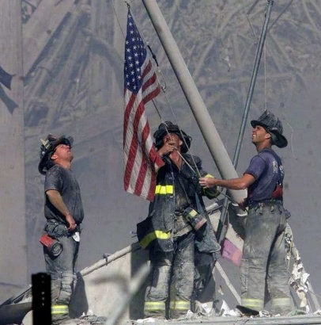

THE PAST 30 YEARS

How will historians remember the past 30 years?
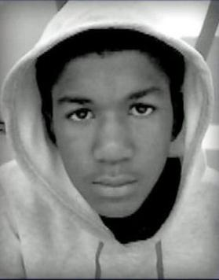
5: THE DIGITAL REVOLUTION
Has the Internet made America a better place?
- Origin of the Internet
- eCommerce
- Cell Phones
- Social Media
- The Pandemic – The World Online
- Digital Dangers
- The Internet and Democratic Institutions

6: CONTEMPORARY POLITICS
Is our political system broken?
- Bush & Clinton
- Bush v. Gore
- George W. Bush
- Great Recession
- Obamacare & the Tea Party
- Political Polarization
- Trump
- #MeToo
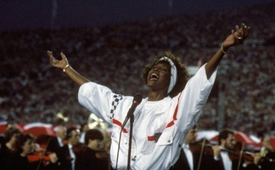
19-1: THE POST-COLD WAR WORLD
Can the United States be the world’s police officer?

BIG IDEA: After the Cold War ended, the United States has taken on the role of the World’s police officer, preventing genocide and maintaining international law. While Americans have been successful in some conflicts, we have also faced limitations to the extent of our power, most notably in the Middle East and with Russia.
TOPICS
- First Gulf War
- Middle East Peace Negotiations
- The Balkan Wars
- Somalia, Rwanda
- Arab Spring
- Putin’s Russia
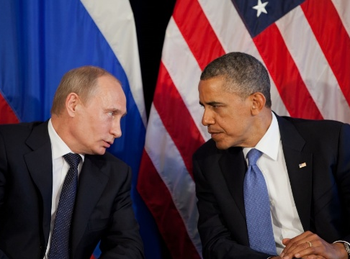
Jon’s Teaching Tips:
The suggested question for this lesson is a great opportunity to let the students think critically since the topics covered include both examples of success and frustration. Showing how contemporary foreign policy concerns are different from the dichotomy of the Cold War Era is useful in helping the students understand change over time.
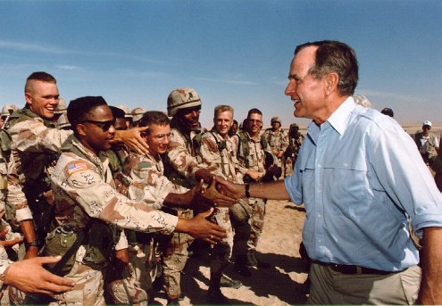
THE LESSON BY THE NUMBERS
Reading Level: 12.3
Audio Time: 29:58
Vocabulary Terms: 22

About as long but harder than most.

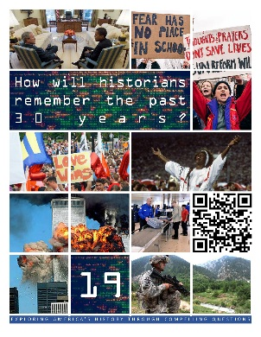
VOCABULARY

IDEAS
Genocide
Russian Sanctions

PEOPLE & GROUPS
Saddam Hussein
Colin Powell
Madeline Albright
Vladimir Putin

EVENTS
The First Gulf War
Arab Spring
2011 Airstrikes in Libya
Syrian Civil War

PLACES
The Balkans
Serbia
Bosnia and Herzegovina
Kosovo
Somalia
Rwanda
Libya
Syria
Ukraine
Crimea

TREATIES
Oslo Accords
Dayton Accords
LESSON SUMMARY
After the end of the Cold War, many people were not sure what the United States’ new role in the world should be. President George H. W. Bush helped define that role in 1991 by using the military to stop Saddam Hussein from annexing Kuwait into Iraq. He organized a coalition of nations and won United Nations approval for the First Gulf War. It was a successful operation, was hugely popular at home, and ended Vietnam Syndrome.
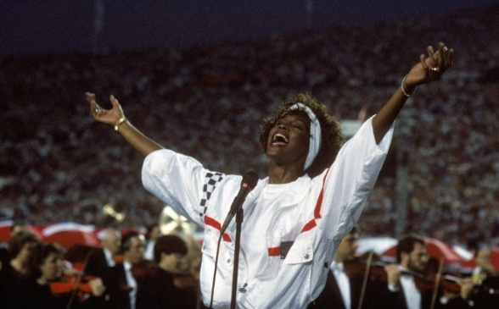
Presidents Carter, Clinton and Trump helped negotiate peace treaties between Israel and its Arab and Palestinian neighbors. President Clinton also guided NATO’s use of the force to end genocide in the Balkans in two separate wars against Serbia.
The United States was unsuccessful in bringing peace to Somalia and refused to intervene in Rwanda to stop a genocide.
In 2010 a series of revolutions and protests in the Middle East and North Africa known as the Arab Spring produced multiple conflicts. The United States used air power in Libya to prevent Muammar Gaddafi from carrying out mass murder, but did not prepare for chaos in that nation after his fall. Americans have provided funding and weapons to rebels in Syria, but have not been fully committed to the civil war there, although Russia has. Congress voted not to participate in the war during the Obama Administration and Trump’s America First policy was popular specifically because many Americans are fearful of involvement in another Middle Eastern conflict.
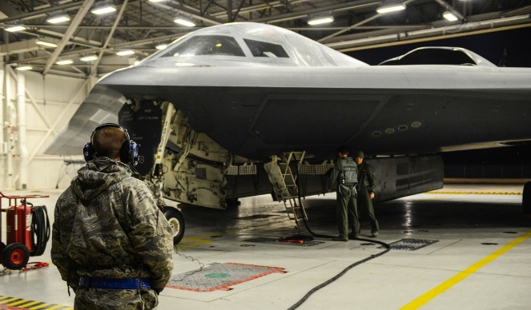
Russian president Vladimir Putin has caused Americans many problems. He invaded the small nation of Georgia, and invaded the much larger neighbor of Ukraine. The United States has protested and imposed sanctions, but has not used military force against this nuclear-armed enemy.
19-2: THE WAR ON TERROR & GUN VIOLENCE
Is the war on terror worth the cost?

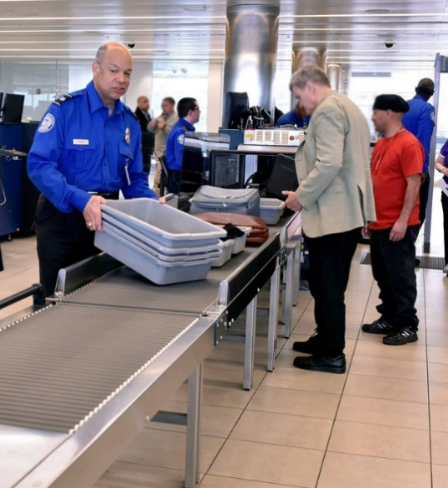
BIG IDEA: Since 2001, the primary foreign policy concern of American presidents has been to prevent terrorist attacks. American forces have fought long wars in Afghanistan and Iraq with mixed results. Back home, Americans have had to give up some of their privacy in exchange for protection. As mass shootings have become more frequent, a debate has grown about balancing safety and Second Amendment rights.
TOPICS
- Domestic Terrorism
- 9/11
- Afghanistan & Iraq
- Patriot Act
- Mass Shootings
- The Second Amendment
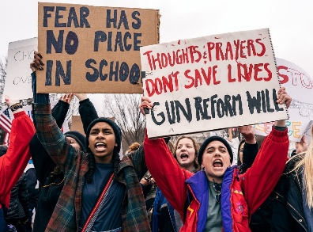
Jon’s Teaching Tips:
This topic is especially interesting to the students since it directly affects many of their lives. Remember, most of them were born after 9/11, so helping them understand some of the details of the event and its immediate aftermath is important. Teachers remember these events clearly, but students do not.
THE LESSON BY THE NUMBERS
Reading Level: 12.6
Audio Time: 40:03
Vocabulary Terms: 39

Harder and longer than most.
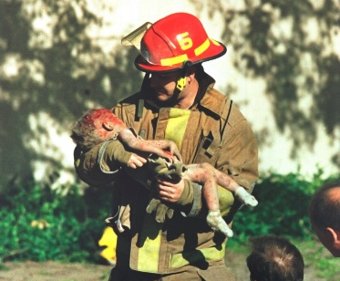
VOCABULARY

IDEAS
Bush Doctrine
Axis of Evil
Weapons of Mass Destruction (WMDs)
Winning Hearts and Minds

PEOPLE & GROUPS
Al-Qaeda
Osama bin Laden
Taliban
Neoconservatives
Richard “Dick” Cheney
Donald Rumsfeld
Islamic State (ISIS)
Edward Snowden
National Rifle Association (NRA)

EVENTS
Branch Davidian Raid
Bombing of the Oklahoma City Federal Building
1998 Embassy Bombings
USS Cole Attack
September 11, 2001
War on Terror
Invasion of Afghanistan
Iraq War
Iraqi Insurgency
The Surge
Columbine High School Shooting
2017 Las Vegas Shooting
Stoneman Douglas High School Shooting

PLACES
World Trade Center
Pentagon
Guantanamo Bay Detention Camp
Abu Ghraib Prison

LAWS
USA Patriot Act
Second Amendment
LESSON SUMMARY
In the 1990s, a major terrorist attack took place in Oklahoma City at a federal office building. The attackers were anti-government veterans.
The September 11 attacks were carried out by al-Qaeda, a group operating out of Afghanistan that was led by Osama bin Laden. They hijacked airplanes and crashed them into the two towers of the World Trade Center in New York City and into the Pentagon near Washington, DC. A fourth plane crashed when the passengers tried to retake control from the hijackers. It was the worst terrorist attack in American history.
Al-Qaeda was not new. They had attacked two American embassies in Africa and a navy ship. President Clinton had ordered a missile strike on one of their bases in response.
After 9/11 President George W. Bush proposed the Bush Doctrine, arguing that America should strike first to prevent attacks. This idea justified war against Afghanistan and Iraq. The United States invaded Afghanistan in order to destroy Al-Qaeda. The war ended quickly as American forces toppled the Taliban government. Unfortunately, creating a new, stable government proved difficult, and American forces spent 20 years in Afghanistan trying to support the new government and fight Taliban insurgents.
Bush decided to invade Iraq, claiming that Saddam Hussein still had chemical and nuclear weapons. The invasion went well, but getting rid of Hussein, who had kept everyone in line, led to fighting among groups within the country and an insurgency against the American occupation. The ongoing war ruined Bush’s popularity. Revelations of torture of prisoners in Iraq and the detention of terror suspects in Guantanamo Bay upset many Americans and damaged America’s reputation in the world.
In order to find terrorists and stop their attacks, Congress passed laws permitting extensive surveillance of American citizens. Eventually some of this power was taken away as people learned how much privacy they were giving up in the name of security.
GOVERNMENT AGENCIES
Department of Homeland Security
Transportation Security Administration (TSA)
National Security Agency (NSA)

SPEECHES
Bush’s Mission Accomplished Speech

COURT CASES
District of Columbia v. Heller
In recent years mass shootings have come to be a new sort of terror and political movements have started to try to limit access to guns. Students form an important anti-gun group, while the NRA serves as a well-funded pro-gun lobby. The Second Amendment guarantees Americans’ right to own guns, which makes gun regulation less likely in the United States than in other nations.
19-4: RACE IN CONTEMPORARY AMERICA
Will there ever be a post-racial America?

BIG IDEA: During the 2010s the Black Lives Matter movement emerged as a response to police violence against African American men. The movement expanded as events brought a wide variety of problems facing minority communities to the nation’s attention. Despite the election of the first African American president, the past decade shows how divided and unequal America remains.
TOPICS
- Segregation Today
- Obama
- BLM during Obama’s Presidency
- Confederate Symbols
- BLM and Sports
- #SayHerName & AAPI Hate
- BLM & Trump
- George Floyd Protests
- Voting Rights
Jon’s Teaching Tips:
This will be an emotional topic and I recommend warning the students before they pick up their phones. Many of the police shootings are available in video online and can be quite disturbing. That being said, this lesson can help students understand how some things, especially prejudices and economic status, can be resistant to change.
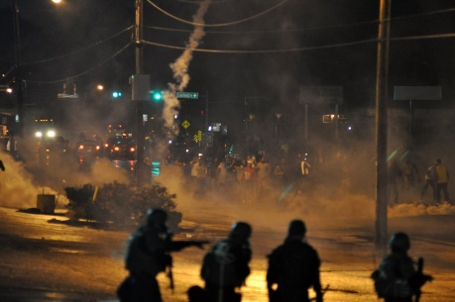
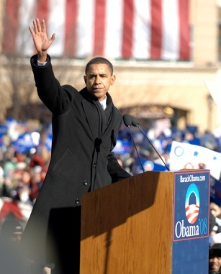
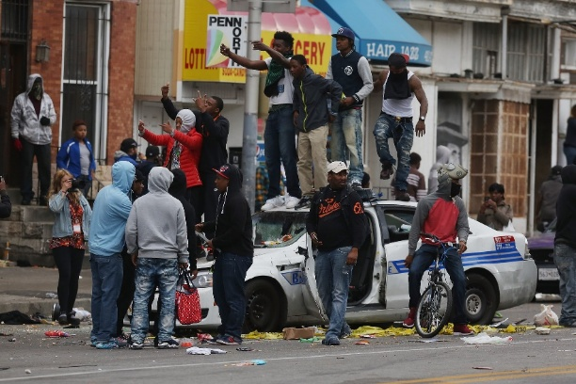
THE LESSON BY THE NUMBERS
Reading Level: 12.8
Audio Time: 50:52
Vocabulary Terms: 38

Harder and longer than most.

VOCABULARY

IDEAS
White Flight
Ferguson Effect
Community Policing
Body Cameras
Voter Suppression

PEOPLE & GROUPS
Barack Obama
Treyvon Martin
Eric Garner
Michel Brown, Jr.
Tamir Rice
Freddie Gray, Jr.
Walter Scott
Colin Kaepernick
Beyoncé
George Floyd

EVENTS
Flint Water Crisis
Black Lives Matter (BLM)
Ferguson Unrest
2015 Baltimore Protest
McKinney Pool Party
Charleston Church Shooting
University of Missouri Protests
2016 Super Bowl Halftime Show
Unite the Right
George Floyd Protests
Trump’s Photo Op at St. John’s Church
Blue Lives Matter
Stop AAPI Hate

LAWS
Stand-Your-Ground Laws
Voter ID Laws

COURT CASES
Shelby County v. Holder
LESSON SUMMARY
The Even after the Civil Rights Movement of the 1960s, America remains a racially segregation nation. People tend to live in communities with other people of their same race. In some places such as Flint, Michigan or New Orleans after Hurricane Katrina, White community leaders have been accused of harming African American neighborhoods by neglecting to provide proper services.
Barack Obama was elected in 2008 as the first African American president. In the beginning, he encouraged people to think that the nation was moving past its divided past, but later he explicitly dealt with race in speeches.
During Obama’s presidency, new cell phone cameras and social media made evidence of shootings of unarmed African Americans common and the Black Lives Matter movement grew to bring attention to this ongoing problem. Protests took place after numerous shootings. Protests in Ferguson, Missouri and Baltimore, Maryland turned violent and were met with police using military equipment and tactics.
A shooting in an African American church in Charleston, South Carolina by a White nationalist led to a movement to remove symbols of the Confederacy, especially the old Confederate battle flag and statues of Confederate soldiers.
Athletes have supported these protests by kneeling during the national anthem. Beyoncé protested by using Black Power symbolism during her performance at the Super Bowl.
Other groups such as African American women and Asian and Pacific Islanders have also begun movements to address racism and violence.
President Trump was criticized by many Americans for his comments and actions related to racial conflicts. Some felt that he was encouraging White supremacists or disrespecting the right of people to assemble and protest.
The most significant racial justice protests since the 1960s happened in the summer of 2020 when marches were held in hundreds of cities to protest police violence after the murder of George Floyd. Numerous changes have been enacted as a result, including changing names and increased efforts to make sure minority groups are represented and portrayed respectfully in business and popular culture.
BLM has been criticized as anti-police and encouraging racial division. Although there has not been a decline in police shootings, police departments around the country have implemented reforms such as an increased emphasis on community policing, banning some tactics, and the use of body cameras.
SPEECHES, SLOGANS & SYMBOLS
2002 Democratic National Convention Keynote Speech
A More Perfect Union Speech
I Can’t Breathe
Hands Up, Don’t Shoot
Blue Lives Matter
Confederate Battle Flag
Thin Blue Line Flag
The Shelby County v. Holder case invalidated parts of the Voting Rights Act of 1965 and in many Republican-controlled states new restrictions on voting rights have been enacted.
19-6: CONTEMPORARY POLITICS
Is our political system broken?

BIG IDEA: Politics in America has always been contentious and there have never been some “good old days” when everyone got along and debated respectfully. However, in the past 30 years the Great Recession, taxes, government spending, racial justice issues, immigration, mass media, the rise of social media, and the personal failings of politicians have all contributed to a shift toward more extreme division.
Jon’s Teaching Tips:
Politics is complicated, but the past 30 years we have grown to be more tribal and less willing to be open to new ideas. Americans are becoming more geographically divided and especially recently, divided by education. Social media has driven this trend. Since our students are future voters, let’s help them understand better the political world we live in and how it got that way.
TOPICS
- Bush & Clinton
- Bush v. Gore
- George W. Bush
- Great Recession
- Obamacare & the Tea Party
- Political Polarization
- Trump
- #MeToo
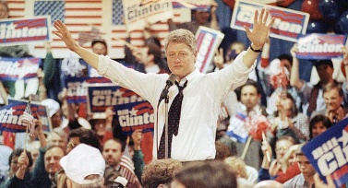
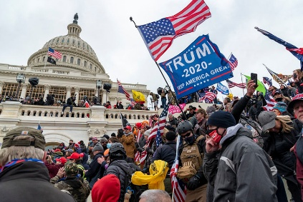
THE LESSON BY THE NUMBERS
Reading Level: 11.7
Audio Time: 47:05
Vocabulary Terms: 49

About as hard but longer than most.

VOCABULARY

IDEAS
Perjury
Impeachment
Charter Schools
School Vouchers
Preexisting Conditions
The 99%
Prosecutorial Discretion

PEOPLE & GROUPS
Bill Clinton
New Democrats
Hillary Clinton
Newt Gingrich
Kenneth Starr
Monica Lewinsky
George W. Bush
Ted Cruz
Dreamers
Donald Trump

EVENTS
Republican Revolution
Hurricane Katrina
Real Estate Market Crash
Great Recession
Occupy Wall Street
Tea Party
#MeToo
Coronavirus Pandemic
First Impeachment of Donald Trump
The Big Lie
2021 Storming of the Capitol
Second Impeachment of Donald Trump

ECONOMIC CONCEPTS
Mortgage Backed Securities
Subprime Mortgage
Credit Rating Agency
Credit Default Swap
SCIENCE
Agent Orange

LESSON SUMMARY
George H. W. Bush was the last president from his generation. He lost his bid for reelection in 1992 to Bill Clinton. Clinton was the first Baby Boomer president and was famous for his engaging personality and also for scandal. Clinton described himself as a New Democrat and embraced some conservative ideas. This helped him win in a time when conservative ideas were more popular.
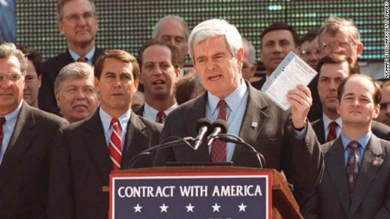
Clinton signed NAFTA but failed to reform healthcare. In 1994 Republicans took back control of Congress for the first time in decades and a period of confrontation between Congress and the President ensued. Clinton’s scandals hurt him in his second term. Investigations of his business deals morphed into an investigation of an affair he had while he was president. He was impeached by the House but not convicted in the Senate. In the end, however, his political talents and a robust economy saved him, and he was the most popular outgoing president ever.
The 2000 presidential election was very close. It all came down to Florida where Al Gore asked for a recount. The procedures ended up being debated in the courts and in the case of Bush v. Gore the Supreme Court handed the election to George W. Bush. It was a rare case when the winner of the popular vote did not become president.
Bush implemented tax cuts for all Americans, especially the wealthy in keeping with traditional Republican ideas about how to support the economy. During his presidency there was a growing divide between the very rich and most other Americans. He also signed the NCLB education law. Later he concentrated on the War on Terror. The War in Iraq and the government’s botched response to Hurricane Katrina ruined his popularity during his second term.
Deregulation and speculation led to problems in the financial markets. A real estate bubble grew during Bush’s tenure that included the creation of mortgage backed securities and credit default swaps. In 2007 everything came crashing down and the Great Recession started. Bush and Obama responded by bailing out banks and the auto industry. Later, Obama passed a stimulus bill to pump tax money into the economy.

CONTINUED ON THE NEXT PAGE…

President Obama and Democrats passed healthcare reform in 2009. The government’s response to the Great Recession and Obamacare were unpopular with voters on both the right and the left. Occupy Wall Street and the Tea Party grew as a result. Republicans in Congress formed fierce opposition to Obama. He responded by using executive orders to make significant changes to environmental and immigration policy.
VOCABULARY CONTINUED

LAWS, POLICIES & PROGRAMS
Health Security Act
Contract with America
Welfare Reform
Bush Tax Cuts
No Child Left Behind Act (NCLB)
Troubled Asset Relief Program (TARP)
The Stimulus
Obamacare
Deferred Action for Childhood Arrivals (DACA)
DREAM Act
Border Wall
Family Separation

GOVERNMENT AGENCIES
Federal Emergency Management Agency (FEMA)

QUOTES
“Read my lips: no new taxes”
“I did not have sexual relations with that woman”

COURT CASES
Bush v. Gore

Beginning in the 1990s the United States has grown increasingly politically polarized. Republicans and Democrats work together less, are more divided geographically, are less likely to vote for someone from the other party or even to have friends from the other party. Extreme partisanship is fueled by media outlets and amplified by social media where algorithms are designed to help you find like-minded people, thus isolating people from dissenting opinions. More and more voters are likely to describe the other party as hating America and trying to ruin the country.
Donald Trump won in 2016 by capitalizing on various political trends, such as anti-globalization, anti-environmentalism, fatigue of wars, Clinton scandals, and anti-feminism. President Trump broke with tradition in many ways, which was part of why his supporters liked him. Although most presidents stretch the truth, Trump told an unprecedented number of lies during his four years in office. His willingness to lie and attacks on his political opponents led to him being impeached twice, once for asking the President of Ukraine to help him find information that would hurt then-candidate Biden and a second time for encouraging his supporters to attack the Capitol Building.
Over the past few decades an intense political debate has emerged around questions related to immigration. As a result of immigration reform in the 1960s, large numbers of immigrants have arrived from Asia and Latin America. Some believe it is time to start to reduce the number of arrivals. Others view these new residents as a benefit to America. Since most non-White Americans vote Democratic, the debate over immigration has become intensely politicized. Fights over the fate of children brought to the country illegally and criticism of President Trump’s proposed border wall and ban on Muslim immigrants made immigration a major political issue in the 2010s.
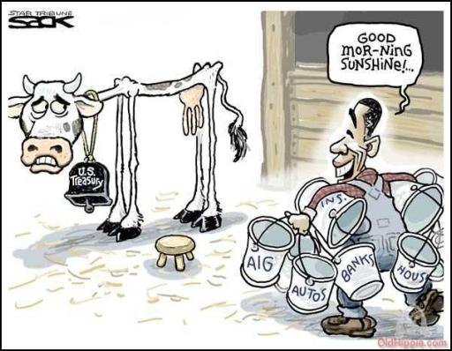
In response to Trump’s accusations of sexual abuse, the #MeToo movement rose to expose abusers and assert women’s power in American politics.

